K30SD
Kawasaki ER-6N ´12-

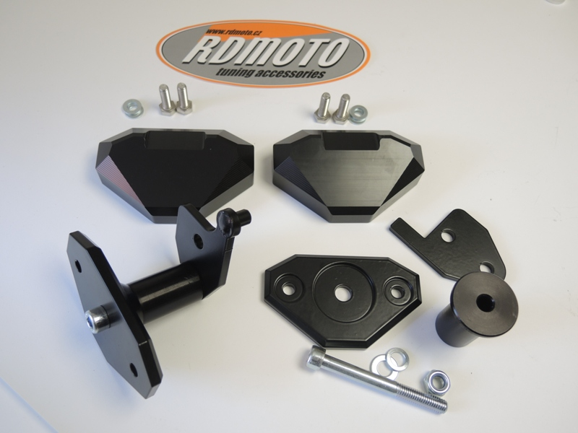
Kit for left side:
1
6
3
6
3
1
7
8
8
7
2
ID. | Description | Cat.NO | QTY
1 | Slider SLD | SLD | 1
2 | Bracket for SLD | 537 | 1
3 | Bolt M8x25 | 815 | 2
4 | Washer M10 | 804 | 1
5 | Nut M10 | 810 | 1
6 | Washer M8 | 802 | 2
7 | Dural cylinder d=60mm | 14 | 1
8 | Steel adapter | 649 | 1
9 | Washer (spring) M10 | 801 | 1
10 | Bolt M10x90mm | 880 | 1
Kit for right side:
4,5 a 9
10
2
10
ID. | Description | Cat.No | QTY
1 | Slider SLD | SLD | 1
2 | Bracket for SLD | 537 | 1
3 | Bolt M8x25 | 815 | 2
4 | Washer M10 | 804 | 1
5 | Nut M10 | 810 | 1
6 | Washer M8 | 802 | 2
7 | Dural. cylinder d=60mm | 14 | 1
8 | Steel adapter | 648 | 1
9 | Washer spring M10 | 801 | 1
10 | Bolt M10x90mm | 880 | 1
Steel adapter for left side

Instruction to assembly left side:

- Dismantle original bolt from frame M10.
- On the frame mounting steel adapter (ID8) use original bolt.
- Put on the bolt M10x90 (ID10) bracket for SLD (ID2) and dural. cylinder d=60mm (ID7), this set fit on the steel adapter and use washers and nut (ID4, ID9 and ID5).
- Fit on the bracket slider (ID1) use bolts and washers (ID6), (ID3).

Warning- use the glue of all threads. We recommended use medium strong glue.

Instruction to assembly right side :

- Dismantle original bolt from frame M10.
- On the frame mounting steel adapter (ID8) use original bolt.
- Put on the bolt M10x90 (ID10) bracket for SLD (ID2) and dural. cylinder d=60mm (ID7), this set fit on the steel adapter and use washers and nut (ID4, ID9 and ID5).
- Fit on the bracket slider (ID1) use bolts and washers (ID6), (ID3).

Warning- use the glue of all threads. We recommended use medium strong glue.

