K31SDM
Kawasaki ER-6F 2012-

Kit for left side: |  |  |  |  | Kit for right side:
ID. | Description | Cat.n. | Qty |  |  | ID. | Description | Cat.n. | Qty
1 | Bracket for SLDM | 537/B | 1 |  |  | 1 | Bracket for SLDM | 537/B | 1
2 | Duralumin adapter | 9 | 1 |  |  | 2 | Duralumin adapter | 9 | 1
3 | Dural.cylinder d=40mm | 469 | 1 |  |  | 3 | Dural.cylinder d=40mm | 469 | 1
4 | Bolt M10x80 | 852 | 1 |  |  | 4 | Bolt M10x80 | 852 | 1
5 | Nut M10-safety | 810 | 1 |  |  | 5 | Nut M10-safety | 810 | 1
6 | Steel adapter | 639 | 1 |  |  | 6 | Steel adapter | 638 | 1
7 | Bolt M8x70 | 841 | 2 |  |  | 7 | Bolt M8x70 | 841 | 2
8 | Bolt M6x20 | 1024 | 2 |  |  | 8 | Bolt M6x20 | 1024 | 2
9 | Washer M6 | 1023 | 2 |  |  | 9 | Washer M6 | 1023 | 2
10 | 3M Tape | 3M | 1 |  |  | 10 | 3M Tape | 3M | 1

Instruct. to assembly- lesft side:

- Take out side fairings from bike. Dismantle bolts M8 from frame.
- Steel adapter ID.6 fitting on the frame,use bolts ID.7 (photo below).
- Bolt M10x80 ID.4 insert through the bracket ID.1,dural. reduction ID.2 and dural. cylinder ID.3.
- You can stick the 3M tape on the place, wher fairing is touching with adapter.
- This kit mounting on the steel adapter, from back side tighten bolt with nut ID.5.
- Fairing put back on the bike.
- Take bolts ID.7 and washers M8 ID.9 make a mounting sliders on the bracket.

Instruct. to assembly- right side:

- Take out side fairings from bike. Dismantle bolts M8 from frame.
- Steel adapter ID.6 fitting on the frame,use bolts ID.7 (photo below).
- Bolt M10x80 ID.4 insert through the bracket ID.1,dural. reduction ID.2 and dural. cylinder ID.3.
- You can stick the 3M tape on the place, wher fairing is touching with adapter.
- This kit mounting on the steel adapter, from back side tighten bolt with nut ID.5.
- Fairing put back on the bike.
- Take bolts ID.7 and washers M8 ID.9 make a mounting sliders on the bracket.

Warning – put the safety glue on all threads during the assembly. Use medium strong one.

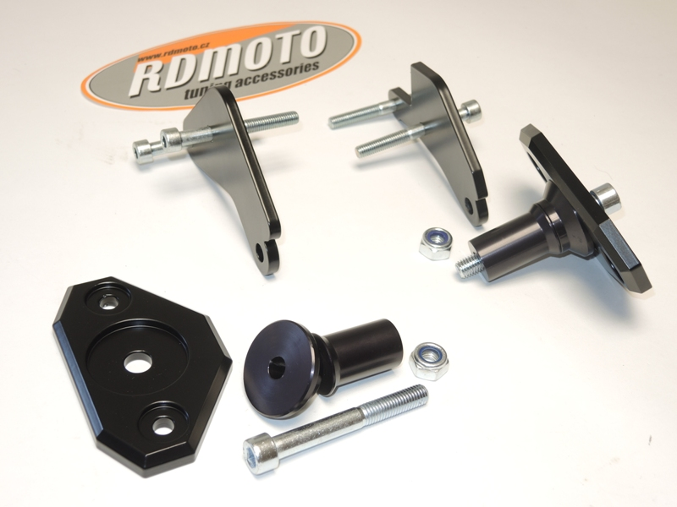
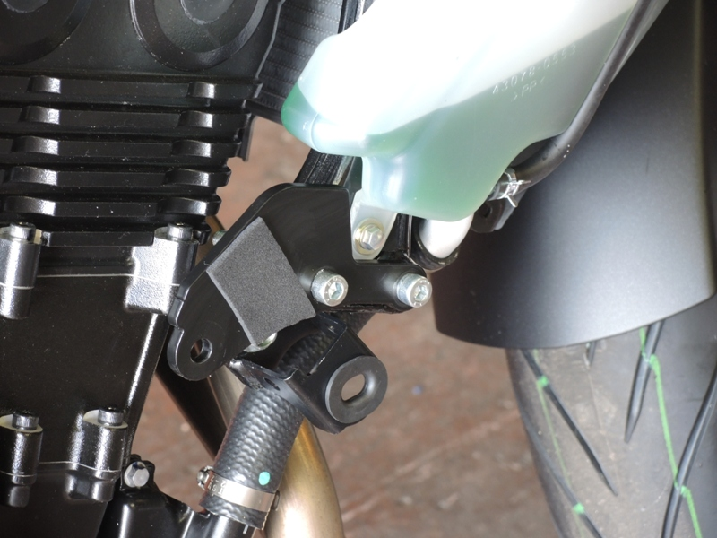
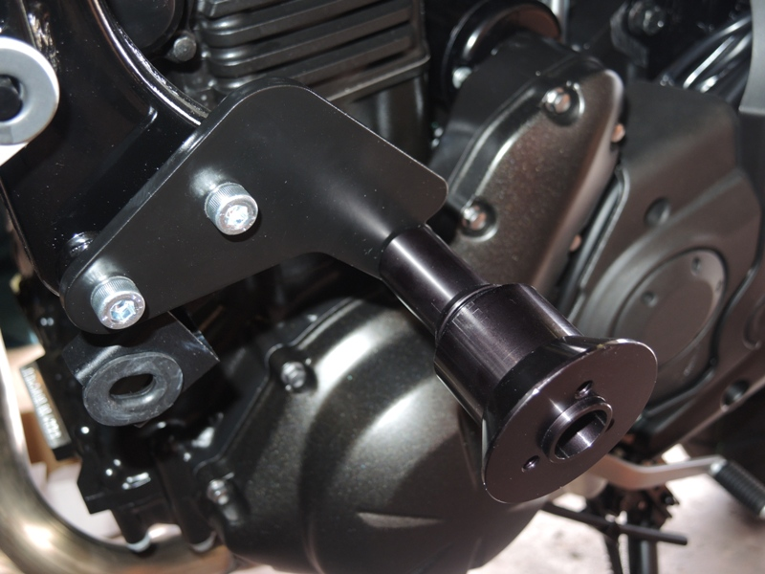
Fitting kit SL01. Ilustration photo,for placet the gripping on the frame only.

