K31S
Kawasaki ER-6F 2013-

Kit for left side:

ID. | Description | Cat.No. | QTY
1 | Slider RDmoto | SL | 1
2 | Cover | SLcap.. | 1
3 | Adapter for SL01 | DV-313 | 1
4 | Bolt M6x25 | 877 | 3
5 | Bolt M4x16 | 876 | 2
6 | Bolt M10x70mm | 851 | 1
7 | Dural.cylinder 40mm | 469 | 1
8 | Bolt M8x70mm | 841 | 2
9 | Steel bracket | 639 | 1
10 | Nut M10 | 810 | 1

Kit for right side:

ID. | Description | Cat.No. | QTY
1 | Slider RDmoto | SL | 1
2 | Cover | SLcap.. | 1
3 | Adapter for SL01 | DV-313 | 1
4 | Bolt M6x25 | 877 | 3
5 | Bolt M4x16 | 876 | 2
6 | Bolt M10x70mm | 851 | 1
7 | Dural.cylinder 40mm | 469 | 1
8 | Bolt M8x70mm | 841 | 2
9 | Steel bracket | 638 | 1
10 | Nut M10 | 810 | 1
Instruction to assembler- left side :

- Dismantle original bolt form frame.
- By bolts (ID.8) mounting steel bracket (ID9) on the frame.
- Mounting duralumin cylinder (ID7) and dural. adapter (ID3), use bolt (ID6) on the steel bracket.
- This set fixed,use nut M10 (ID10)
- Put on slider (ID 1) use bolts M6 (ID 4)
- Insert cover inside the slider (ID 2) use bolts (ID 5).

Warning- use glue for threads of all connect.

Instruction to assembler- right side :

- Dismantle original bolt form frame.
- By bolts (ID.8) mounting steel bracket (ID9) on the frame.
- Mounting duralumin cylinder (ID7) and dural. adapter (ID3), use bolt (ID6) on the steel bracket.
- This set fixed,use nut M10 (ID10)
- Put on slider (ID 1) use bolts M6 (ID 4)
- Insert cover inside the slider (ID 2) use bolts (ID 5).

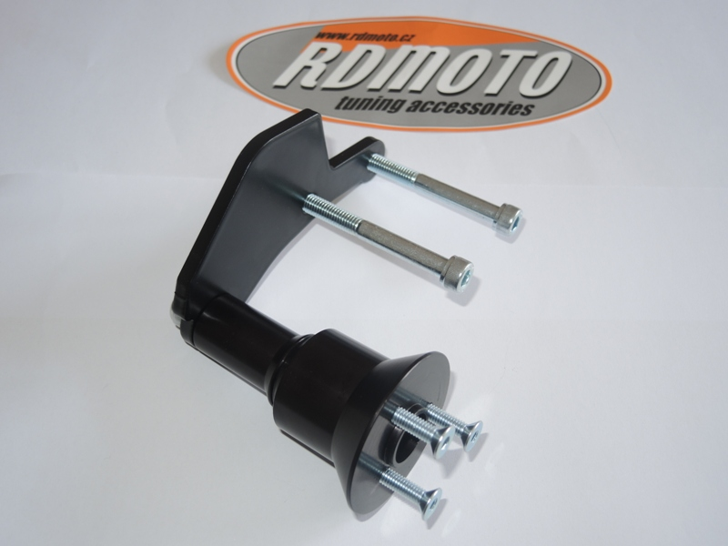
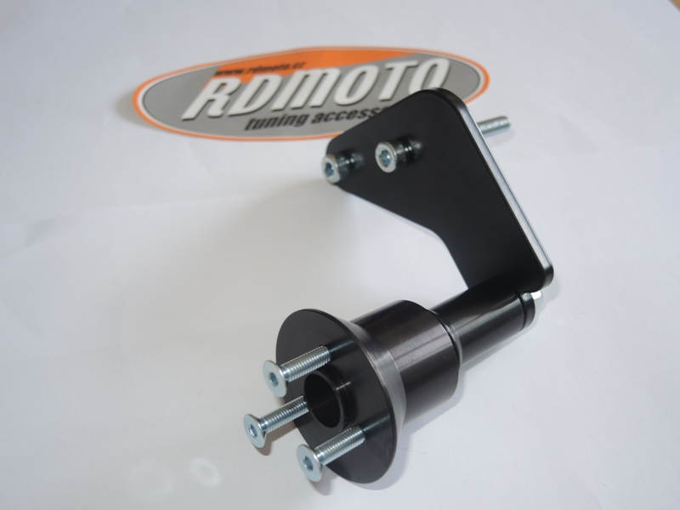
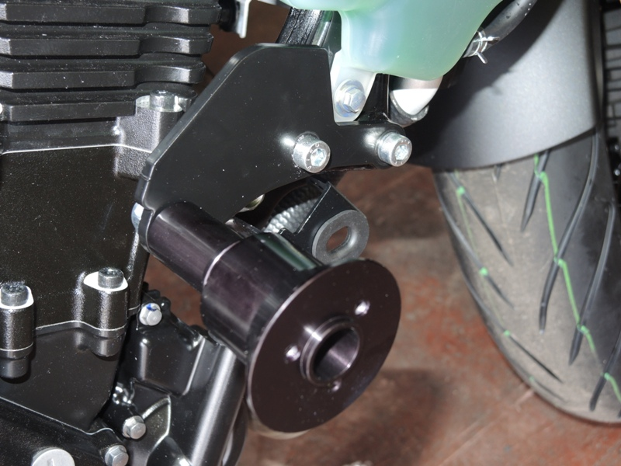
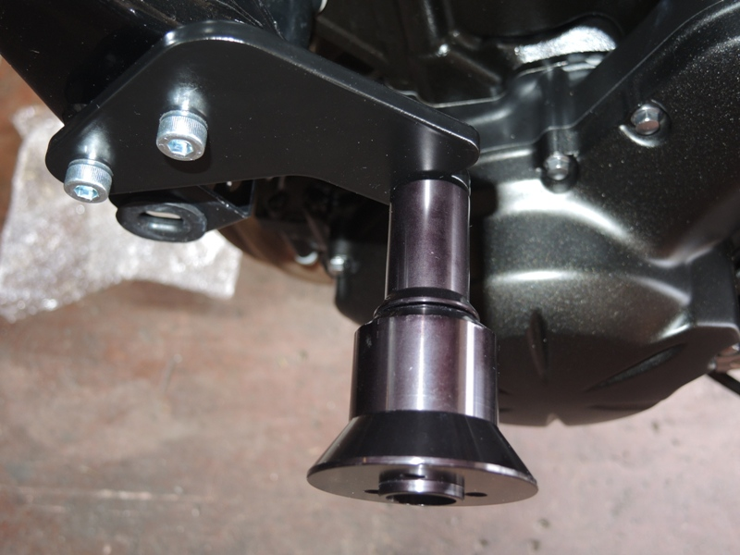
Left side
Right side.

