K31
Kawasaki ER-6F 2013-

Kit for the left side |  |  |  |  | Kit for the right side
No. | Description | Cat.No | Pcs |  | No. | Description | Cat.No | Pcs
1 | steel insert M10 | X1 | 1 |  | 1 | steel insert M10 | X1 | 1
2 | screw M10x80mm | 852 | 1 |  | 2 | screw M10x80mm | 852 | 1
3 | duralumin cylinder d = 40mm | 469 | 1 |  | 3 | duralumin cylinder d = 40mm | 469 | 1
4 | screw M8x70mm | 841 | 2 |  | 4 | screw M8x70mm | 841 | 2
5 | steel adapter | 639 | 1 |  | 5 | steel adapter | 638 | 1
6 | nut M10-insurance | 810 | 1 |  | 6 | nut M10-insurance | 810 | 1
7 | pad M10 flat | 804 | 1 |  | 7 | pad M10 flat | 804 | 1

Mounting - left side:

- remove the original plastic side and screws M8 of the motorcycle frame
- by screws (item 4) mount on the motorcycle frame steel adapter (item 5)
- to the crash protector insert a steel insert (item 1) and screw (item 2)
- from the back side of crash protector insert to the screw duralumin cylinder (item 3)
- entire assembly mount on the steel adapter and tighten by nut (item 6) with pad (item 7)
- mount back the plastic side

Warning - the threads of the screws is recommended to use premium adhesive moderate (blue color).
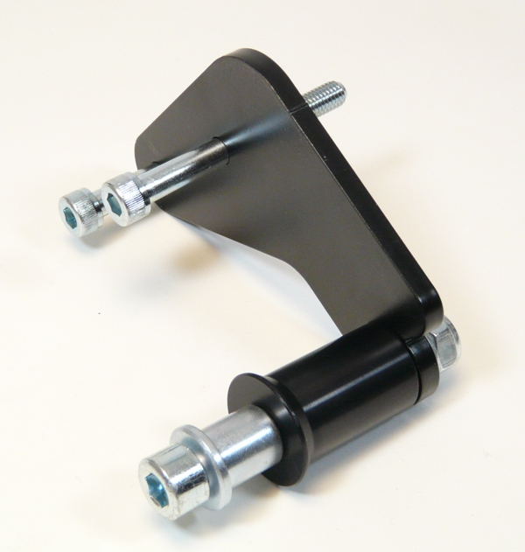
Mounting - right side:

- remove the original plastic side and screws M8 of the motorcycle frame
- by screws (item 4) mount on the motorcycle frame steel adapter (item 5)
- to the crash protector insert a steel insert (item 1) and screw (item 2)
- from the back side of crash protector insert to the screw duralumin cylinder (item 3)
- entire assembly mount on the steel adapter and tighten by nut (item 6) with pad (item 7)
- mount back the plastic side

Warning - the threads of the screws is recommended to use premium adhesive moderate (blue color).

