K33SD
Kawasaki Ninja 300 2013-

Kit for left side: Kit for right side:

ID. | Description | Cat.No | QTY
1 | Slider | SLD | 1
2 | Bracket for SLD | 537 | 1
3 | Bolt M8x25 | 815 | 2
4 | Washer M8 | 802 | 2
5 | Dural. redutc. d=15mm | DV-149 | 1
6 | Dural. cylinder d=70mm | 470 | 1
7 | Bolt M12x40 | 1021 | 1
8 | Bolt M10x60 | 850 | 2
9 | Nut M10 | 810 | 2
10 | Washer M10 | 804 | 4
11 | Steel adapter | 642 | 1
12 | Bolt M12x40 | 857 | 1
ID. | Description | Cat.N | Ks
1 | Slider | SLD | 1
2 | Bracket for SLD | 537 | 1
3 | Bolt M8x25 | 815 | 2
4 | Washer M8 | 802 | 2
5 | Dural. redutc. d=15mm | DV-149 | 1
6 | Dural. cylinder d=70mm | 470 | 1
7 | Bolt M12x40 | 1021 | 1
8 | Bolt M10x60 | 850 | 2
9 | Nut M10 | 810 | 2
10 | Washer M10 | 804 | 4
11 | Steel adapter | 643 | 1
12 | Bolt M12x40 | 857 | 1

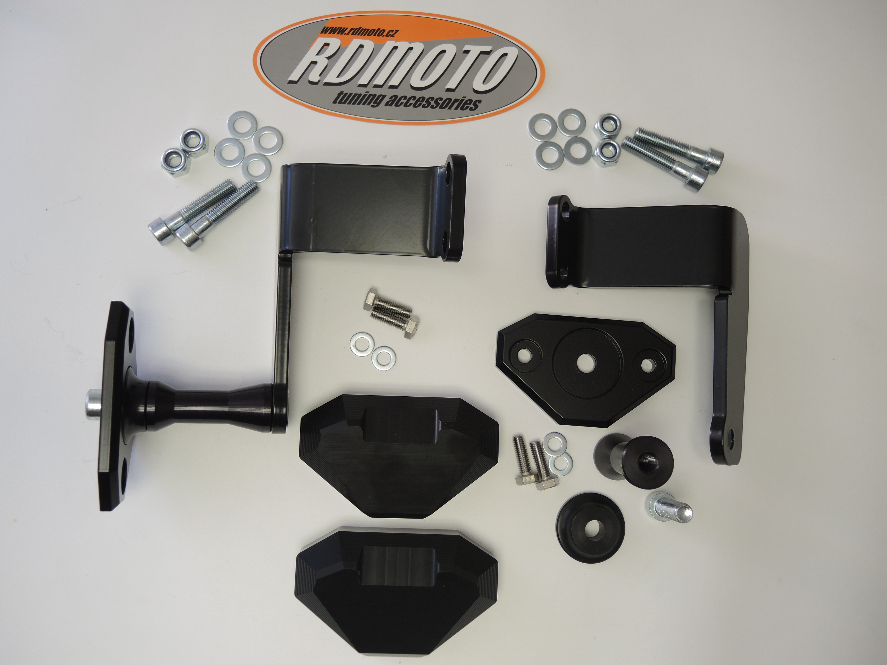
9,10
9,10
8
11

11
8

3,4
7
6
5

12
2

2
6

12

5

3,4
1

Instruction to assembly- left side:

- Take out fairing and original bolts M10 from frame.
- On the steel adapter ID.11 mounting dural.cylinder ID.6 use bolt ID.7.
- This set mounting on the frame use the washers ID.10, bolts ID.8 and nuts ID.9.
- Put fairing on the bike,now.
- Put on the bolt ID.12 bracket for SLD ID.2 and dural. reduction ID.5
- This set fixed on the dural. cylinder.
- Mounting slider ID.1 use the bolts and washers ID.3 and ID.4.

Warning- we recommend use the glue of all threads. Medium strong.

Instruction to assembly- right side:

- Take out fairing and original bolts M10 from frame.
- On the steel adapter ID.11 mounting dural.cylinder ID.6 use bolt ID.7.
- This set mounting on the frame use the washers ID.10, bolts ID.8 and nuts ID.9.
- Put fairing on the bike,now.
- Put on the bolt ID.12 bracket for SLD ID.2 and dural. reduction ID.5
- This set fixed on the dural. cylinder.
- Mounting slider ID.1 use the bolts and washers ID.3 and ID.4.

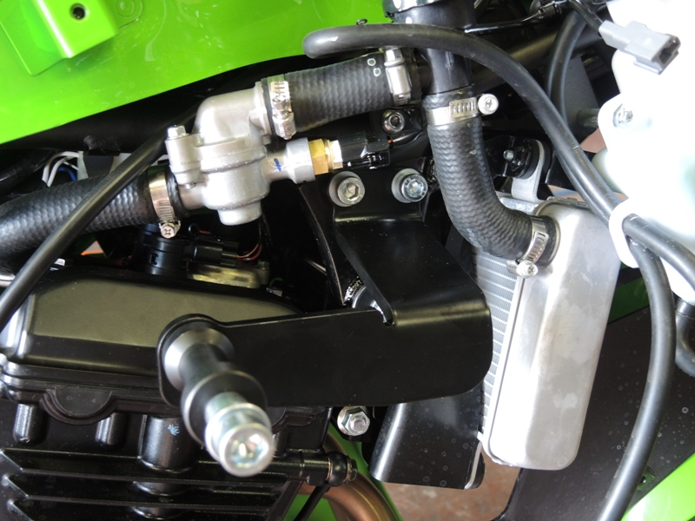
Warning- we recommend use the glue of all threads. Medium strong.

