K33S
Kawasaki Ninja 300 2013-

Kit for left side: Kit for right side:
ID. | Description | Cat.No | Qty
1 | Steel adapter | 643 | 1
2 | Bolt M12x40 | 1021 | 1
3 | Bolt M10x60 | 850 | 2
4 | Dural. cylinder d=70 | 470 | 1
5 | Nut M10 | 810 | 2
6 | Washer M10 | 804 | 4
7 | Adapter for SL01 | 1137 | 1
8 | Bolt M12x40 | 857 | 1
9 | Bolt M6x25 | 877 | 3
10 | Bolt M4x16 | 876 | 2
ID. | Description | Cat.No | Qty
1 | Steel adapter | 642 | 1
2 | Bolt M12x40 | 1021 | 1
3 | Bolt M10x60 | 850 | 2
4 | Dural.cylinder d=70 | 470 | 1
5 | Nut M10 | 810 | 2
6 | Washer M10 | 804 | 4
7 | Adapter for SL01 | 1137 | 1
8 | Bolt M12x40 | 857 | 1
9 | Bolt M6x25 | 877 | 3
10 | Bolt M4x16 | 876 | 2
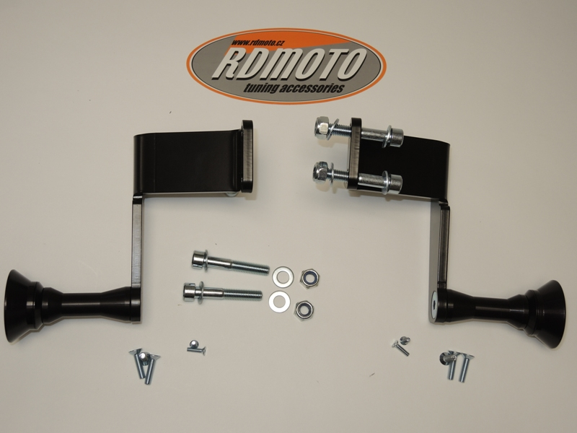
4
1
8
9
5
10
3
6
6
9
2
5
8
7
4
10
1
3
2
6
7

Instruction to assembly:

Assembly for left and right side is same.
Do the first left side and after do the right side.
- Take off fairings and bolts M10 from frame.
- Mount dural.cylinder ID.4,use bolt M12x40 ID.2 into the steel adapter ID.1.
- This set mounted on frame , use bolts ID.3 washers ID.6 and nuts ID.5.
- Put fairing back on the bike.
- The bolt M12 ID.8 insert into the adapter for SL01 ID.7 and mounting it on the steel adapter.
- Use bolts M6x25 ID.9 for fixed sliders, insert cover and use bolts M4x16 ID.10

Warning – use the glue of all threads. Medium strong.
