K34-2
Kawasaki ZX636R Ninja,´13-´14

Fitting kit left side: Fitting kit right side:
ID | Description | Cat.n | QTY
1 | Steel box | X1 | 1
2 | Dural.adapter | 1128 | 1
3 | Bolt M10x80x1,25 | 920 | 1
ID | Description | Cat.n | QTY
1 | Steel box | X1 | 1
2 | Dural.adapter | 1129 | 1
3 | Bolt M10x90x1,25 | 890 | 1

Instruction to assembly left side:
- Take out original bolt M10 from frame.
- Insert steel box ID.1 into the protector.
- Insert bolt ID.3 M10x80 into the protector and put on it dural.adapter ID.2.
- This set instal into the frame.

Instruction to assembly right side:
- Take out original bolt M10 from frame.
- Don´t dismantle special crown nut!
- Insert steel box ID.1 into the protector.
- Insert bolt ID.3 M10x80 into the protector and put on it dural.adapter ID.2.
- This set instal into the frame.

Warning : Use the glue of all threads-medium strong.
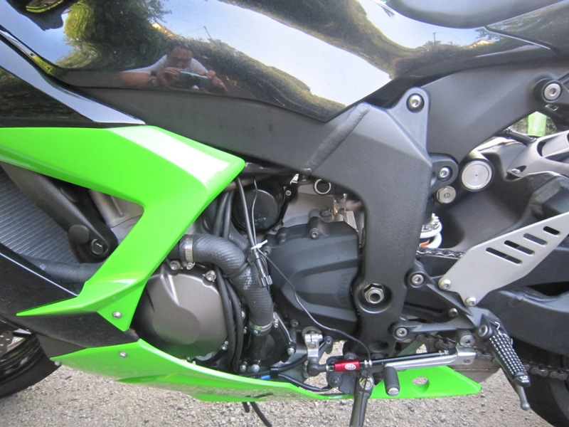
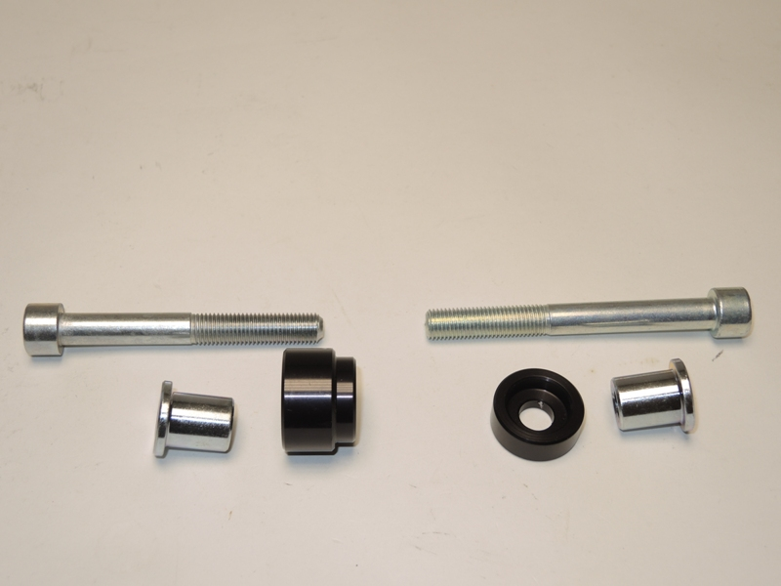
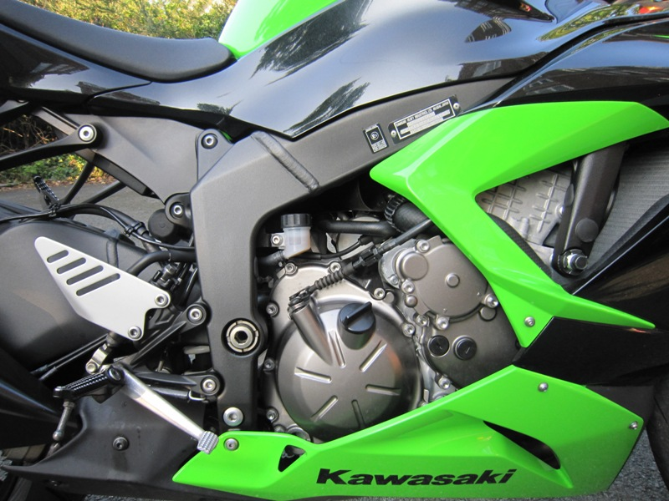
2
1
3
1
2
3

