K34SDM
Kawasaki ZX-6R/RR 2013-

LEFT SIDE KIT RIGHT SIDE KIT
ID | Popis | Cat.No. | Pcs
1 | Slider SLDM | - | 1
2 | SLDM adapter | 537 | 1
3 | Bolt M10x40 | 854 | 1
4 | Bolt M8x25mm | 832 | 2
5 | Poly. Cylinder 20mm | X6 | 2
6 | Dural. cylinder 17,5mm | 102 | 1
7 | Bolt M10x70x1,25 (cone) | 957 | 1
8 | Dural. adapter | 540 | 1
9 | Dural. cylinder 20mm | DV10 | 1
10 | Washer M10 (spring) | 801 | 1
11 | 3M tape |  | 1
12 | Bolt M6x20 | 1023 | 2
13 | Washer M6 | 1024 | 2
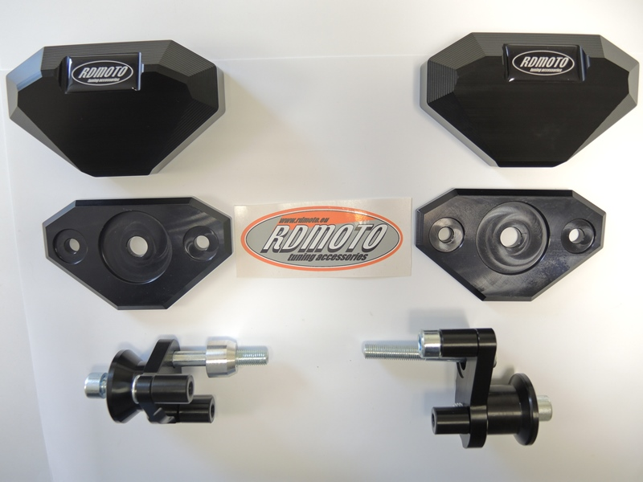
1
1
ID | Description | Cat.no. | Pcs
1 | Slider SLDM | - | 1
2 | SLDM adapter | 537 | 1
3 | Bolt M10x30 | 882 | 1
4 | Bolt M10x50 | 849 | 1
5 | Poly. Cylinder 20mm | X6 | 1
6 | Poly cylinder 20mm | X10 | 1
7 | Bolt M10x70x1,25 | 898 | 1
8 | Dural. adapter | 539 | 1
9 | Bolt M8x25mm | 832 | 1
10 | Dural. cylinder 30mm | DV11 | 1
11 | Washer M10 (spring) | 801 | 1
12 | 3M tape |  | 1
13 | Bolt M6x20 | 1023 | 2
14 | Washer M6 | 1024 | 2

2
2

6
3
7
8
8
6
9

4
7
3

11
9
101
5
5
4
10

INSTRUCTIONS

- Dismantle side fairing and bolt M10 from the frame.
- Stick 3M tape on the frame to prevent its damage.
- Assembly fitting kit according to the picture. Mount this kit into the frame of motorcycle using bolt ID7.
- Mount side fairing back on the motorcycle.
- Fit protectors using two bolts ID13 and washers ID14.

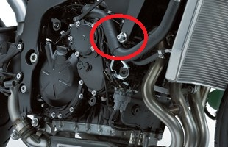
We recommend to use safety glue on all threads.

