K34S
Kawasaki ZX-636R/RR 2013-
Kit for left side: Kit for right side:
ID | Description | Cat.N | Qty
1 | Dural.adapter for SL01 | 317 | 1
2 | Bolt M10x25 | 868 | 1
3 | Bolt M10x30 | 882 | 1
4 | Bolt M6x25 | 877 | 3
5 | Poly.cylinder d=20mm | X6 | 1
6 | Poly. cylinderd=20 | X10 | 1
7 | Bolt M10x70x1,25 | 898 | 1
8 | Dural.adapter | 539 | 1
9 | Bolt M8x25mm | 832 | 1
10 | Bolt M4x16 | 876 | 2
12 | 3M tape |  | 1
13 | Washer M10 spring | 801 | 1
ID | Description | Cat.N | Qty
1 | Dural.adapter for SL01 | 317 | 1
2 | Bolt M10x25 | 868 | 1
3 | Bolt M6x25 | 877 | 3
4 | Bolt M8x25mm | 832 | 2
5 | Poly.cylinder d=20mm | X6 | 2
6 | Dural.cylinder d=17,5mm | 102 | 1
7 | Bolt M10x70x1,25 (cone head) | 957 | 1
8 | Dural.adapter | 540 | 1
9 | Bolt M4x16 | 876 | 2
10 | 3M tape |  | 1
11 | Washer M10 spring | 801 | 1
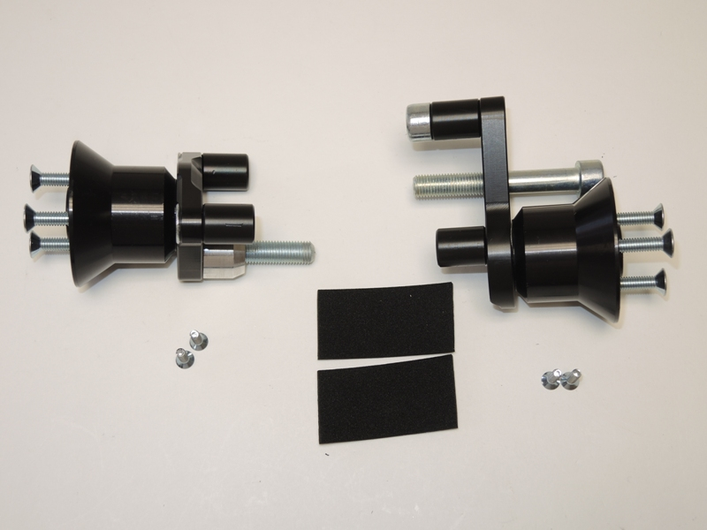
3
4
2,11
2,14
1
1
4
5
5
7
8
9
3
10
4
8
5
7
10
9
6

6

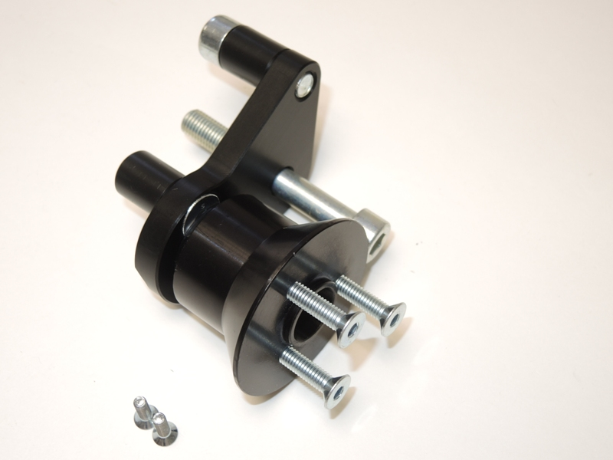
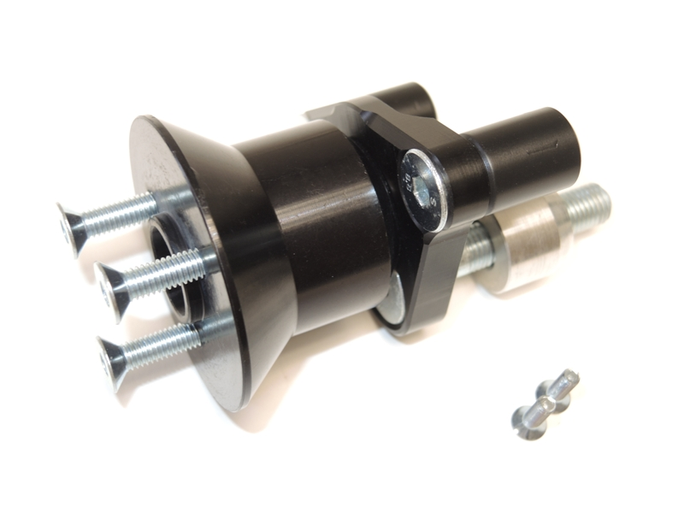
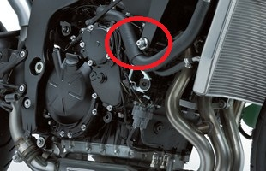

Instruction to assembly-left side:

- Take out fairing and bolt from frame.
- To put together dural.adapter ID.8 (if is not assembled), insert bolts M8x25 ID.4 and from back side mount polyamid cylinders ID.5. To stick 3M tape on the frame ID.10.
- Use bolt M10x70x1,25 ID.7 and mount dural.adapter on the frame, insert dural. cylinder ID.6 d=17,5 between the adapter and frame.
- Now put fairing on the bike.
- Take dural. adapter ID.1 and fitting it by bolt ID.2 and washer ID.11, for gripping slider´s use bolts ID.3 Insert aluminim cap into slider use bolt ID.9

Instruction to assembly-right side:

- Take out fairing and bolt from frame.
- To put together dural.adapter ID.8 (if is not assembled), insert bolt M8x25 ID.9 and from back side mount polyamid cylinder ID.5. Take bolt ID.3 and mount poly. Cylinder ID.6, bolt with cylinder mount into the adapter ,stick 3M tape on the frame ID.12.
- Use bolt M10x70x1,25 ID.7 and mount dural.adapter on the frame.
- Now put fairing on the bike .
- Take ID.1 and fitting it by bolt ID.2 and washer spring ID.13. Use bolt ID.4 for gripping slider. Insert aluminim cap into slider use bolt ID.10

Warning – use glue of all threads- medium strong.

If you have assembly dural adapters together from company- Cheb all bolts.

