K34
Kawasaki ZX-6R/RR 2013-
Kit for left side: Kit for right side:
ID | Description | Cat.No | QTY
1 | Protector | PH | 1
2 | Steel box | X1 | 1
3 | Bolt M10x45 | 848 | 1
4 | Bolt M8x25mm | 832 | 2
5 | Poly.cylinder d=20mm | X6 | 2
6 | Dural.cylinder d=17,5mm | 102 | 1
7 | Bolt M10x70x1,25 (cone head) | 957 | 1
8 | Dural.adapter | 540 | 1
9 | Dural. cylinder d=10 | DV1 | 1
10 | Washer spring M10 | 801 | 1
11 | 3M tape |  | 1
ID | Description | Cat.No | QTY
1 | Protector | PH | 1
2 | Steel box | X1 | 1
3 | Bolt M10x30 | 882 | 1
4 | Bolt M10x55 | 1008 | 1
5 | Poly.cylinder d=20mm | X6 | 1
6 | Poly.cylinder d=20mm | X10 | 1
7 | Bolt M10x70x1,25 | 898 | 1
8 | Dural.adapter | 539 | 1
9 | Bolt M8x25mm | 832 | 1
10 | Dural.cylinder d=20mm | DV2 | 1
12 | Washer-spring M10 | 801 | 1
13 | 3M tape |  | 1

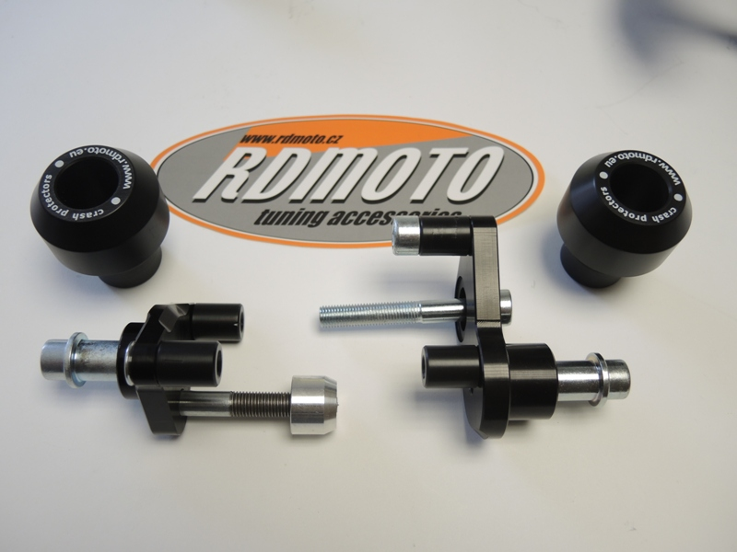

6
1
1

3

5
7
4
3
9
4

12
10

2
5
10
6
2
8
7
9
8

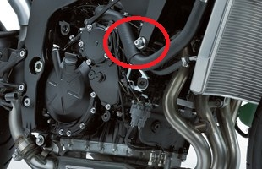

Instruction to assembly-left side:

- Take out fading and bolt from frame.
- To put together dural.adapter ID.8 (if is not assembled), insert bolts M8x25 ID.4 and from back side mount polyamid cylinders ID.5. To stick 3M tape on the frame ID.11.
- Use bolt M10x70x1,25 ID.7 and mount dural.adapter on the frame, insert dural. cylinder ID.6 d=17,5 between the adapter and frame.
- Now put fading on the bike.
- Take protector ID.1 insert steel box ID.2 an washer ID.10 and under the protector insert dural.cylinder ID.9. Use bolt M10x45mm ID.3.

Instruction to assembly-right side:

- Take out fading and bolt from frame.
- To put together dural.adapter ID.8 (if is not assembled),to adapter insert bolt M8x25 ID.9 and from back side mount polyamid cylinders ID.5. Take bolt ID.3 and mount poly. Cylinder ID.6, bolt with cylinder mount into the adapter To stick 3M tape on the frame ID.13.
- Use bolt M10x70x1,25 ID.7 and mount dural.adapter on the frame.
- Now put fading on the bike .
- Take protector ID.1 insert steel box ID. and washer spring ID.12. Use bolt ID.4 M10x55 and under the protektor insert dural.cylinder d=20mm ID.10

Warning – use glue of all threads- medium strong.

If you have assembly dural adapters together from company- Check all bolts.

