K35SD
Kawasaki Z800´013-

 | Kit for left side |  |  |  | Kit for right side
No. | Description | Cat. No. | Quant.
- | ------ | - | -
2 | Dural. adapter on the frame | 547 | 1
3 | Dural. cylinder d=20mm | 495 | 2
4 | Holder for SLD | 537 | 1
5 | Dural. reduction d=20mm | 10 | 1
6 | Bolt M8x25mm | 815 | 2
7 | Washer spring M8 | 800 | 2
8 | Bolt M8x70mm | 841 | 2
9 | Washer spring M10 | 801 | 1
10 | Bolt M10x45mm | 848 | 1
11 | Plastic cover - black | X5 | 2
12 | 3M sticker |  | 1
No. | Description | Kat.No. | Quant.
- | ------- | - | -
2 | Dural. adapter on the frame | 547 | 1
3 | Dural. cylinder d=20mm | 495 | 2
4 | Holder for SLD | 537 | 1
5 | Dural. reduction d=15mm | 9 | 1
6 | Bolt M8x25mm | 815 | 2
7 | Washer spring M8 | 800 | 2
8 | Bolt M8x70mm | 841 | 2
9 | Washer spring M10 | 801 | 1
10 | Bolt M10x40mm | 854 | 1
11 | Plastic cover - black | X5 | 2
12 | 3M sticker |  | 1

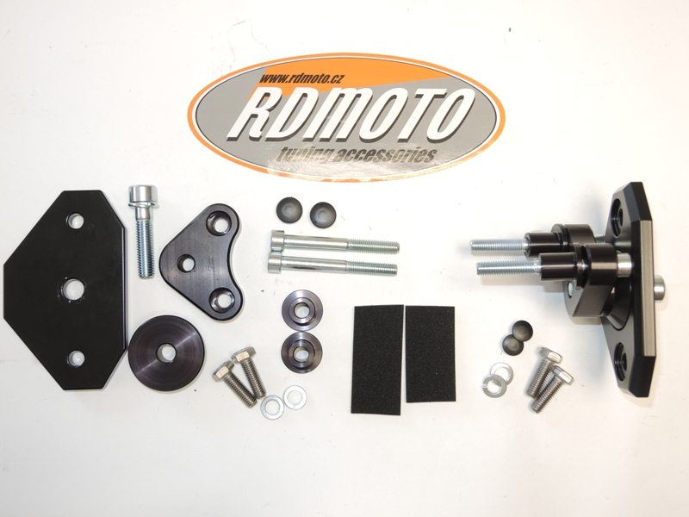

4
9,10
44
2
3
2
11

8
8

9,10
11

5
3
12
7
6
5
6,7

Instruction left side:
- Remove original bolt M8 from frame.
- Insert the frame cylinder (No.3) and mounting duralumin adapter on the frame (no.2) using bolt M8 (no.8).
- Mounting SLD holder (no.4 ) using duralumin reduciton (no.5),bolt M10 (poz.10) and washer (no.9) all kit fixed on the duralumin adapter.
- Using bolt M8x25 (no.6) and washer (poz.7) mounting slider SLD.

Insert plastic covero in to the bolt and stick 3M between the duralumin holde rand motorcycle frame.

Instruction- right side:

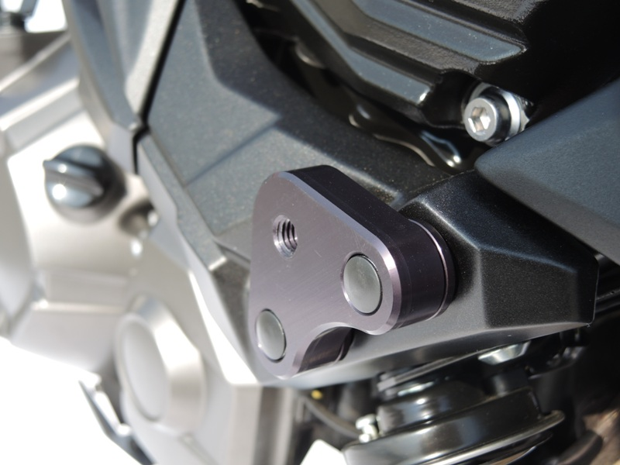
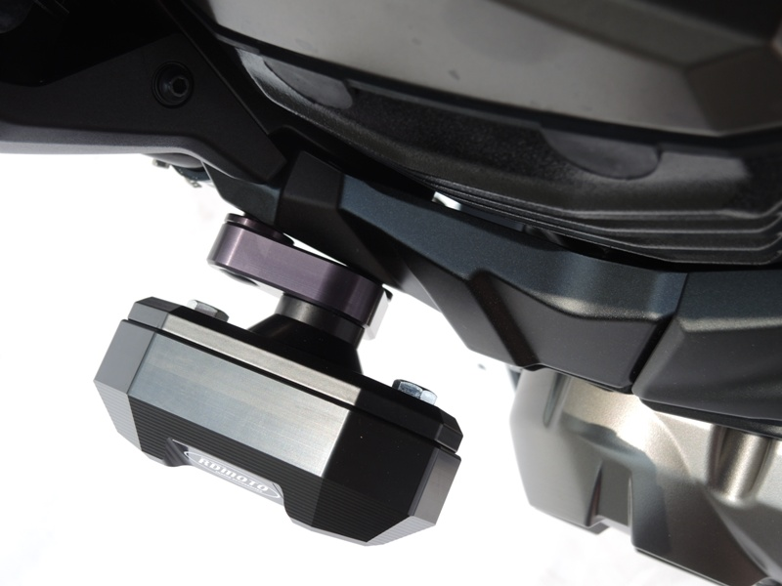
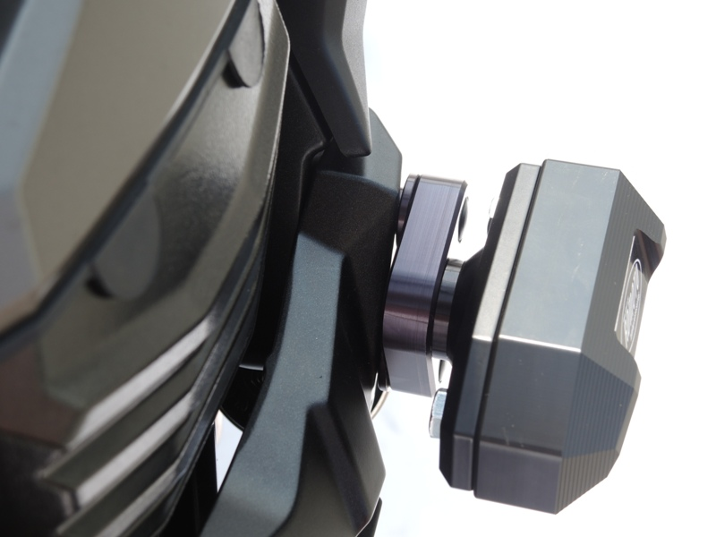
- Remove original bolt M8 from frame.
- Insert the frame cylinder (No.3) and mounting duralumin adapter on the frame (no.2) using bolt M8 (no.8).
- Mounting SLD holder (no.4 ) using duralumin reduciton (no.5),bolt M10 (poz.10) and washer (no.9) all kit fixed on the duralumin adapter.
- Using bolt M8x25 (no.6) and washer (poz.7) mounting slider SLD.

Insert plastic covero in to the bolt and stick 3M between the duralumin holde rand motorcycle frame.

Warning – we recommend to use safety glue on threads of all bolts (moderate strong – blue colour).

