K35S
Kawasaki Z800´013-

Kit for left side: | Kit for right side

No. | Description | Cat.no. | Quant. |  | No. | Description | Cat. No. | Quant
1 | slider RDmoto | SL | 1 |  | 1 | slider RDmoto | SL | 1
2 | cover | SLcap.. | 1 |  | 2 | cover | SLcap.. | 1
3 | Adapter for slider | 313 | 1 |  | 3 | Adapter for slider | DV-292 | 1
4 | Duralumin adapter on the frame | 547 | 1 |  | 4 | Bolt M10x30mm | 882 | 1
5 | Bolt M10x30mm | 882 | 1 |  | 5 | Bolt M6x25 | 877 | 3
6 | Bolt M6x25 | 877 | 3 |  | 6 | Bolt M4x16 | 876 | 2
7 | Bolt M4x16 | 876 | 2 |  | 7 | Bolt M8x70mm | 841 | 2
8 | Bolt M8x70mm | 841 | 2 |  | 8 | dural. cylinder d=20mm | 495 | 2
9 | Dural. cylinder d=20mm | 495 | 2 |  | 9 | Duralumin adapter | 547 | 1
10 | Washer spring M10 | 801 | 1 |  | 10 | Plastic cover - black | X5 | 2
11 | Cover- black | X5 | 2 |  | 11 | 3M sticker |  | 1
12 | 3M sticker |  | 1 |  | 12 | Washer spring M10 | 801 | 1
 |  |  |  |  | 13
Instruction for left side :

- Dismantle original bolts M8 from frame.
- Insert to the frame duralumin cylinder (no.7) and mounting on the frame duralumin adaper (no.2) by bolt M8 (no.86).
- Mounted on the adapter duralumin adapter for slider (no.2) using the washer (no.8) and bolt (no.3).
- Mounting slider SL01 (no.1) using the bolt M6 (no.6).
- Put on the slider cover (no.2) using the bolt M4 (no.7).
- Stick on the 3M sticker between the adapter and motorcycle frame.

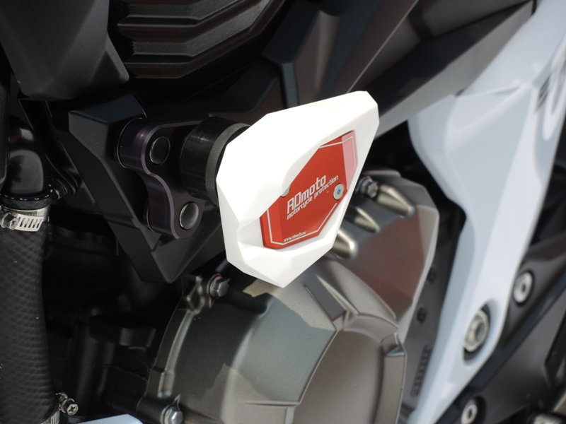
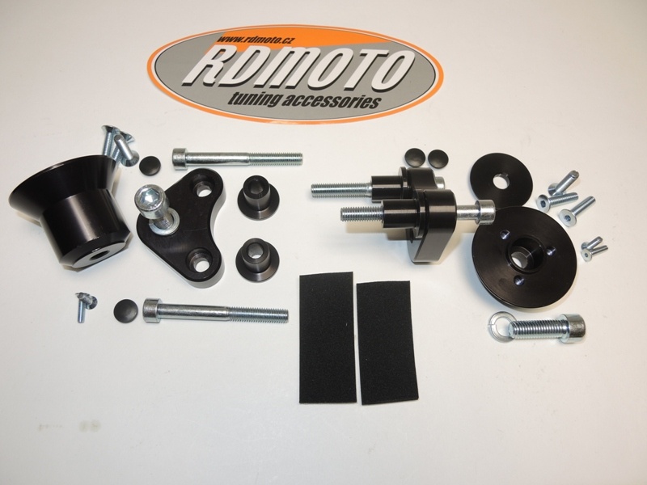

Instruction right side:

Warning – we recommend to use safety glue on threads of all bolts (moderate strong – blue colour).
- Dismantle original bolts M8.
- Insert to the frame dural. cylinder (no.8) and mounting on the frame dural. adapter (no.9) using bolts M8 (no.7).
- Mounting adapter for slider (no.3), using washer (no.12) and bolt (no.4).
- Mounting slider SL01 (no.1) using bolt M6 (no.5)
- Mounting cover (no.2) using bolt M4 (no.6)
- Insert the bolt on the frame plastic cover.

