K36SD
Kawasaki ZZR1400/ZX-14R 2012-
Kit for the left side |  |  |  |  |  |  |  |  | Kit for the right side
ID | Description |  | Cat.no. |  | pcs |  |  |  | ID | Description |  | Cat.no. |  | pcs
1.1 | Aluminium adapter |  | 707 |  | 1 |  |  |  | 1.2 | Aluminium adapter |  | 708 |  | 1
2 | Dural roller l=90mm |  | 238 |  | 1 |  |  |  | 2 | Dural roller l=90mm |  | 238 |  | 1
3 | Dural roller l=12mm |  | 80 |  | 1 |  |  |  | - | - |  | - |  | -
4 | Screw M10x140 |  | 953 |  | 1 |  |  |  | 4 | Screw M10x140 |  | 953 |  | 1
5 | Dural roller l=20mm |  | 2 |  | 1 |  |  |  | 5 | Dural roller l=20mm |  | 2 |  | 1
6 | Washer M10 |  | 801 |  | 1 |  |  |  | 6 | Washer M10 |  | 801 |  | 1
7 | Dural holder for slider SLD |  | 537 |  | 1 |  |  |  | 7 | Dural holder for slider SLD |  | 537 |  | 1
8 | Screw M8x25mm |  | 815 |  | 2 |  |  |  | 8 | Screw M8x25mm |  | 815 |  | 2
9 | Washer M8 |  | 802 |  | 2 |  |  |  | 9 | Washer M8 |  | 802 |  | 2
10.1 | Screw M10x65x1,25 |  | 945 |  | 1 |  |  |  | 10.2 | Screw M10x55x1,25 |  | 915 |  | 1
11 | Screw M8x35 |  | 861 |  | 1 |  |  |  | - | - |  | - |  | -

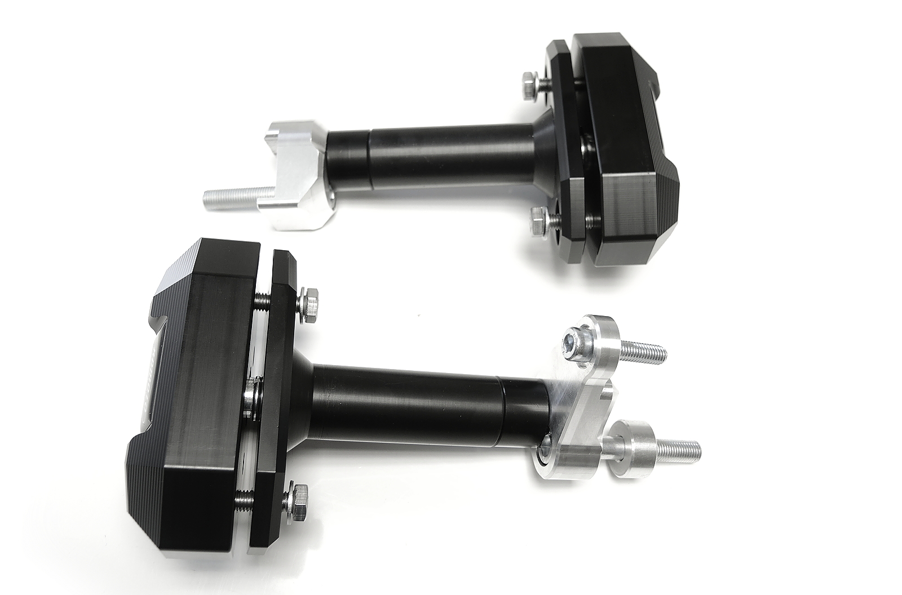

ID5
ID2

ID1.1

ID10.2

ID8+9

ID11
ID4+6
ID10.1
ID3
ID1.2
ID7

Assembly for the left side:

- Remove fairing from motorcycle.
- First install aluminium adapter.
- Aluminium adapter (ID1.1) attach with screw M10 (ID10.1) a M8 (ID11).
- Dont forget to place dural roller (ID3) under screw M10 (ID9).
- Now install fairing back.
- Attach slider holder (ID7) with screw M10 (ID4) on aluminium adapter. Between slider holder and aluminum adapter are two dural rolers (ID2) and (ID5). Dont forget to insert washer (ID6).
- Now attach slider on slider holder with two screws (ID8) and washers (ID9).

Assembly for the right side
(almoast the same as on the left)

Diferences:

- Instead of Aluminium adapter (1.1) use aluminum adapter (1.2).
- There is not any 12mm dural roller (ID3).
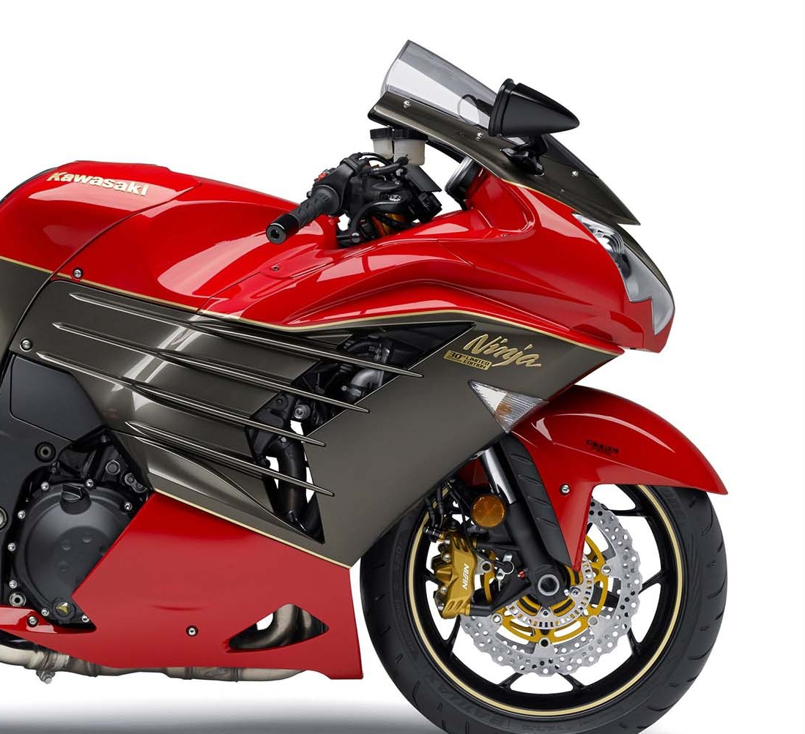
- Instead of Screw (ID10.1) use screw (ID10.2).

