K36
Kawasaki ZZR1400/ZX-14R 2012-
Kit for the left side |  |  |  |  |  |  |  |  | Kit for the right side
ID | Description |  | Cat.no. |  | pcs |  |  |  | ID | Description |  | Cat.no. |  | pcs
1.1 | Aluminium adapter |  | 707 |  | 1 |  |  |  | 1.2 | Aluminium adapter |  | 708 |  | 1
2 | Dural roller l=90mm |  | 143 |  | 1 |  |  |  | 2 | Dural roller l=90mm |  | 143 |  | 1
3 | Dural roller l=12mm |  | 80 |  | 1 |  |  |  | - | - |  | - |  | -
4 | Screw M10x130 |  | 883 |  | 1 |  |  |  | 4 | Screw M10x130 |  | 883 |  | 1
5 | Steel insert M10 |  | X1 |  | 1 |  |  |  | 5 | Steel insert M10 |  | X1 |  | 1
6.1 | Screw M10x65x1,25 |  | 945 |  | 1 |  |  |  | 6.2 | Screw M10x55x1,25 |  | 915 |  | 1
7 | Screw M8x35 |  | 861 |  | 1 |  |  |  | - | - |  | - |  | -

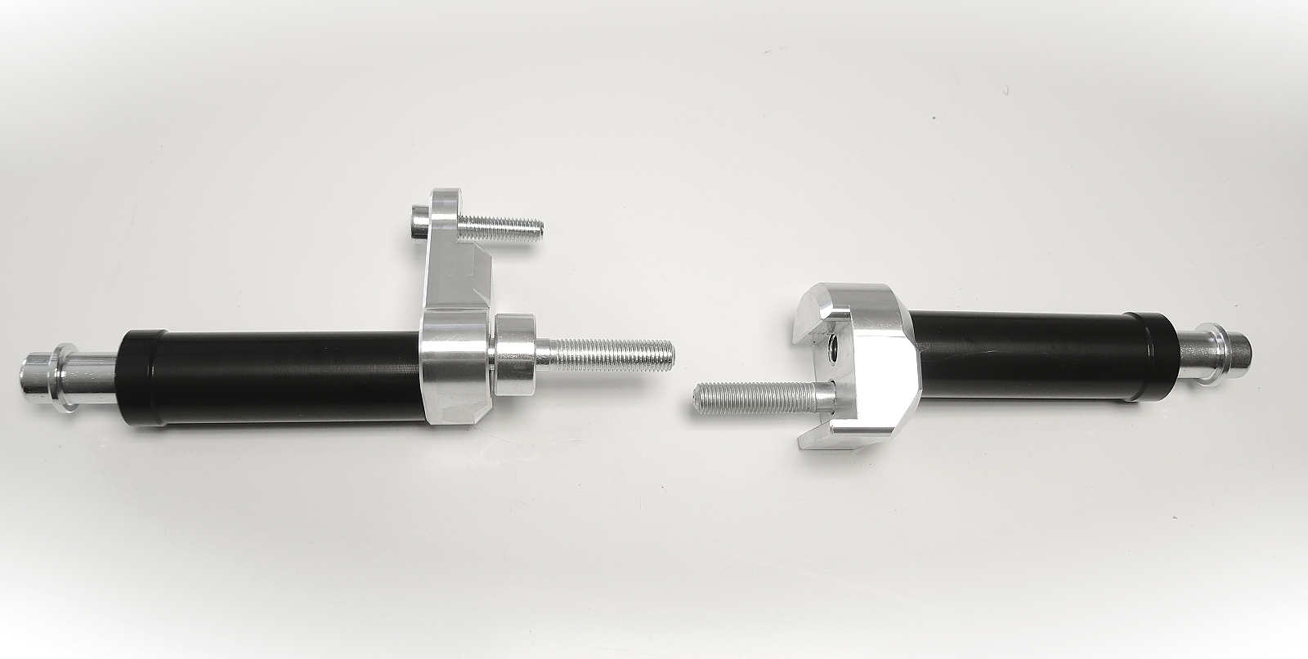
ID1.1
ID7
ID1.2
ID6.1
ID6.2
ID2
ID3
ID5+4

Assembly for the left side:

- Remove fairing from motorcycle.
- First install aluminium adapter.
- Attach aluminium adapter (ID1.1) with screws M10 (ID6.1) and M8 (ID7).
- Dont forget to place dural roller (ID3) under screw M10 (ID6.1).
- Now install fairing back.
- Attach protector on the aluminium adapter with screw M10 (ID4) dural adapter (ID2) and steel insert (ID5).

Assembly for the right side
(almoast the same as on the left)

Diferences:

- Instead of Aluminium adapter (1.1) use aluminum adapter (1.2).
- There is not any 12mm dural roller (ID3).
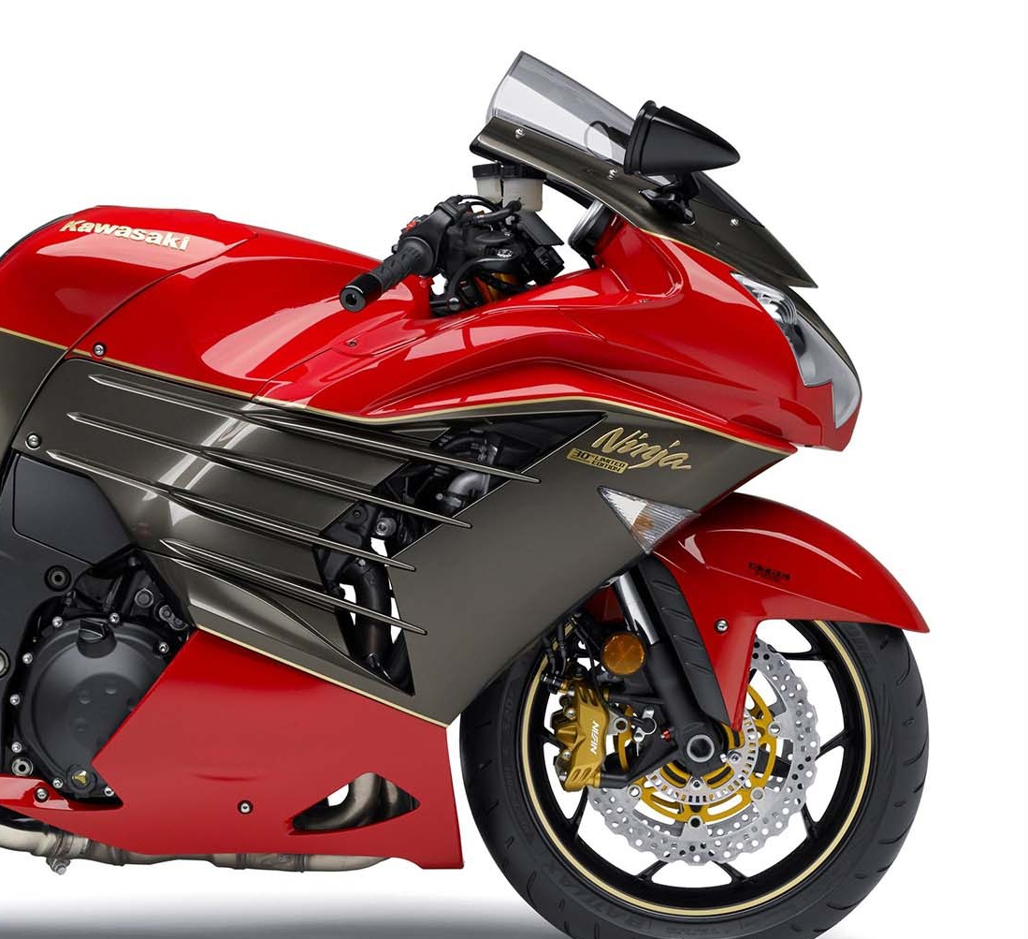
- Instead of Screw (ID6.1) use screw (ID6.2).

