K38SDM
Kawasaki Z 300 2015-

Kit for left side: Kit for right side:
ID. | Description | Cat.No | Qty
1 | Steel adapter | 705 | 1
2 | Alu spacer d=5mm | 16 | 2
3 | Bolt M10x60 | 850 | 2
4 | Washer M10 | 804 | 4
5 | Nut M10 | 810 | 2
6 | Alu. slider holder | 537/B | 1
7 | Al. spacer len=30mm | 11 | 1
8 | Bolt M10x60 | 850 | 1
9 | Bolt M6x20 | 1024 | 2
10 | Washer M6 | 1023 | 2
ID. | Description | Cat.No | Qty
1 | Steel adapter | 704 | 1
2 | Alu spacer d=5mm | 16 | 2
3 | Bolt M10x60 | 850 | 2
4 | Washer M10 | 804 | 4
5 | Nut M10 | 810 | 2
6 | Alu. slider holder | 537/B | 1
7 | Al. spacer len=30mm | 11 | 1
8 | Bolt M10x60 | 850 | 1
9 | Bolt M6x20 | 1024 | 2
10 | Washer M6 | 1023 | 2

7

6

3,4,5

7
2
3,4,5
8

8
6

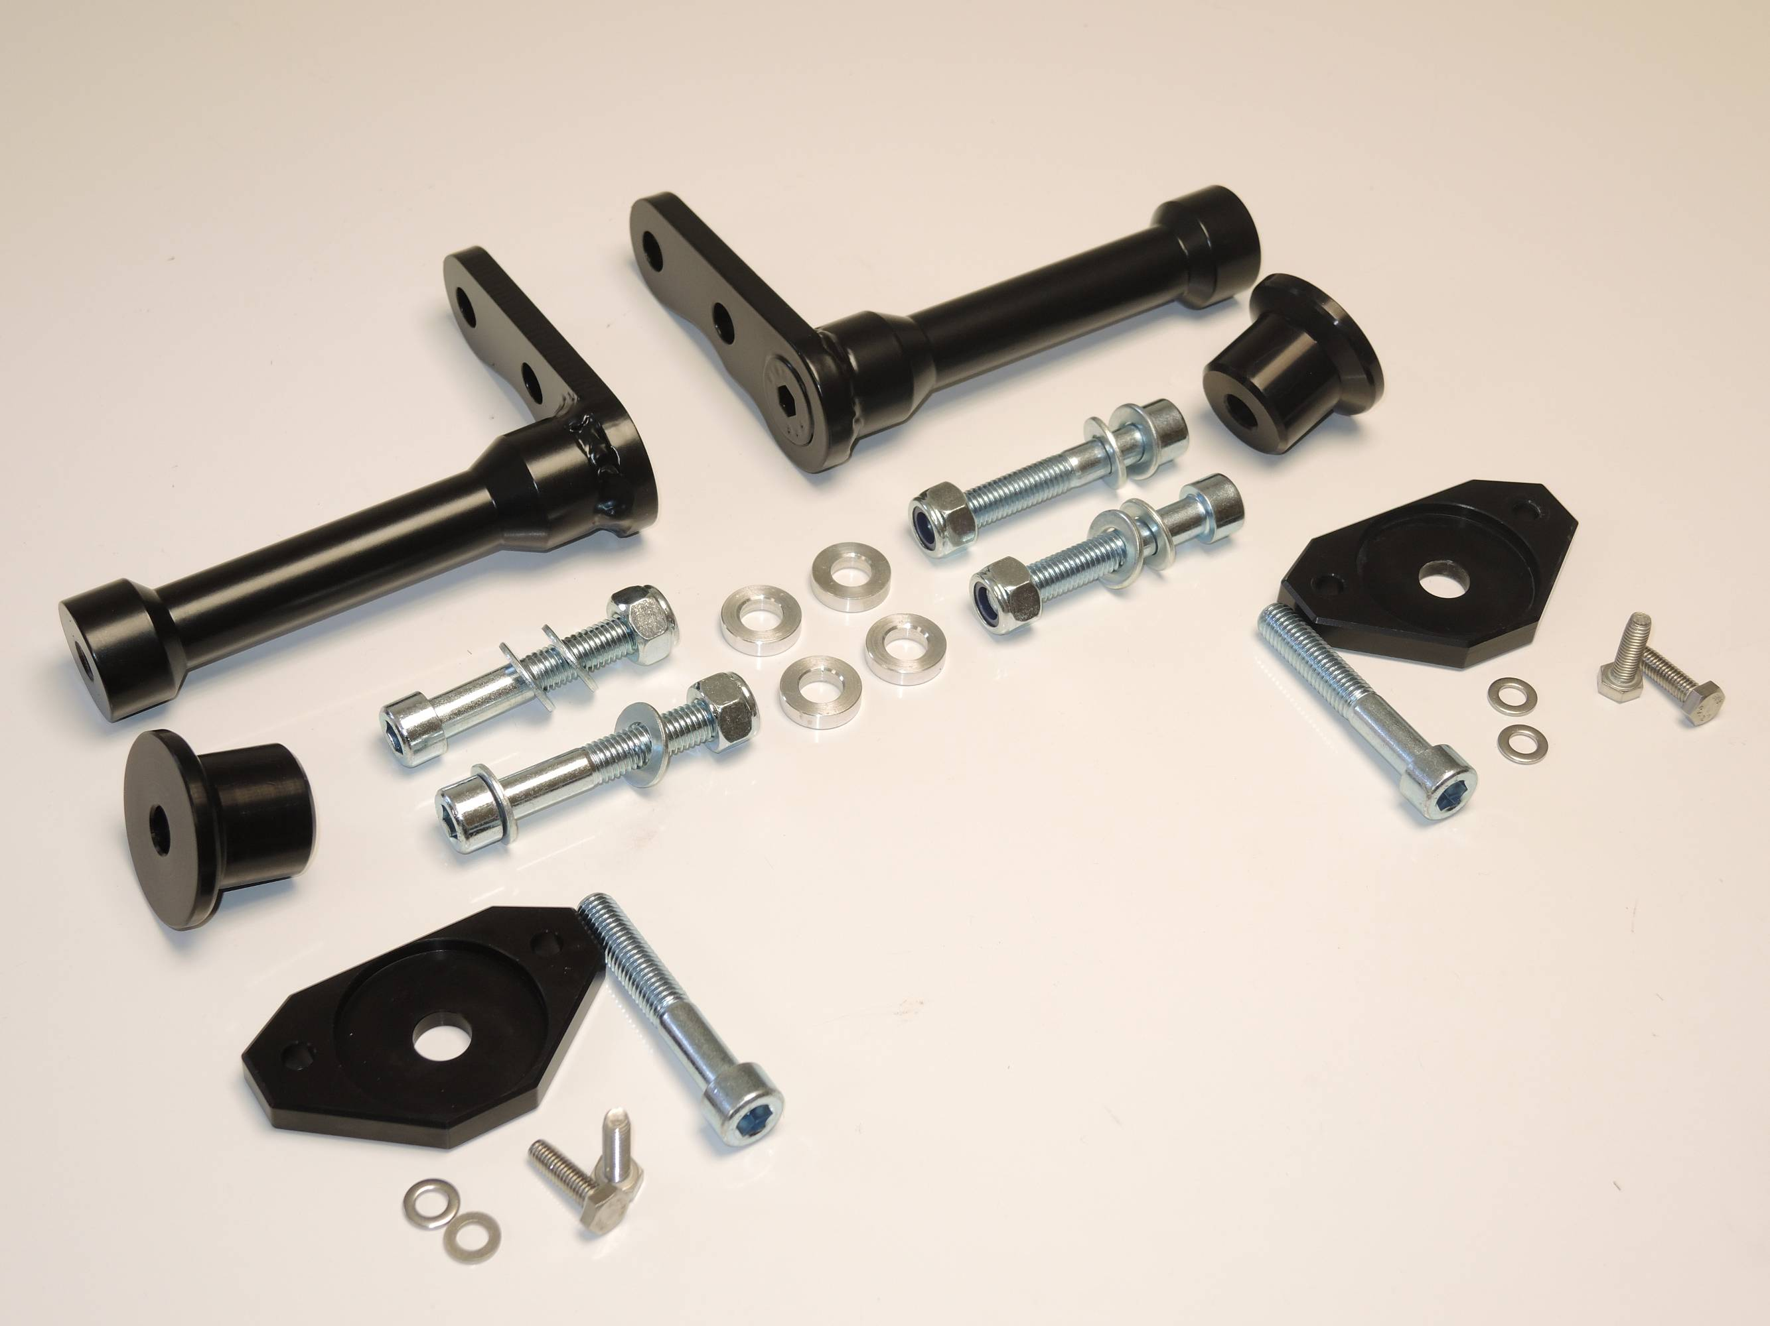

Instruction to assembly:

Assembly for left and right side is same.
Make first left side and after done right side.
- Take off fairings and bolts M10 from frame.
- Mounting steel holder ID.1. Under the steel adapter place alu spacers ID.2. use bolts M10x60 ID.3, washers ID.4 and tighten it by nuts ID.5, unde the nuts place washers.
- Put fairing back on the bike.
- On the bolt ID.8 insert slider holder ID.6, under the slider holder place alu. spacer ID.7. This kit assmebly by bolt ID.8.
- Place slider and fix it by bolts and washers M8.

Warning – use the glue of all threads. Medium strong.
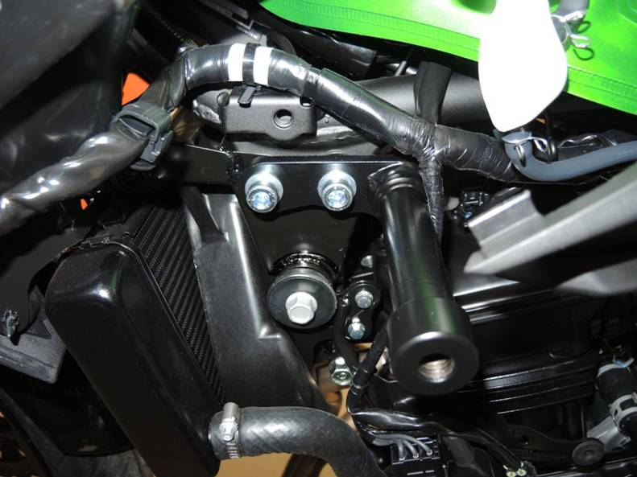
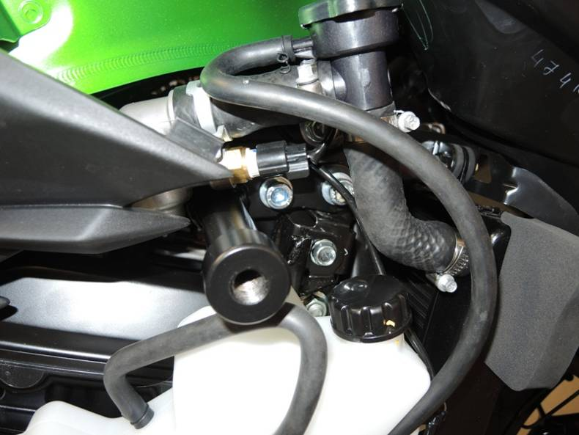

3,4
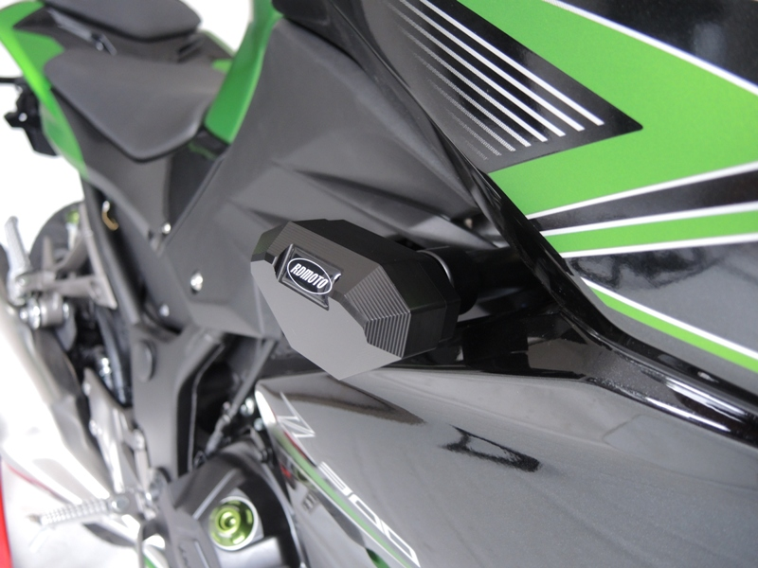
1
3,4
1
6

