K38S
Kawasaki Z 300 2015-

Kit for left side: Kit for right side:
ID. | Description | Cat.No | Qty
1 | Steel adapter | 705 | 1
2 | Alu spacer d=5mm | 16 | 2
3 | Bolt M10x60 | 850 | 2
4 | Washer M10 | 804 | 4
5 | Nut M10 | 810 | 2
6 | Alu. slider holder | 317 | 1
7 | Bolt M10x35 | 847 | 1
8 | Bolt M6x25 | 877 | 3
9 | Bolt M4x16 | 876 | 2
ID. | Description | Cat.No | Qty
1 | Steel adapter | 704 | 1
2 | Alu spacer d=5mm | 16 | 2
3 | Bolt M10x60 | 850 | 2
4 | Washer M10 | 804 | 4
5 | Nut M10 | 810 | 2
6 | Alu. slider holder | 317 | 1
7 | Bolt M10x35 | 847 | 1
8 | Bolt M6x25 | 877 | 3
9 | Bolt M4x16 | 876 | 2

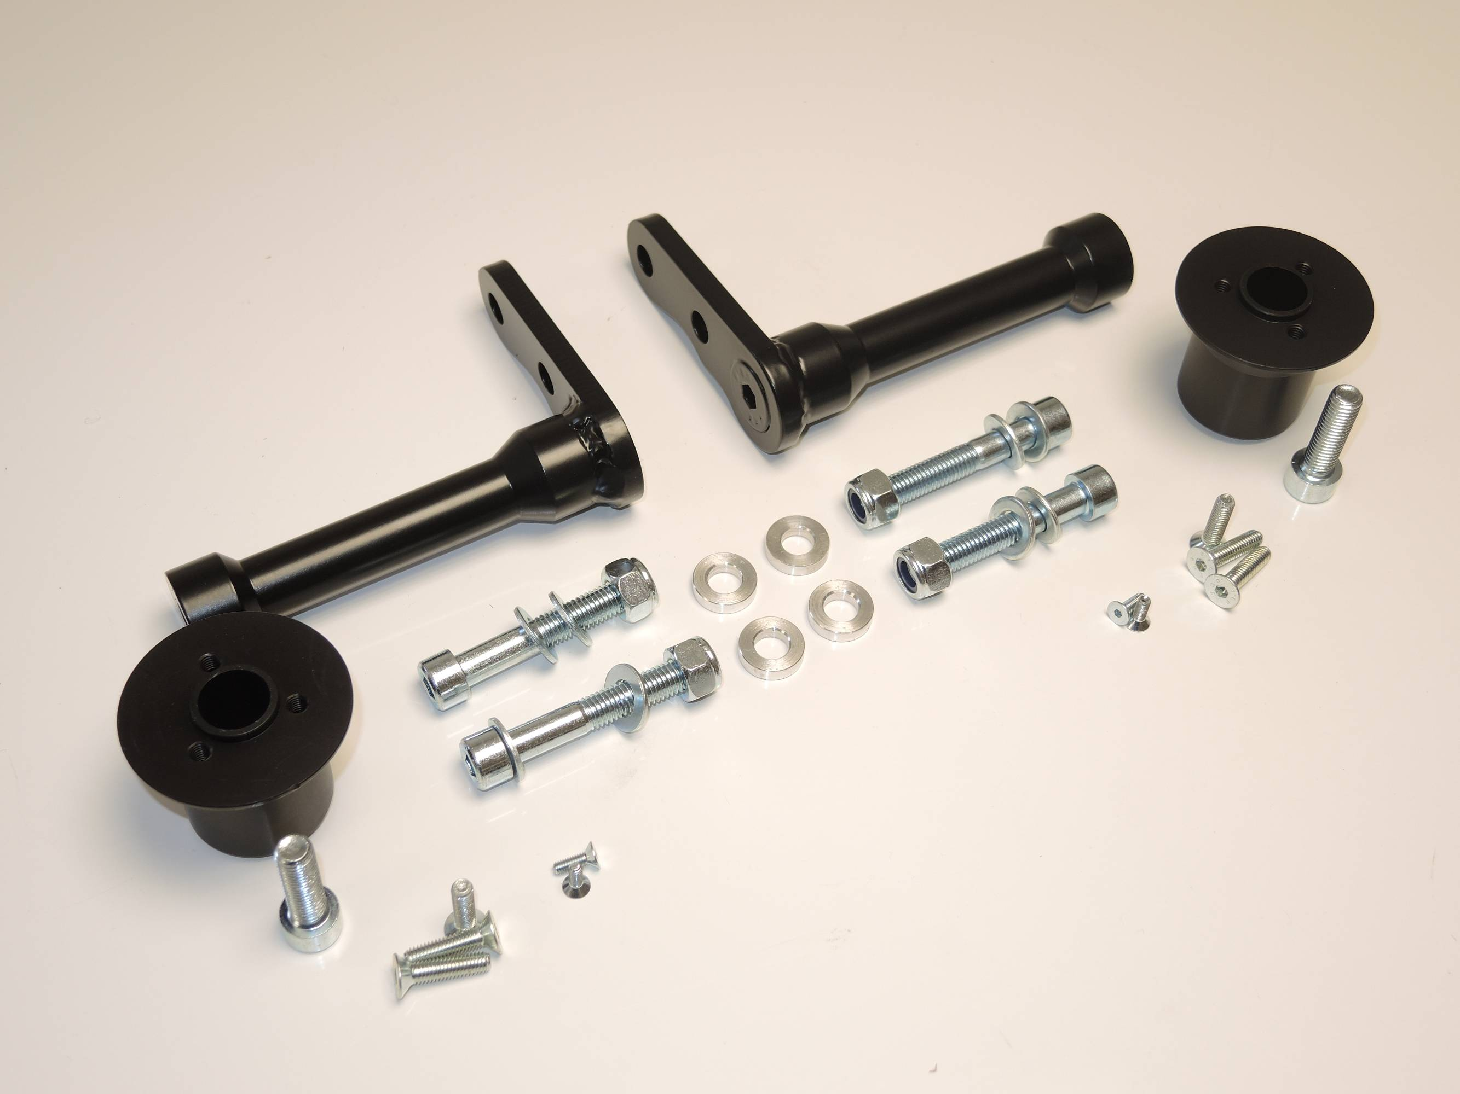

6

3,4,5

3,4,5
8
6
3,4,5
2

3,4,5

8

Instruction to assembly:

Assembly for left and right side is same.
Make first left side and after done right side.
- Take off fairings and bolts M10 from frame.
- Mounting steel holder ID.1. Under the steel adapter place alu spacers ID.2. use bolts M10x60 ID.3, washers ID.4 and tighten it by nuts ID.5, unde the nuts place washers.
- Put fairing back on the bike.
- The bolt M12 ID.7 insert into the adapter for SL01 ID.6 mounting it on the steel adapter.
- Use bolts M6x25 ID.8 for fixed sliders, insert cover and use bolts M4x16 ID.9

Warning – use the glue of all threads. Medium strong.
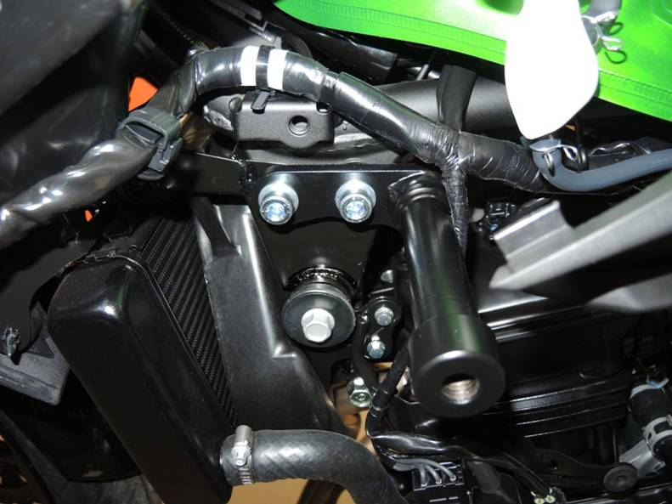
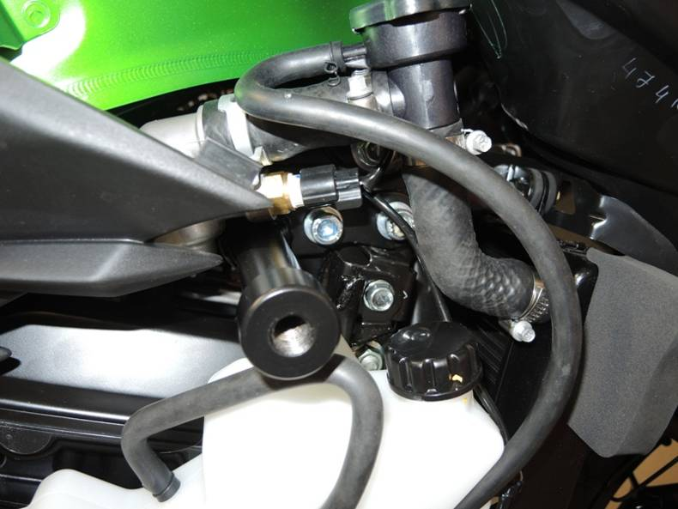
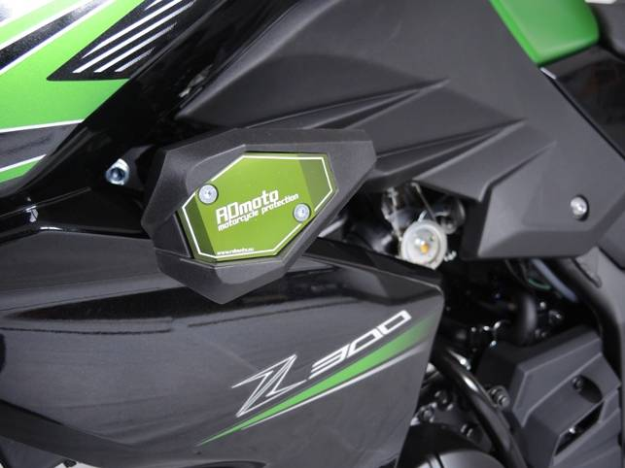
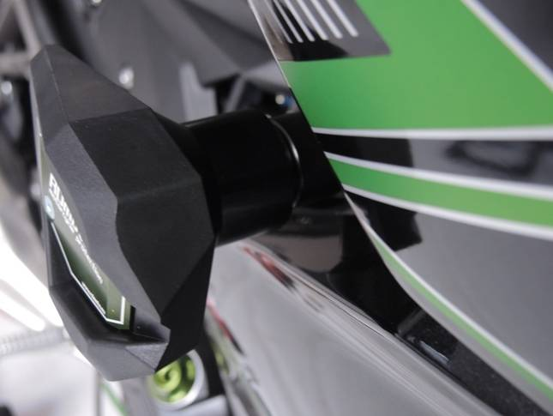
1
3,4
3,4
1
6
2

