K38
Kawasaki Z 300 2015-

Kit for left side: Kit for right side:
ID. | Description | Cat.No | Qty
1 | Steel adapter | 705 | 1
2 | Alu spacer d=5mm | 16 | 2
3 | Bolt M10x60 | 850 | 2
4 | Washer M10 | 804 | 4
5 | Nut M10 | 810 | 2
6 | Steel box | X1 | 1
7 | Bolt M10x45 | 848 | 1
ID. | Description | Cat.No | Qty
1 | Steel adapter | 704 | 1
2 | Alu spacer d=5mm | 16 | 2
3 | Bolt M10x60 | 850 | 2
4 | Washer M10 | 804 | 4
5 | Nut M10 | 810 | 2
6 | Steel box | X1 | 1
7 | Bolt M10x45 | 848 | 1

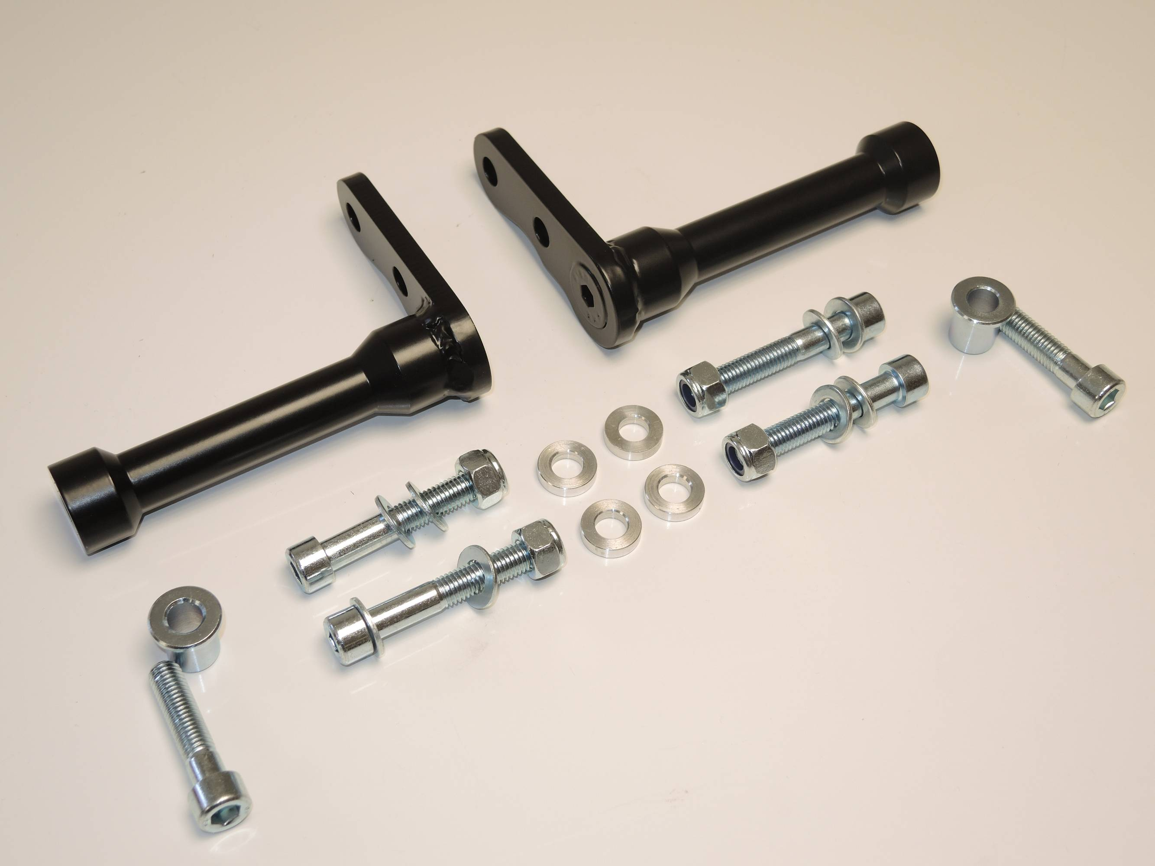

3,4,5
6

7

3,4,5
3,4,5

2
6
3,4,5

7

Instruction to assembly:

Assembly for left and right side is same.
Make first left side and after done right side.
- Take off fairings and bolts M10 from frame.
- Mounting steel holder ID.1. Under the steel adapter place alu spacers ID.2. use bolts M10x60 ID.3, washers ID.4 and tighten it by nuts ID.5, unde the nuts place washers.
- Put fairing back on the bike.
- Place steel box ID.6 into the protector and use bolt for tightening ID.7

Warning – use the glue of all threads. Medium strong.
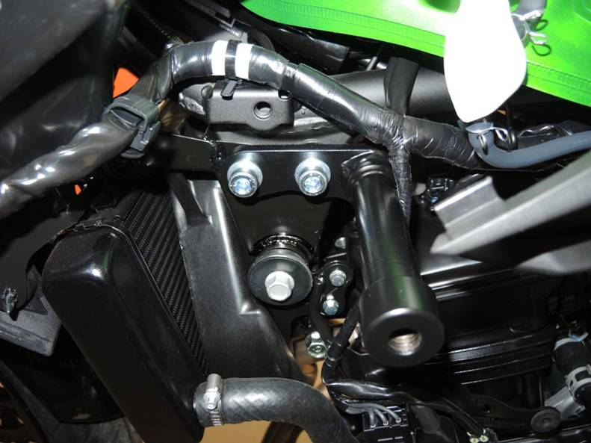
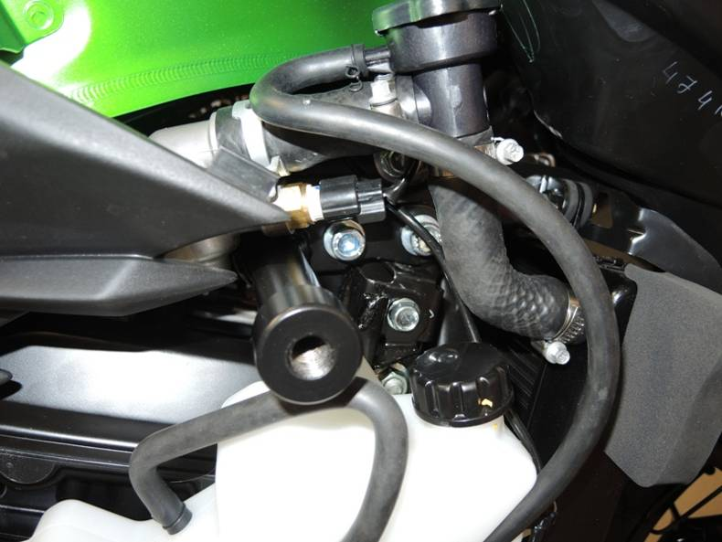

3,4
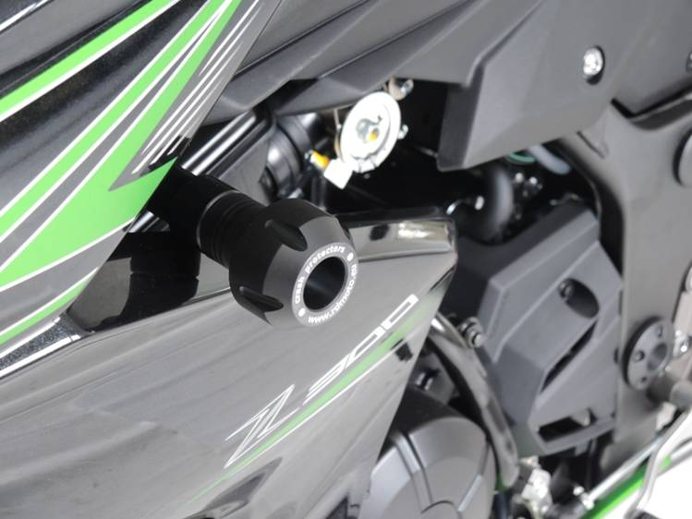
1
3,4
1
6

