K39SD

**Kawasaki Versys 650 2014-**

**Fitting kit left side: Fitting kit right side:**

|  |  |  |  |
| --- | --- | --- | --- |
| **ID.** | **Description** | **Cat.N** | **Qt** |
| 1 | Dural.bracket for SLD | 537 | 1 |
| 2 | Dural. spacer L=30 | 11 | 1 |
| 3 | Bolt M10x200 | 889 | 1 |
| 4 | Bolt M8x25 | 815 | 2 |
| 5 | Washer M8 | 800 | 2 |
| 6 | Nut M10 | 814 | 1 |

|  |  |  |  |
| --- | --- | --- | --- |
| **ID.** | **Description** | **Cat.N** | **Qt** |
| 1 | Dural.bracket for SLD | 537 | 1 |
| 2 | Dural.spacer l=70 | 15 | 1 |
| 3 | Bolt M10x200 | 889 | 1 |
| 4 | Bolt M8x25 | 815 | 2 |
| 5 | Washer M8 | 800 | 2 |
| 6 | Nut M10 | 814 | 1 |

**Instruction to assembly:**

1. Remove the engine mounting bolts.
2. Leave all spacers, bushes and nuts in place.
3. Insert bolts ID.3 through the ID.1 and ID.2. Shorter dural. spacer for right side.
4. Assembly these kit into the frame, use original nuts.
5. Place sliders on the dural.brackets, take washers ID.5 insert are on the bolts ID.4 and tighten sliders.

**Warning - on the threads of all bolts recommend the use of premium adhesive moderate (blue).**

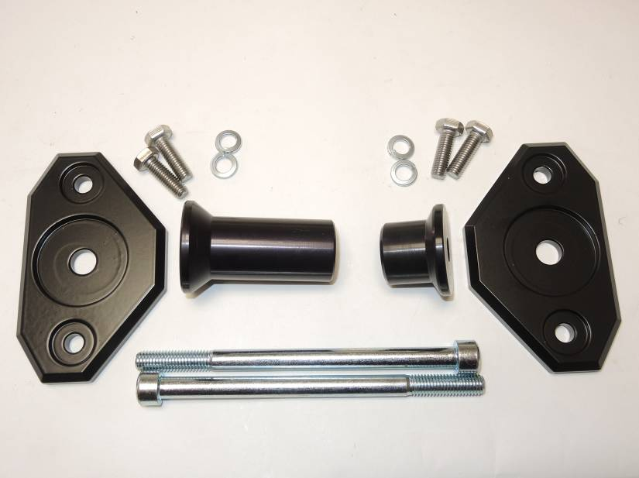

4

5

5

1

4

1

2

3

