K39S
Kawasaki Versys 650 2015-

Kit for left side: Kit for right side:
ID | info | Cat.no. | pcs
1 | Dural. Adapter - 90mm | 346 | 1
2 | Nut M10 | X11 | 1
3 | Screw M6x25 | 877 | 3
4 | Scew M4x16 | 876 | 2

ID | info | Cat.no. | pcs
1 | Dural. adapter - 40mm | 317 | 1
2 | Nut M10 | X11 | 1
3 | Screw M6x25 | 877 | 3
4 | Screw M4x16 | 876 | 2
5 | Steel connecting rod  M10x455x1,25x30x30 |  | 1

Mounting procedure is same on both sides. Diference is only in dimensions of adapters.

- Dismount original screws from frame of motorcycle.
- Leave silentblock and original steel washer on frame.
- Pass connecting rod M10 ID.5. through frame and engine.
- Put adapters ID.1 on connecting rod (90mm on the left and 40mm on the right). Tighten rod with nuts M10 ID.2.
- Fit slider on adapter with three screws ID.3.
- Fit cover on slider with two screws ID.2.

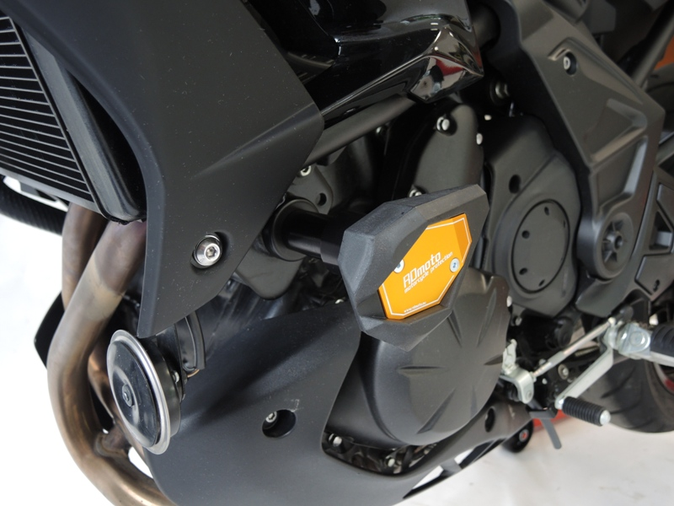
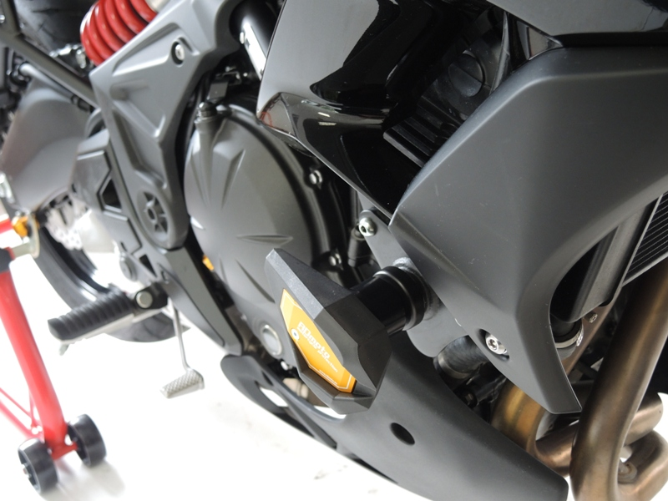
We recommend: use the glue on all threads. Medium strong.

