K41S
Kawasaki Ninja 250SL (15)
Kit for the left side |  |  |  |  |  |  |  |  | Kit for the right side
ID | Description |  | Cat.no. |  | Pcs |  |  |  | ID | Description |  | Cat.no. |  | pcs
1 | Adapter - spacer |  | DV5 |  | 1 |  |  |  | 1 | Steel adapter |  | DV5 |  | 1
2 | Slider adapter |  | DV317 |  | 1 |  |  |  | 2 | Slider adapter |  | DV317 |  | 1
3 | Bolt M6x25 |  | 877 |  | 3 |  |  |  | 3 | Bolt M6x25 |  | 877 |  | 3
4 | Bolt M4x16 |  | 876 |  | 2 |  |  |  | 4 | Bolt M4x16 |  | 876 |  | 2
5 | Bot M8x40 |  | 835 |  | 1 |  |  |  | 5 | Bot M8x40 |  | 835 |  | 1
6 | Poly spacer 40mm |  | X65 |  | 1 |  |  |  | 6 | Poly spacer 40mm |  | X65 |  | 1
7 | Bolt M10x75 |  | 1007 |  | 1 |  |  |  | 7 | Bolt M10x75 |  | 1007 |  | 1
8 | Washer M10 |  | 801 |  | 1 |  |  |  | 8 | Washer M10 |  | 801 |  | 1
9 | Alu adapter |  | DV1216 |  | 1 |  |  |  | 9 | Adapter |  | DV1216 |  | 1
10 | Bolt M6x30 |  | 864 |  | 1 |  |  |  | 10 | Bolt M6x30 |  | 864 |  | 1
11 | Washer M6 (flat) |  | 947 |  | 1 |  |  |  | 11 | Washer M6 (flat) |  | 947 |  | 1
12 | Rod 10x335x30x30 |  |  |  | 1 |  |  |  | - | - |  | - |  | -
13 | Nut M10 (safety) |  | 804 |  | 1 |  |  |  | 13 | Nut M10 (safety) |  | 804 |  | 1
14 | Washer M10 (flat) |  | 810 |  | 1 |  |  |  | 14 | Washer M10 (flat) |  | 810 |  | 1
15 | Left steel adapter |  | 712 |  | 1 |  |  |  | 15 | Right steel adapter |  | 713 |  | 1

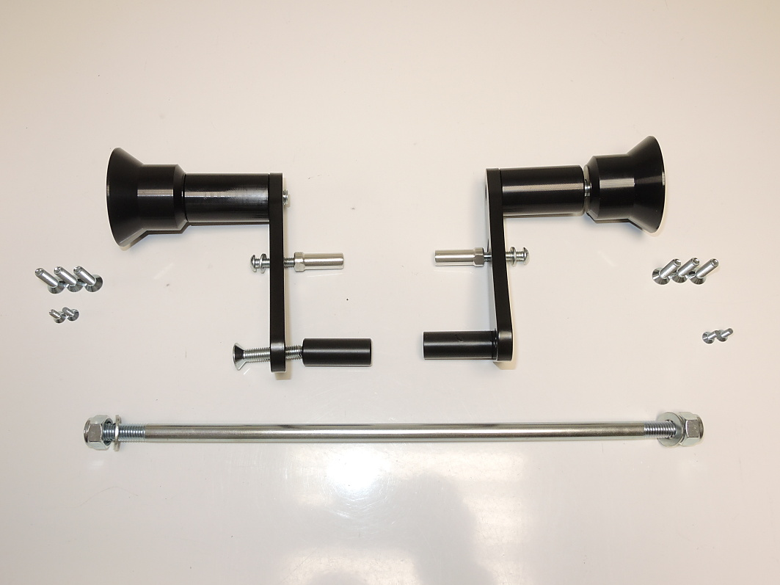

ID7+8

ID1

ID2
ID15

ID3

ID9
ID10+11

ID6

ID4

ID5

ID13+14

ID12

Instructions:

- We recommend to use the glue on all threads (medium strong).
- Remove original rod from the frame of motorcycle.
- Assembly kit for protectors according to the picture below.
  - Assembly Bolt M8 (ID5) with poly spacer (ID6) on the steel adapter (ID15).
  - Assembly Bolt M6 (ID10 + washer (ID11)) with alu adapter (ID9) on the steel adapter (ID15).
  - In the end fit slider adapter (ID2) + spacer (ID1) on the alu adapter (ID15) using bolt M10 (ID7 + wahser (ID8).
- Mount this adaper on the frame using connection rod (ID12).
- Tighten rod using two M10 safety nuts (ID13 + washer (ID14)).
- Fit slider on the slider adapter using three M6 bolts (ID3).
- Fit coloured covers on the slider using two M4 bolts (ID4).

