K41
Kawasaki Ninja 250SL (15)
Kit for the left side |  |  |  |  |  |  |  |  | Kit for the right side
ID | Description |  | Cat.no. |  | Pcs |  |  |  | ID | Description |  | Cat.no. |  | pcs
1 | Dural. cylinder |  | DV5 |  | 1 |  |  |  | 1 | Dural. cylinder |  | DV5 |  | 1
2 | Steel insert |  | X1 |  | 1 |  |  |  | 2 | Steel insert |  | X1 |  | 1
3 | Bot M8x40 |  | 835 |  | 1 |  |  |  | 3 | Bot M8x40 |  | 835 |  | 1
4 | Poly spacer 40mm |  | X65 |  | 1 |  |  |  | 4 | Poly spacer 40mm |  | X65 |  | 1
5 | Bolt M10x80 |  | 852 |  | 1 |  |  |  | 5 | Bolt M10x80 |  | 852 |  | 1
6 | Alu adapter |  | DV1216 |  | 1 |  |  |  | 6 | Adapter |  | DV1216 |  | 1
7 | Bolt M6x30 |  | 864 |  | 1 |  |  |  | 7 | Bolt M6x30 |  | 864 |  | 1
8 | Washer M6 (flat) |  | 947 |  | 1 |  |  |  | 8 | Washer M6 (flat) |  | 947 |  | 1
9 | Rod 10x335x30x30 |  |  |  | 1 |  |  |  | 9 | - |  | - |  | -
10 | Nut M10 (safety) |  | 804 |  | 1 |  |  |  | 10 | Nut M10 (safety) |  | 804 |  | 1
11 | Washer M10 (flat) |  | 810 |  | 1 |  |  |  | 11 | Washer M10 (flat) |  | 810 |  | 1
12 | Left steel adapter |  | 712 |  | 1 |  |  |  | 12 | Right steel adapter |  | 713 |  | 1

ID12

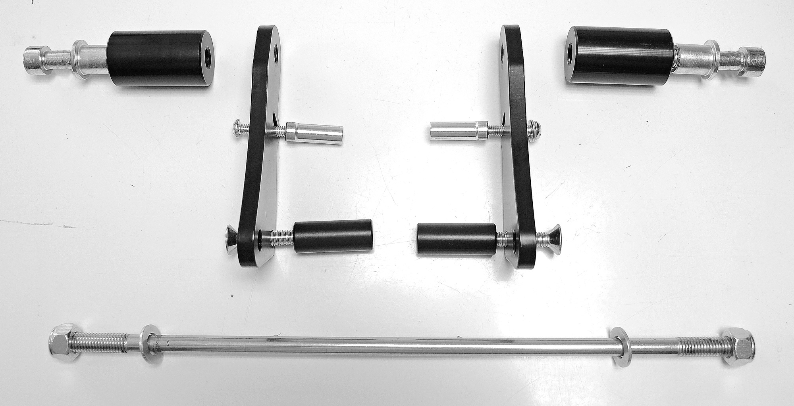
ID1

ID2+ID5

ID7+8+6

ID4

ID3

ID10+11

ID9

Instructions:

- We recommend to use the glue on all threads (medium strong).
- Remove original rod from the frame of motorcycle.
- Mount kit for protectors according to the picture below.
  - Mount Bolt M8 (ID3) with poly spacer (ID4) on the steel adapter (ID12).
  - Assembly Bolt M6 (ID7 + washer (ID8)) with alu adapter (ID6) on the steel adapter (ID12).
- Mount this adaper on the frame using connection rod (ID9).
- Tighten rod using two M10 safety nuts (ID10 + washer (ID11).
- In the end mount protector with dural. cylinder (ID1) and steel insert (ID2) on the steel adapter (ID12) using bolt M10 (ID5).

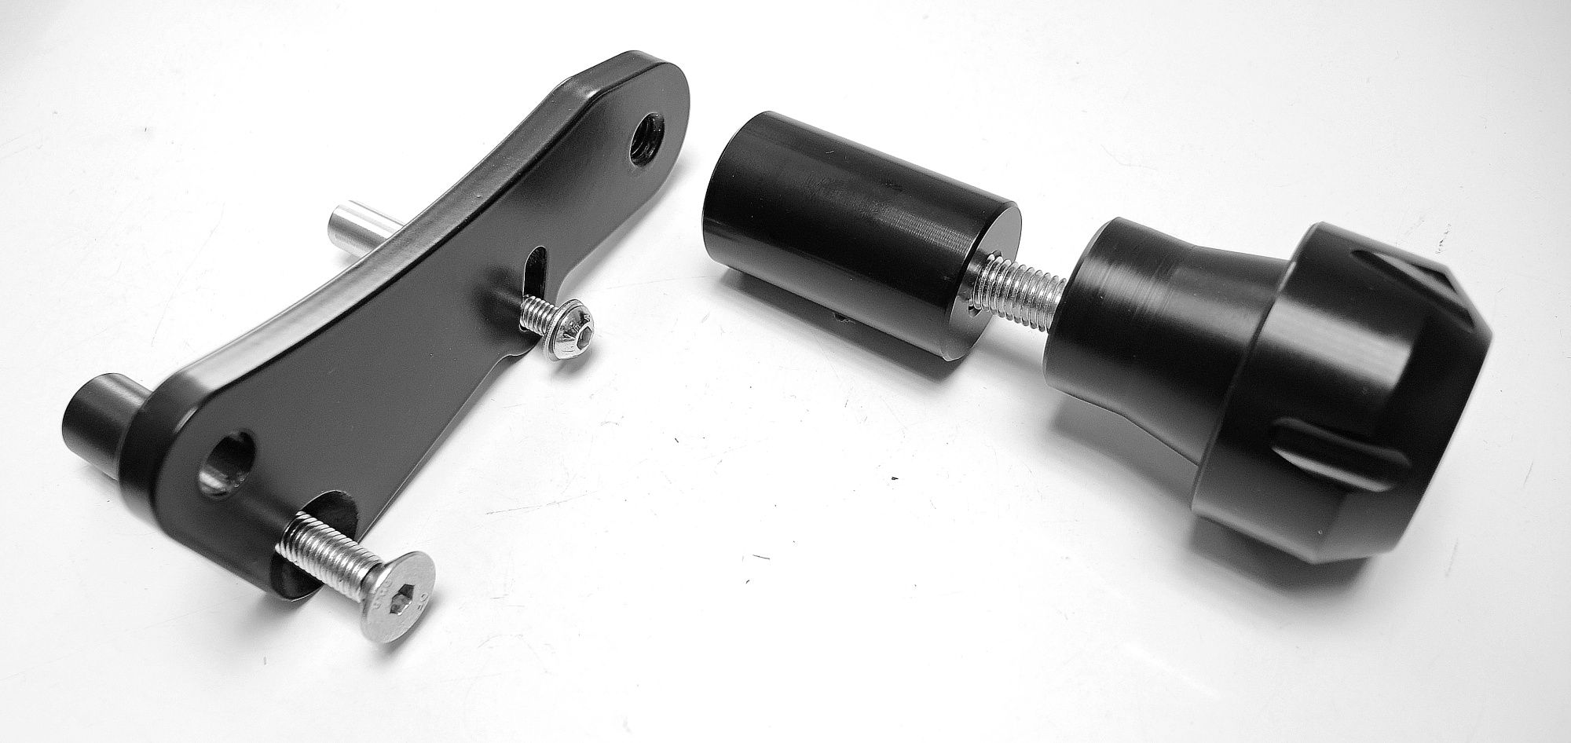
ID9

