K42S
Kawasaki ZX-10R (16-)
Left side mounting kit |  |  |  |  |  |  |  | Right side mounting kit
ID | Description |  | Cat.No. | Pcs |  |  |  | ID |  | Description |  | Cat.No. |  | Pcs
1 | SL adapter |  | DV 321 | 1 |  |  |  | 1 |  | SL adapter |  | DV 322 |  | 1
2 | Bolt M10x50x1,25mm |  | 921 | 1 |  |  |  | 2 |  | Bolt M10x70x1,25 |  | 898 |  | 1
3 | Bolt M6x25 |  | 877 | 3 |  |  |  | 3 |  | Bolt M6x25 |  | 877 |  | 3
4 | Bolt M4x16 |  | 876 | 2 |  |  |  | 4 |  | Bolt M4x16 |  | 876 |  | 2

Instructions:
- We recommend to use the glue on all threads (medium strong).
- Remove original bolt from the frame.
- Mount SL adapter ID1 on the frame of motorcycle using bolt ID2.
  - Note: longer bolt is on the right side.
- Mount slider on the slider adapter using three bolts M6 (ID3).
- In the end mount coloured cover using two bolts M4 (ID4).
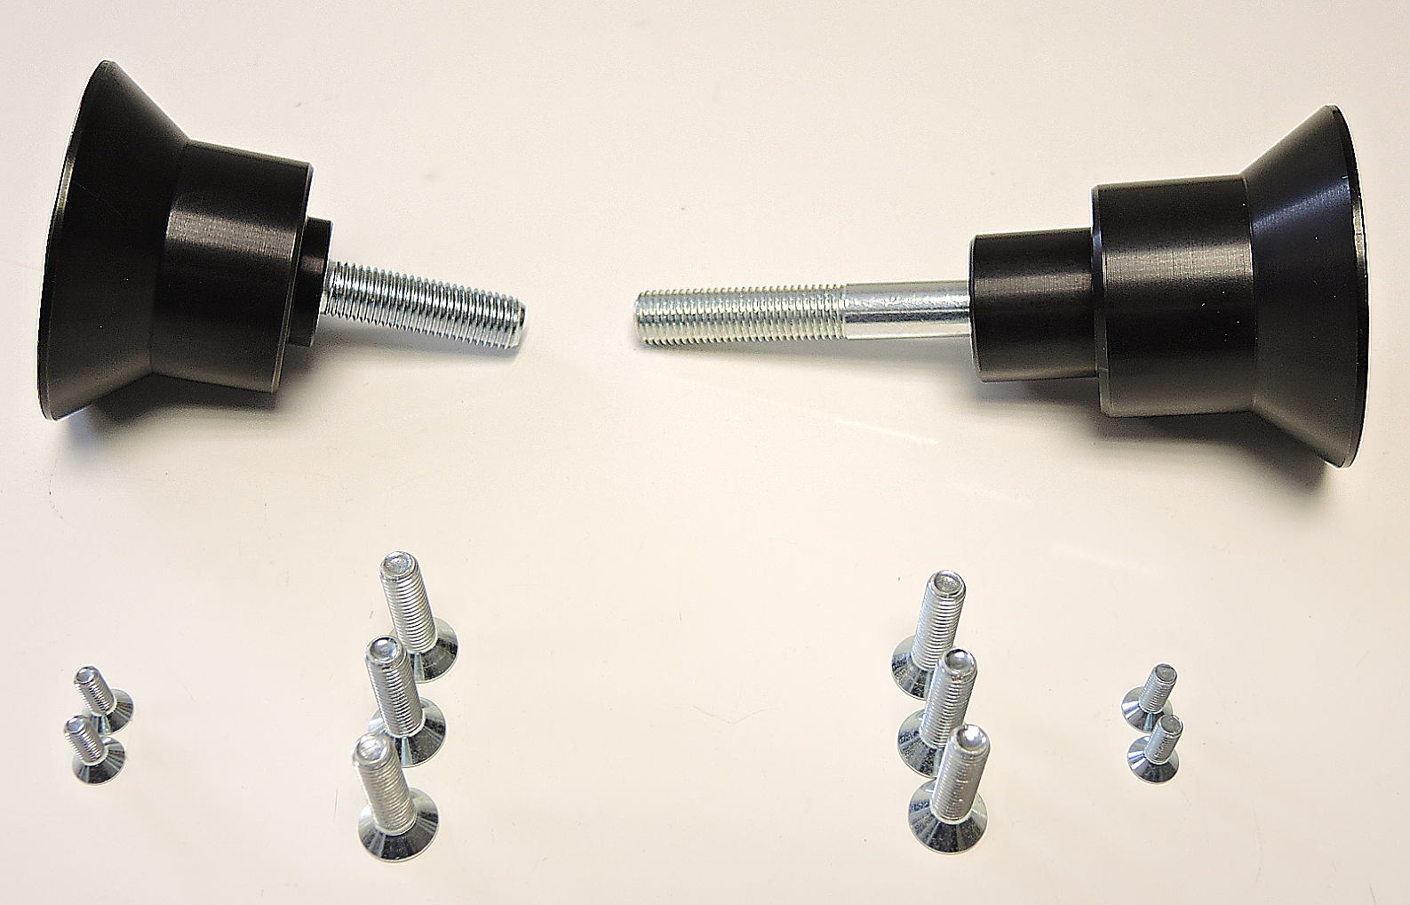

ID1
ID3

ID3

ID4

