K45S
Kawasaki Z1000 SX 2017-

Mounting Kit - Left Side: |  |  |  |  | Mounting Kit - Right Side:
ID | Description | Cat.No | Pcs |  |  | ID | Description | Cat.No | Pcs
1 | SL adapter l=60mm | 318 | 1 |  |  | 1 | SL adapter l=60mm | 318 | 1
2 | Dural. adapter | 548 | 1 |  |  | 2 | Dural. adapter | 549 | 1
3 | Dural. adapter | 550 | 1 |  |  | 3 | Dural. sleeve l=6,5mm | 403 | 1
4 | Dural. sleeve l=3mm | 402 | 1 |  |  | 4 | Dural. sleeve l=16,4mm | 404 | 1
5 | Bolt M10x35 | 847 | 1 |  |  | 5 | Bolt M10x35 | 847 | 1
6 | Bolt M10x100x1,25mm | 892 | 2 |  |  | 6 | Bolt M10x100x1,25mm | 892 | 1
7 | Bolt M6x30mm | 864 | 2 |  |  | 7 | Bolt M10x60x1,25mm | 896 | 1
8 | Plastic cap – black | X4 | 2 |  |  | 8 | Plastic cap – black | X4 | 2
9 | 3M tape |  | 1 |  |  | 9 | 3M tape |  | 1
10 | Bolt M6x25 | 877 | 3 |  |  | 10 | Bolt M6x25 | 877 | 3
11 | Bolt M4x16 | 876 | 2 |  |  | 11 | Bolt M4x16 | 876 | 2

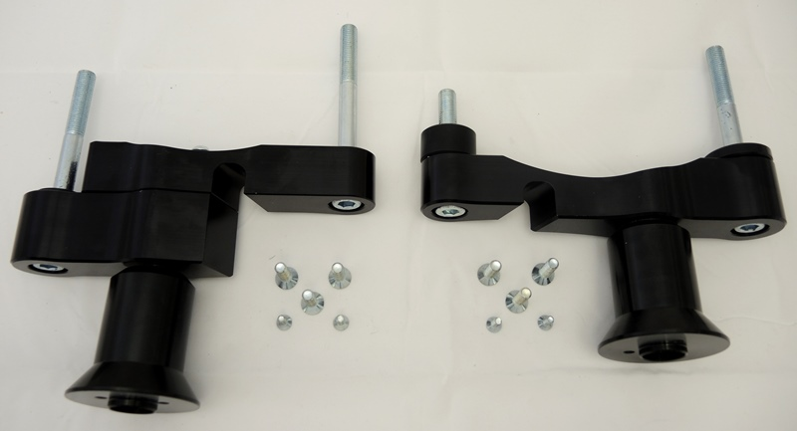

Mounting instructions – Left Side:

- Remove original bolts and fairings.
- Assembly dural. adapter consisting of 2 parts ID.2 + ID.3. Screw these adapters with bolts ID.7.
- When the adapter is ready, insert the bolts ID.6. Thread the dural. sleeve ID.4 on the front bolt.
- Mount this whole assembly into the motorcycle frame, tighten and put plastic caps ID.8 on the bolt heads, during the assembly you can use 3M tape in the places of contact of the adapter with the motorcycle frame or with the motor.
- Insert the bolt ID.5 into SL adapter ID.1.
- Mount this entire assembly on the dural. adapter.
- Finally, attach the slider with the M6 ​​bolts ID.10 and fasten the plate with the bolt ID.11.

Warning: We recommend using medium strength (blue) thread glue during assembly.

ILLUSTRATION PICTURE USED FROM K28S

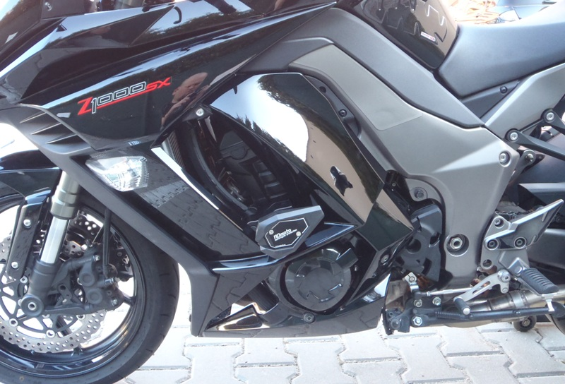

Mounting instructions – Right Side:

- Remove original bolts and fairings.
- Take the adapter ID.2, insert the bolts ID.6+ID.7 into the adapter. Thread the dural. sleeve ID.3 on the front bolt and the dural. sleeve ID.4 on the rear shorter bolt.
- Mount this whole assembly into the motorcycle frame, tighten and put plastic caps ID.8 on the bolt heads, during the assembly you can use 3M tape in the places of contact of the adapter with the motorcycle frame or with the engine.
- Insert the bolt ID.5 into SL adapter ID.1.
- Mount this entire assembly on the dural. adapter.
- Finally, attach the slider with the M6 ​​bolts ID.10 and fasten the plate with the bolt ID.11.

Warning: We recommend using medium strength (blue) thread glue during assembly.

ILLUSTRATION PICTURE USED FROM K28S

