K47
Kawasaki Z900 2017-

Kit for the left side |  |  |  |  | Kit for the right side
ID. | Description | Cat.no. | Pcs |  |  | ID | Description | Cat.no. | Pcs
1 | Steel insert M10 | X1 | 1 |  |  | 1 | Steel insert M10 | X1 | 1
2 | Bolt M10x130x1,25mm | 905 | 1 |  |  | 2 | Bolt M10x130x1,25mm | 905 | 1
3 | Dural cylinder 68mm | 145 | 1 |  |  | 3 | Dural cylinder 68mm | 145 | 1

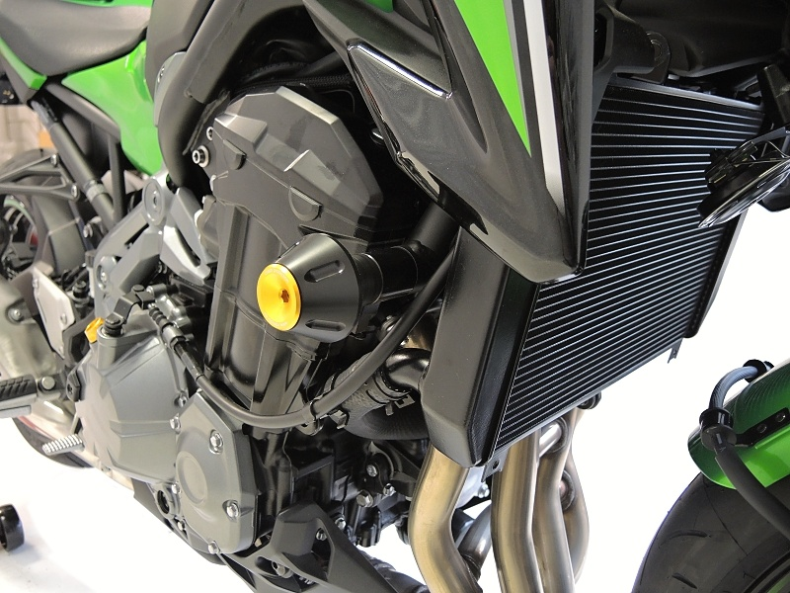

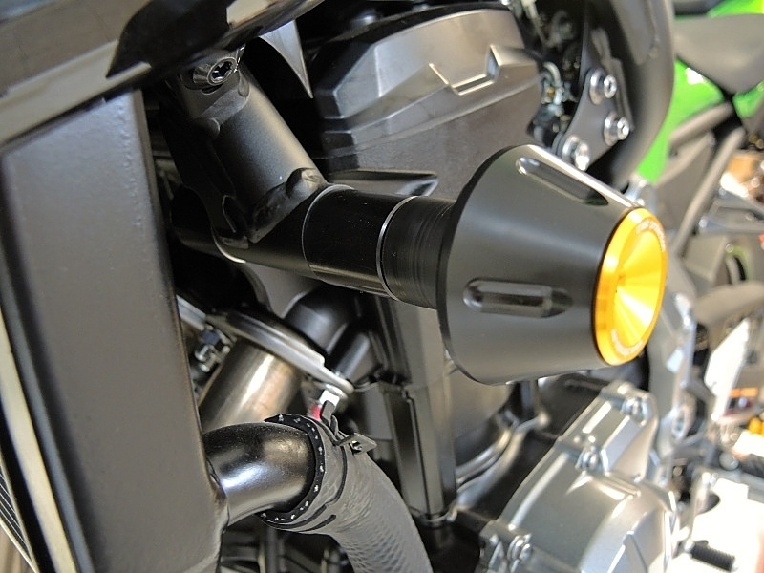

Instructions:

- Put steel inser, protector and dural. cylinder on bolt ID1.
- Fit this kit into on the frame of motorcycle.

We recommend to use safety glue on all threads (medium strong).

