K4SD
Kawasaki Z750 ´04- 06
Kawasaki Z1000 ´03- 06

LEFT SIDE KIT RIGHT SIDE KIT
ID | Description | Cat.no. | Pcs
1 | Dural. adapter | 545 | 1
2 | Bolt M12x25 | 860 | 1
3 | Bolt M10x140 | 953 | 1
4 | Alu. cylinder 56mm | 202 | 1
5 | Nut M10 | 814 | 1
6 | Plastic cap | X4 | 1
7 | Alu. cylinder 40mm | DV12 | 1
8 | Washer M10 (spring) | 801 | 1
9 | Bolt M10x65 | 943 | 1
10 | 3M tape |  | 1
11 | Bolt M8x25 | 815 | 2
12 | Washer M8 | 802 | 2
13 | Adapter SLD | 537 | 1
14 | Threaded rod AL20(M12)x377x30x30 |  | 1
ID | Description | Cat.no. | Pcs
1 | Dural. adapter | 546 | 1
2 | Bolt M12x25 | 860 | 1
3 | Bolt M10x140 | 953 | 1
4 | Alu. cylinder 56mm | 202 | 1
5 | Nut M10 | 814 | 1
6 | Plastic cap | X4 | 1
7 | Alu. cylinder 40mm | DV12 | 1
8 | Washer M10 (spring) | 801 | 1
9 | Bolt M10x65 | 943 | 1
10 | 3M tape |  | 1
11 | Bolt M8x25 | 815 | 2
12 | Washer M8 | 802 | 2
13 | Adapter SLD | 537 | 1

Obrázek 2
3
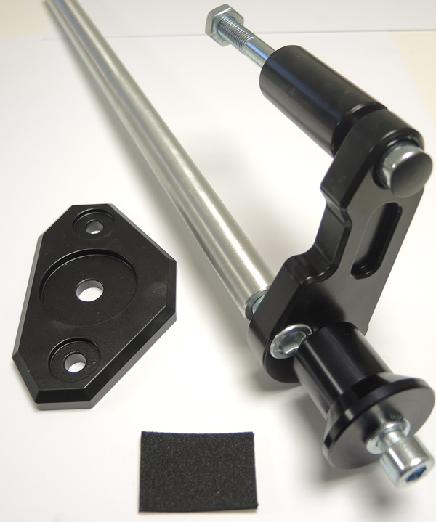
Obrázek 1
5
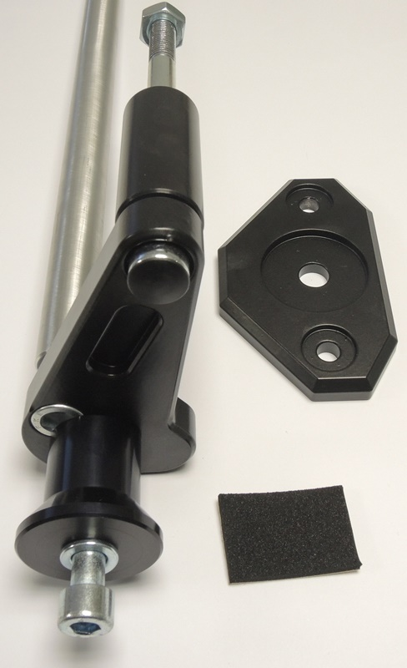
5
4
14

3
13
13
4
6

6
14

1

2
2
7
1
2

7
7
9
8
8
9
8
9

INSTRUCTIONS

- Unbolt original bolt from the frame
- Stick 3M tape on the frame of motorcycle.
- Assembly dural. adapter according to the pictures on page one.
- Fit this kit on the frame of motorcycle.
- Put rod through the engine space and fit it using bolt ID2.
- Repeat same proces on the other side.
- Tighten whole kit.
- Put washer ID8, adapter ID13 and cylinder ID7 on the bolt. Mount this kit into the adapter ID1.
- Fit slider using bolts ID11 and washer ID12.

We recommend to use the glue on all threads (medium strong).
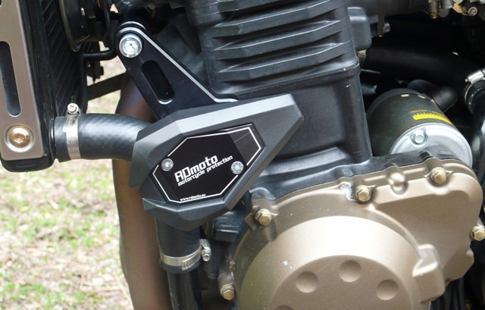
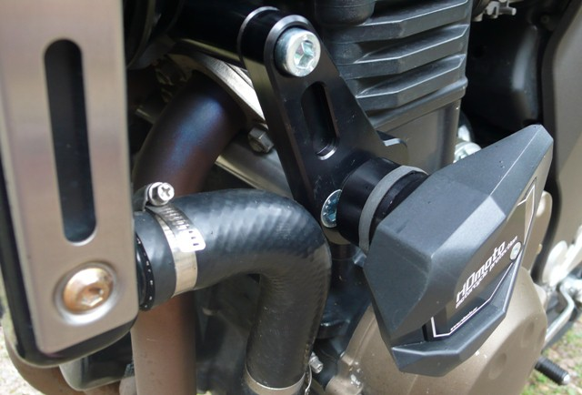
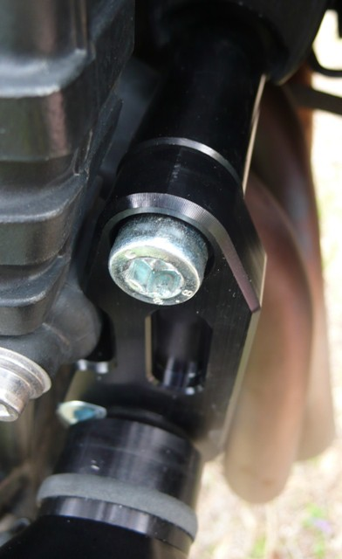

Illustrative pictures (the same kit, different protector)

