K4
Kawasaki Z750 ´04- 06
Kawasaki Z1000 ´03- 06

Fitting kit left side: Fitting kit right side:
ID | Description | Cat.n | QTY
1 | Dural.adapter | 545 | 1
2 | Bolt M12x25 | 860 | 1
3 | Bolt M10x140 | 953 | 1
4 | Alu. spacer d=56mm | 202 | 1
5 | Nut M10 | 814 | 1
6 | Plastic cap | X4 | 1
7 | Alu.spacer d=20mm | DV2 | 1
8 | Steel box | X1 | 1
9 | Bolt M10x60 | 850 | 1
10 | 3M Tape |  | 1
11 | Alu. connecting AL20(M12)x377x30x30 |  | 1
ID | Description | Cat.n | QTY
1 | Dural.adapter | 546 | 1
2 | Bolt M12x25 | 860 | 1
3 | Bolt M10x140 | 953 | 1
4 | Alu. spacer d=56mm | 202 | 1
5 | Nut M10 | 814 | 1
6 | Plastic cap | X4 | 1
7 | Alu.spacer d=20mm | DV2 | 1
8 | Steel box | X1 | 1
9 | Bolt M10x60 | 850 | 1
10 | 3M Tape |  | 1
11

No.2
5
no.1
5
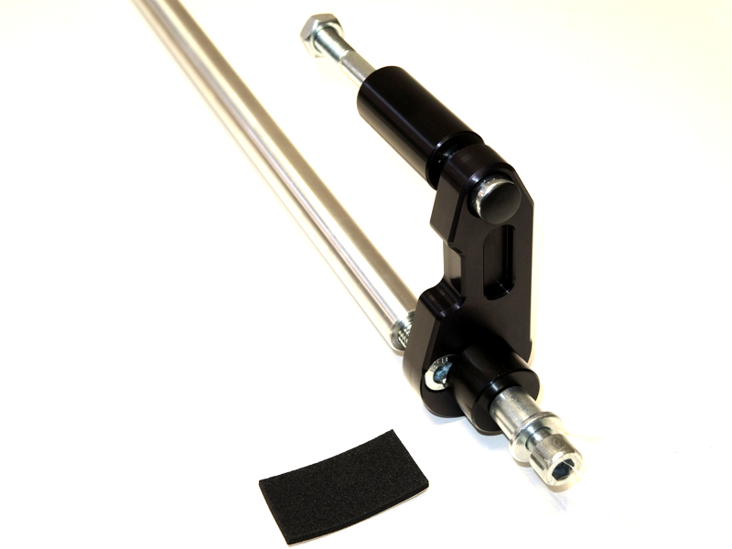
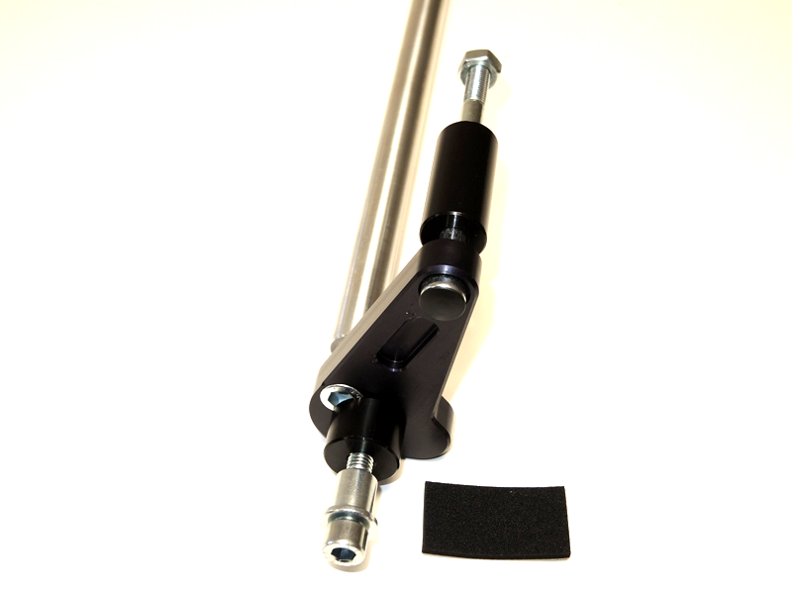
3
3
4
11
4
6

6
1
2
1
7
7
2
8
8
9
9

Instruction to assembly-left side:
- Dismantle original bolt from frame.
- Assembly duralumin adapter as you can see on the picture no.1.
- This kit mount on the bike, tighten it easy.
- Place alu. bar ID.11 in front of engine.
- This bar assembly to alu.adapter by bolt ID.2, tighten easy.
- Same process do on the right side.
- Now re-tighten bolts ID.6 and ID.2 on the both sides.
- Now insert steel boxes ID.8 into the protectors, under the protectors place alu. spacer ID.7. Crash protectors tighten by bolts ID.9.

During assembly you can stick 3M tape on the chassis.

Warning: We recommend use the glue of all threads. Medium strong.
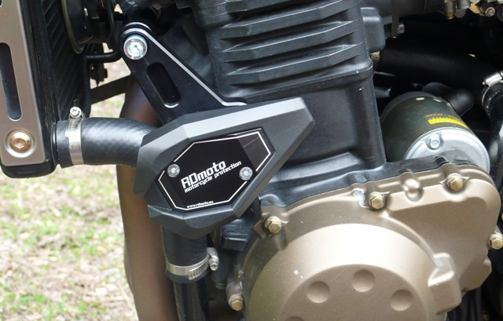
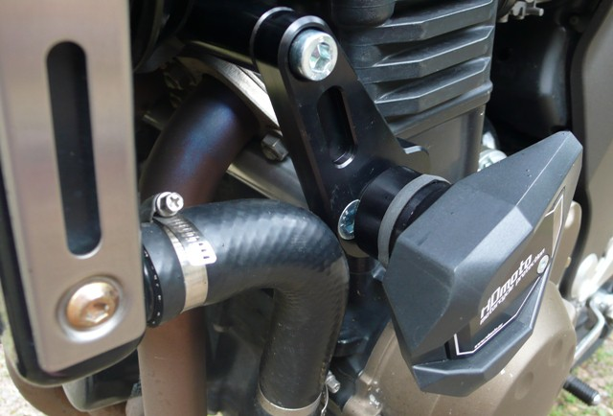
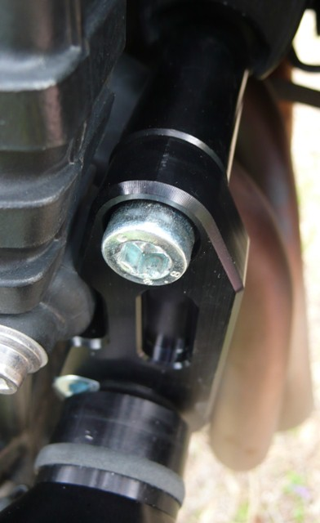
Ilustr. pictures of cash sliders.

