K50SD
Kawasaki Ninja H2 SX SE 2018-

Kit for the Left Side: Kit for the Right Side:
ID | Description | Cat.No | Pcs
1 | Dural. SLD holder | 537 | 1
2 | Dural. adapter | 12 | 1
3 | Dural. sleeve length =72mm | 201 | 1
4 | Bolt M10x150x1,25 | 932 | 1
5 | Washer M8 | 800 | 2
6 | Bolt M8x25 | 815 | 2
ID | Description | Cat.No | Pcs
1 | Dural. SLD holder | 537 | 1
2 | Dural. adapter | 12 | 1
3 | Dural. sleeve l=52mm | 200 | 1
4 | Bolt M10x130x1,25 | 905 | 1
5 | Washer M8 | 800 | 2
6 | Bolt M8x25 | 815 | 2

Mounting- Left Side:
- Remove original bolt from the frame.
- Insert the bolt ID 4 into the dural. holder ID 1 + adalter ID 2 and dural. sleeve ID 3. Mount the whole assembly to the motorcycle frame.
- Place the slider on the plate and mount it using bolts ID 6 and washer ID 5.

Mounting- Right Side:
- Remove original bolt from the frame.
- Insert the bolt ID 4 into the dural. holder ID 1 + adalter ID 2 and dural. sleeve ID 3. Mount the whole assembly to the motorcycle frame.
- Place the slider on the plate and mount it using bolts ID 6 and washer ID 5.
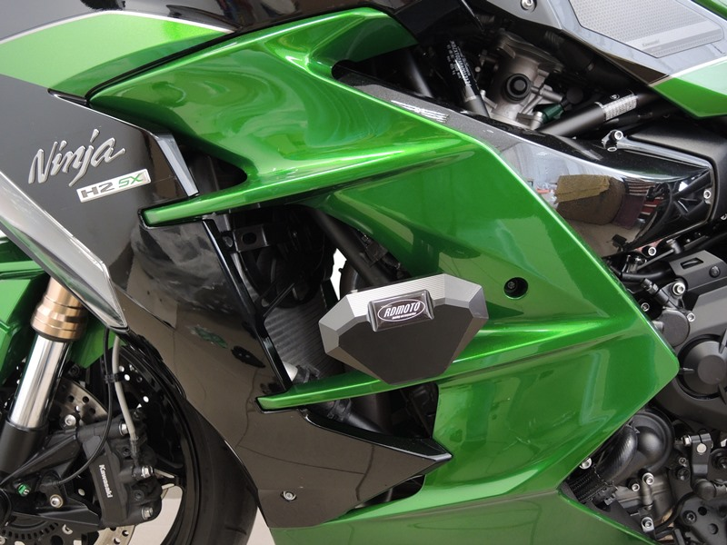

We recommend using medium strenght thread glue during assembly.

