K50
Kawasaki Ninja H2 SX SE 2018-

Kit fot the left side |  |  |  |  | Kit for the right side
No. | Description | Cat.no | Pcs |  |  | No. | Description | Cat.no | Pcs
1 | Steel box M10 | X1 | 1 |  |  | 1 | Steel box M10 | X1 | 1
2 | Bolt M10x125x1,25mm | 924 | 1 |  |  | 2 | Bolt M10x105x1,25mm | 893 | 1
3 | Dural. cylinder d=72mm | 201 | 1 |  |  | 3 | Dural. cylinder d=52mm | 200 | 1

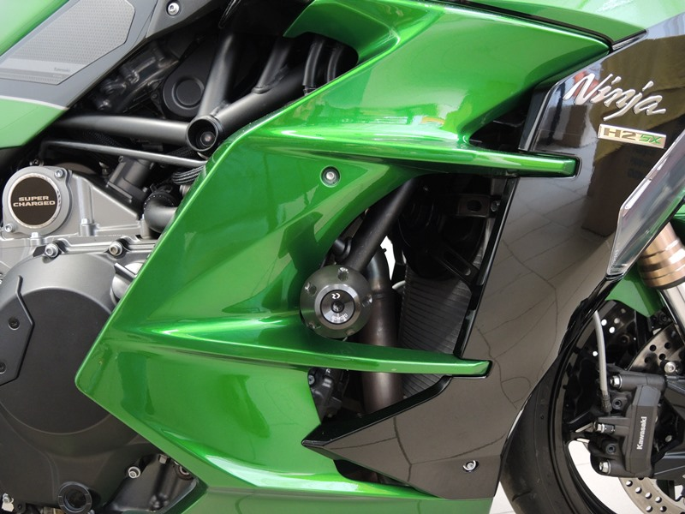

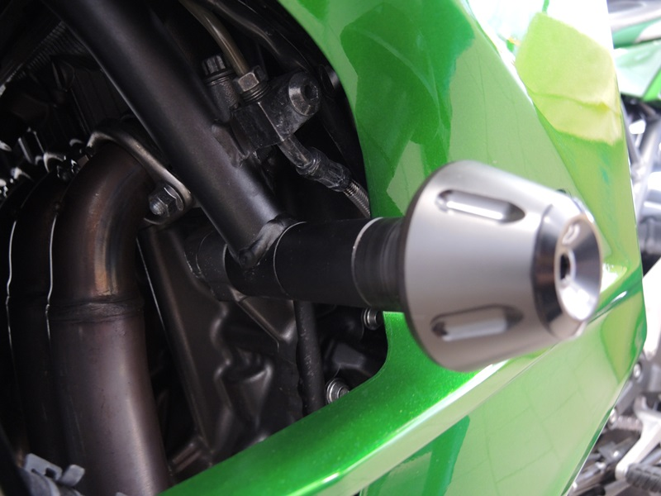

Installation:

Installation of the left and right protector make in gripping about the attached photo above. Give the steel box M10 (No. 1) on both bolts. Put the duralumin cylinder (No. 3) under the protector on the left side and use the bolt (No. 2) for tightening. Put the duralumin cylinder (No. 3) under the protector on the right side and use the bolt (No. 2) for tightening. At first finish the one side and then mount the second side.

Warning – we recommend to use safety glue on threads of all bolts (moderate strong – blue colour).

