K51S
Kawasaki Z400 2019-

Kit for Left Side |  |  |  |  | Kit for Right Side
ID. | Description | Cat.No. | Pcs |  |  | ID. | Description | Cat. No. | Pcs
1 | Bolt M6x25mm | 877 | 3 |  |  | 1 | Bolt M6x25mm | 877 | 3
2 | Bolt M10x130x1,25mm | 905 | 1 |  |  | 2 | Bolt M10x95x1,25mm | 927 | 1
3 | Dural. sleeve d=80mm | 449 | 1 |  |  | 3 | Dural. sleeve d=45mm | 440 | 1
4 | Steel adapter | 751 | 1 |  |  | 4 | Steel adapter | 751 | 1
5 | Bolt M8x12mm | 1060 | 1 |  |  | 5 | Bolt M8x12mm | 1060 | 1
6 | Bolt M10x30x1,25mm | 1006 | 1 |  |  | 6 | Bolt M10x30x1,25mm | 1006 | 1
7 | Dural. sleeve d=54mm | 320 | 1 |  |  | 7 | Dural. sleeve d=54mm | 320 | 1
8 | Allen bolt insertion M10 | X115 | 1 |  |  | 8 | Allen bolt insertion M10 | X115 | 1
9 | Plastic cover M10 | X4 | 1 |  |  | 9 | Plastic cover M10 | X4 | 1
10 | Bolt M4x16mm | 876 | 2 |  |  | 10 | Bolt M4x16mm | 876 | 2

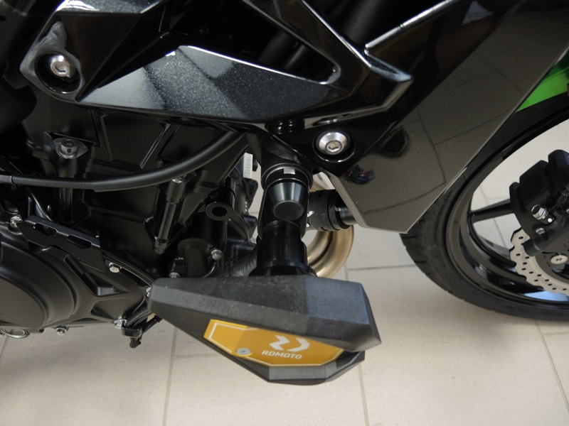
7
4
8
9
3
5
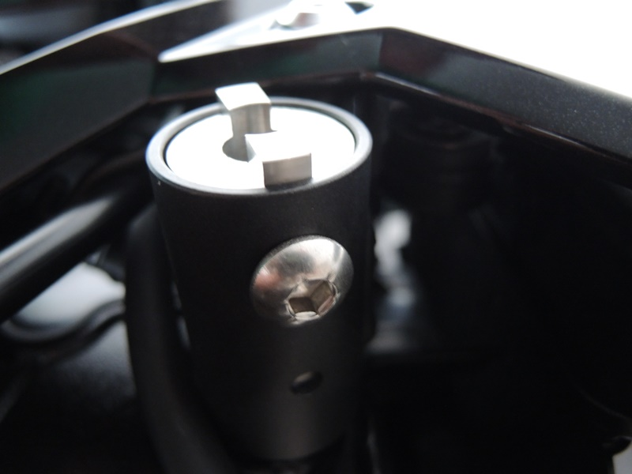

Mounting Instructions:

First, deinstall rear hood and original M10 bolt from motorcycle frame.

Put the M10 ID.8 insertion, ID.4 steel adapter and ID.3 sleeve onto the M10 ID.2 bolt. Then, install this assembly into the motorcycle frame so that you can still screw the M8 ID.5 bolt through the bottom opening of frame into the dural. sleeve (as shown on pictures). Finally, tighten the 10 bolt and install the ID.9 cover.

Equip the M10 ID.6 bolt with ID.3 sleeve and mount it into the steel bracket (adapter).

Use the M6 ID.1 bolts to fix the slider and ID.10 bolts to secure the cover in place.

Follow the same instructions on other (right) side, only difference being shorther ID.3 sleeve and shorther M10 ID.2 bolt.

Note – We recommend using medium strenght thread glue during installation. (blue color).

