K51
Kawasaki Z400 2019-

Kit for Left Side |  |  |  |  | Kit for Right Side
ID | Description | Cat. No. | Pcs |  |  | ID | Description | Cat.No. | Pcs
1 | Steel insertion M10 | X1 | 1 |  |  | 1 | Steel insertion M10 | X1 | 1
2 | Screw M10x130x1,25mm | 905 | 1 |  |  | 2 | Screw M10x95x1,25mm | 927 | 1
3 | Dural. sleeve d=80mm | 449 | 1 |  |  | 3 | Dural. sleeve d=45mm | 440 | 1
4 | Steel adapter | 751 | 1 |  |  | 4 | Steel adapter | 751 | 1
5 | Screw M8x12mm | 1060 | 1 |  |  | 5 | Screw M8x12mm | 1060 | 1
6 | Screw M10x55x1,25 | 915 | 1 |  |  | 6 | Screw M10x55x1,25 | 915 | 1
7 | Dural. sleeve d=20mm | 2 | 1 |  |  | 7 | Dural. sleeve d=20mm | 2 | 1
8 | Allen bolt insertion M10 | X115 | 1 |  |  | 8 | Allen bolt insertion M10 | X115 | 1
9 | Plastic cover M10 | X4 | 1 |  |  | 9 | Plastic cover M10 | X4 | 1

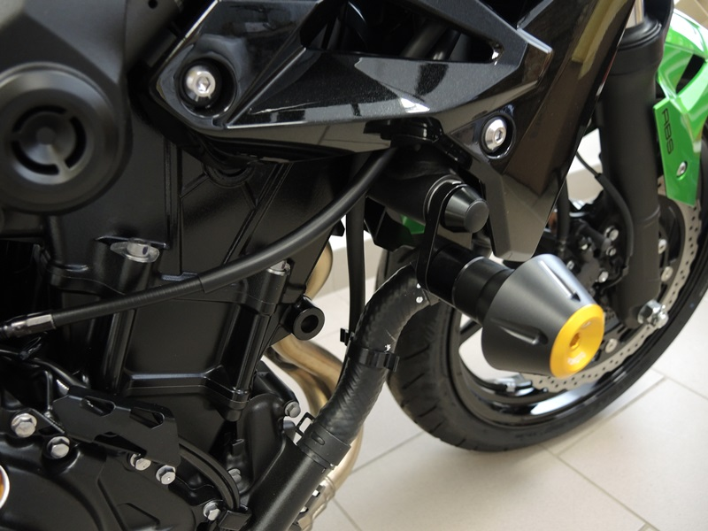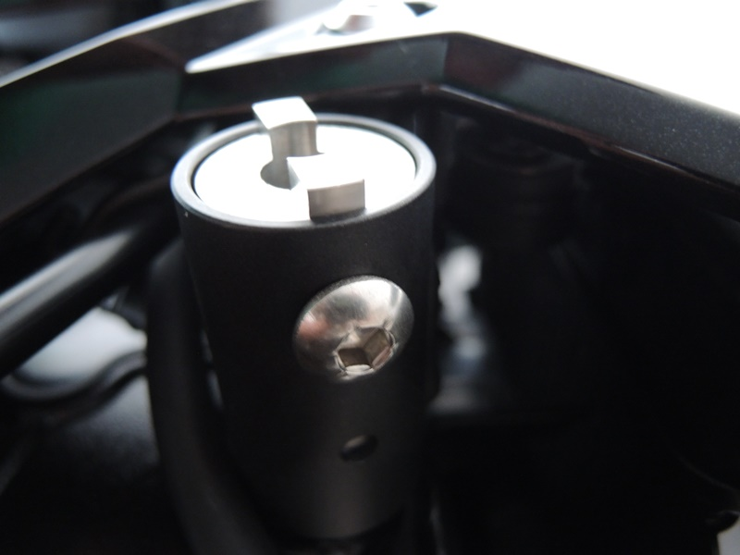
7
4
8
9
3
5

Mounting Instructions:

Begin by deinstalling hood on left side and original M10 screw from motorcycle frame.

Put M10 ID.8 insertion, ID.4 steel adapter and ID.3 sleeve onto the M10 ID.2 screw. Then, mount this assembly into the motorcycle frame so that you still can install the M8 ID.5 screw into the sleeve through the frame (see photos). Tighten the M10 screw and put on the ID.9 cover.

Now put ID.1 insertion, crash protector and ID.7 sleeve onto the M10 ID.6 screw. Finally you can mount this assembly into the steel bracket.

Follow the same instructions on right side, with only exception being the use of shorter sleeve ID.3 and shorter screw M10 ID.2.

Note – We recommend using medium strenght thread glue for all screws (blue color).

