K52S
Kawasaki ZX-6R 636 2019-2020

Kit for left side |  |  |  |  | Kit for right side
ID | Desctription | Cat.No. | Pcs |  |  | ID | Desctription | Cat.No. | Pcs
1 | adapter moto | 1341 | 1 |  |  | 1 | adapter moto | 1342 | 1
2 | adapter slider | 292 | 1 |  |  | 2 | adapter slider | 292 | 1
3 | bolt M6x25mm | 877 | 3 |  |  | 3 | bolt M6x25mm | 877 | 3
4 | bolt M4x16mm | 876 | 2 |  |  | 4 | bolt M4x16mm | 876 | 2
5 | bolt M10x100x1,25mm | 892 | 1 |  |  | 5 | bolt M10x105x1,25mm | 893 | 1
Fitting left side:

- Take ou original bolt from frame.
- Bolt ID.5 insert into the adapter ID.1 and ID.2. This set mounting the place on frame.
- Place slider and tighten it by bolts ID.3.
- Place alu. cover into the slider use bolts ID.4.
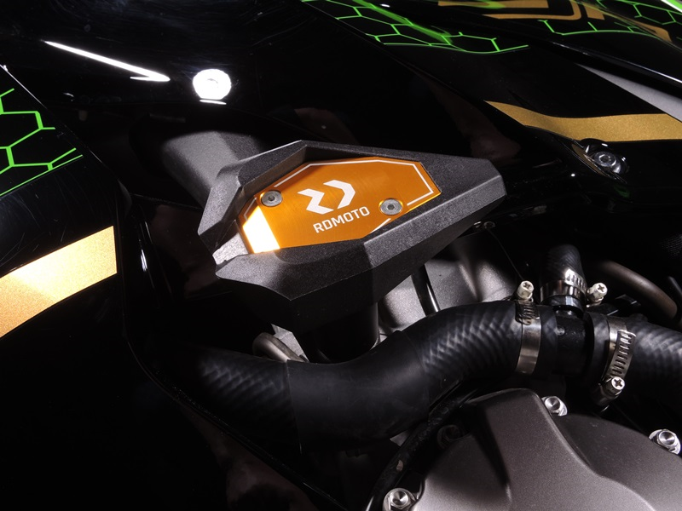

Fitting right side:

- Take ou original bolt from frame.
- Bolt ID.5 insert into the adapter ID.1 and ID.2. This set mounting the place on frame.
- Place slider and tighten it by bolts ID.3.
- Place alu. cover into the slider use bolts ID.4.

Warning - on the threads of the screws we recommend using glue medium strong(blue).

