K5
Kawasaki ZX-9R (2002-)

Left side kit |  |  |  |  | Right side kit
ID | Description | Cat.no. | Pcs |  |  | ID | Description |  | Cat.no. | Pcs
1 | Steel insert | X1 | 1 |  |  | 1 | Steel insert |  | X1 | 1
2 | Dural. cylinder – 15mm | DV144 | 1 |  |  | 2 | Dural cylinder - 15mm |  | DV144 | 1
3 | Bolt M10x110mm | 879 | 1 |  |  | 3 | Bolt M10x110mm |  | 879 | 1
4 | Nut M10 | 814 | 1 |  |  | 4 | Nut M10 |  | 814 | 1
 |  |  | 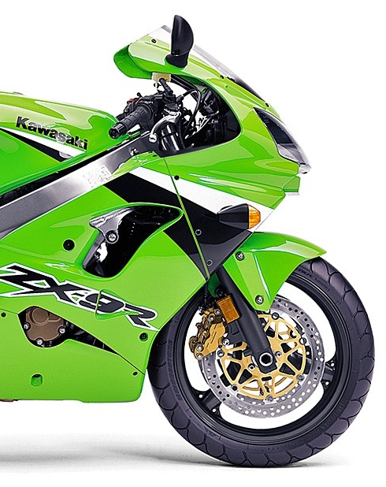

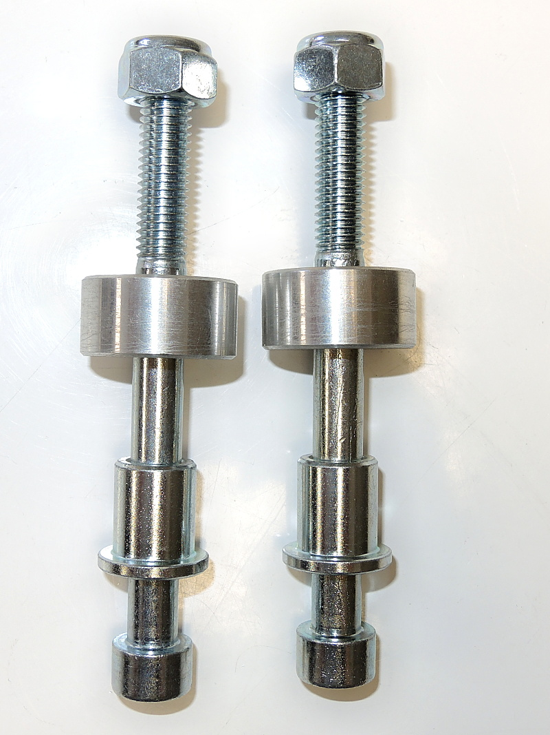
ID4

ID2

ID1

ID3

Instructions:

- Remove original bolt from the frame of motorcycle according to the picture above.
- Insert steel insert (ID1) and bolt (ID3) into protector.
- Put cylinder ID2 on the bolt (cylinder should be between protector and frame of motorcycle).
- Mount this kit into the frame using nut M10 (ID4).

We recommend to use the glue on all threads (medium strong).

