K6
Kawasaki ZX-10R 04-05

Kit for left side: |  |  |  |  | Kit for right side:
ID. | Description | Cat.no. | Qt |  |  | ID. | Description | Cat.no. | QT
1 | Steel adapter | 551 | 1 |  |  | 1 | Steel adapter | 552 | 1
2 | Steel bush | X1 | 1 |  |  | 2 | Steel bush | X1 | 1
3 | Bolt M10x60 | 850 | 1 |  |  | 3 | Bolt M10x60 | 850 | 1
4 | Bolt M10x80x1,25 | 920 | 1 |  |  | 4 | Bolt M10x70x1,25 | 898 | 1
5 | Alu. spacer l=20mm | DV2 | 1 |  |  | 5 | Alu. spacer l=20mm | DV2 | 1
6 | Washer M10 | 804 | 1 |  |  | 6 | Washer M10 | 804 | 1
7 | Alu. spacer l= 14mm | 114 | 1 |  |  | - | ----------------- | -- | --
8 | 3M tape |  | 1 |  |  | 8 | 3M tape |  | 1

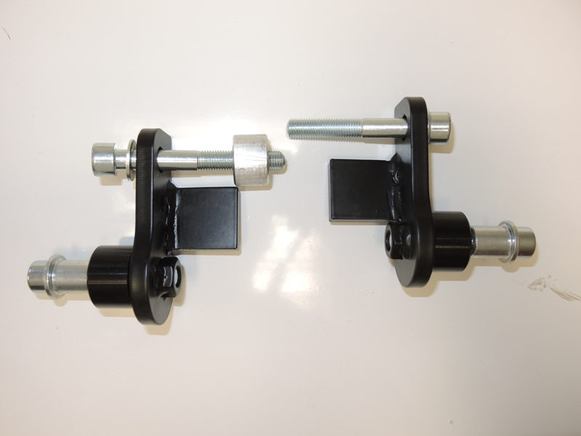
5
3
1
2
4
6
7
1
5
3
2
4
6

- Installation of the left and right protector make in gripping about the attached photo above.

Assembly :

- Take off fairing from the bike.
- Dismantle original bolts from frame as shown on the pictures.
- Place spacer ID.7 under the left steel adapter ID.1. Use bolt ID.4 with washer M10. Tighten this kit on the left hand side.
- Instal steel adapter ID.1 with bolt ID.4 and washer ID.6 on the right side.
- During the assembly you can stick 3M tape on the frame.
- Now place fairing back the bike.
- Place alu. spacers ID.5 under the protectors, insert steel bushes ID.2 into the protectors and mount it on the adapters by bolts ID.3

Warning – we recommend to use safety glue on threads of all bolts (moderate strong – blue colour).

