K7SDM
Kawasaki ER-6N 2006-2008

Kit for the left side |  |  |  |  | Kit for the right side
No. | Description | Cat.no. | Pcs |  |  | No. | Description | Cat.no. | Pcs
1 | Slider adapter | 537/B | 1 |  |  | 1 | Slider adapter | 537/B | 1
2 | Bolt M6x20 | 1024 | 2 |  |  | 2 | Bolt M6x20 | 1024 | 2
3 | Washer M6 | 1023 | 2 |  |  | 3 | Washer M6 | 1023 | 2
4 | Bolt M10x130x1,25mm | 905 | 1 |  |  | 4 | Bolt M10x120x1,25mm | 895 | 1
5 | Bolt M8x60mm | 838 | 1 |  |  | 5 | Bolt M8x40mm | 835 | 2
6 | Bolt M10x55mm | 1002 | 1 |  |  | 6 | Bolt M10x55mm | 1002 | 1
7 | Dural. cylinder 63mm | 118 | 1 |  |  | 7 | Dural. cylinder 4,5mm | 116 | 1
8 | Dural. cylinder 22mm | 117 | 1 |  |  | 8 | Duralumin adapter | 527 | 1
9 | Duralumin adapter | 528 | 1 |  |  | 9 | Pad M10 (plane) | 804 | 1
10 | Pad M10 (plane) | 804 | 1 |  |  | 10 | Dural. cylinder | DV11 | 1
11 | Dural. cylinder | DV11 | 1 |  |  | 11 | Washer M10 (spring) | 801 | 1
12 | Washer M10 (spring) | 801 | 1

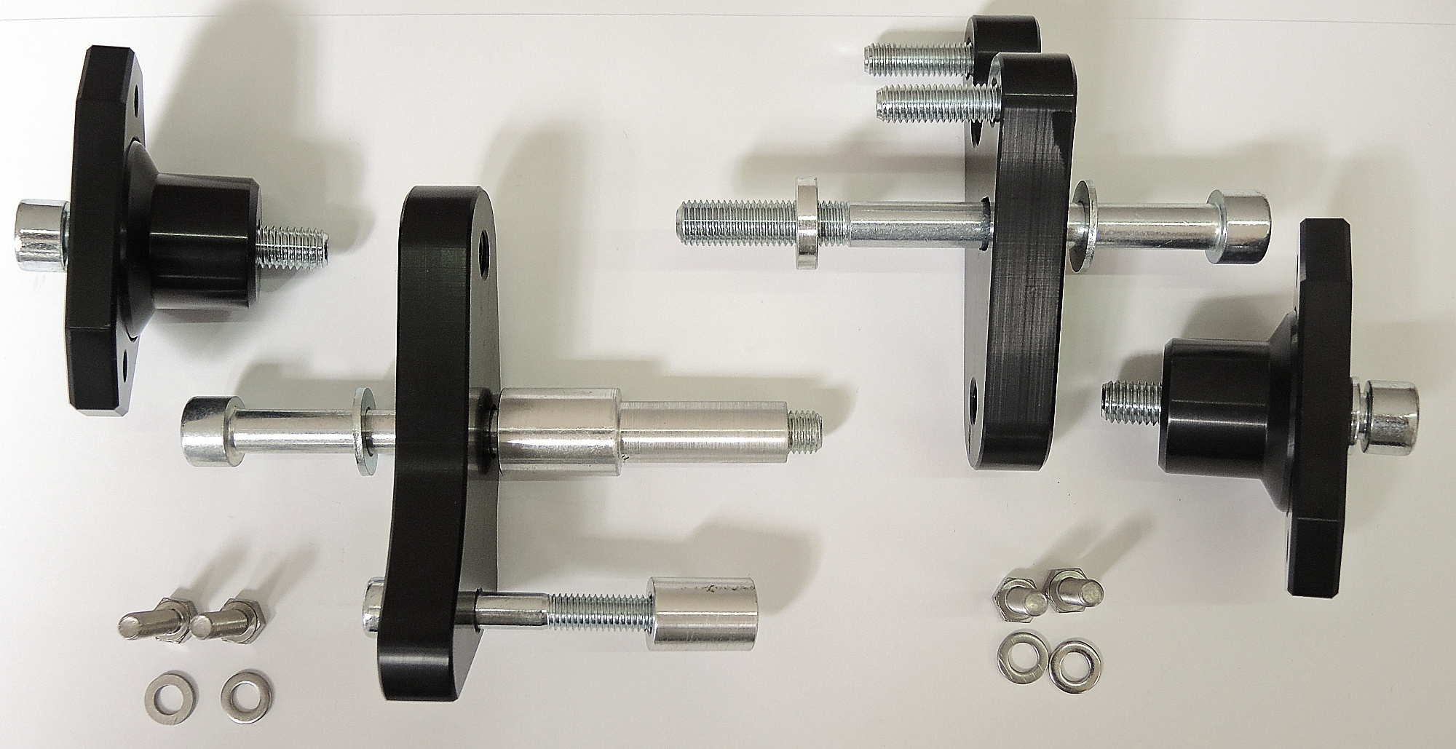
ID5

ID1
ID5

ID11
ID4+7+9
ID6+12
ID8

ID6+11
ID4+7+10
ID10

ID9

ID2
ID2
ID5+8
ID3
ID3

Instructions (left side):

- Dismantle side fairing.
- Fit steel adapter ID9 on the frame using two bolts (ID4+7+10 and ID5+8) according to the picture above.
- Fit slider adapter ID1 and cylinder ID11 using M10 bolt (ID6+ID12) into the steel adapter.
- In the end mount slider using two bolts (ID2) and washers (ID3).

We recommend to use the safety glue on all threads.

Instructions (right side):

- Dismantle side fairing.
- Fit steel adapter ID8 on the frame using two bolts (ID4+7+9 and two ID5) according to the picture above.
- Fit slider adapter ID1 and cylinder ID10 using M10 bolt (ID6+ID11) into the steel adapter.
- In the end mount slider using two bolts (ID2) and washers (ID3).

We recommend to use the safety glue on all threads.

