K7S
Kawasaki ER-6N 2006-2008

Kit for the left side |  |  |  |  | Kit for the right side
No. | Description | Cat.no. | Pcs |  |  | No. | Description | Cat.no. | Pcs
1 | Slider adapter | DV-313 | 1 |  |  | 1 | Slider adapter | DV-313 | 1
2 | Bolt M6x25 | 877 | 3 |  |  | 2 | Bolt M6x25 | 877 | 3
3 | Bolt M4x16 | 876 | 2 |  |  | 3 | Bolt M4x16 | 876 | 2
4 | Bolt M10x130x1,25mm | 905 | 1 |  |  | 4 | Bolt M10x120x1,25mm | 895 | 1
5 | Bolt M8x60mm | 838 | 1 |  |  | 5 | Bolt M8x40mm | 835 | 2
6 | Bolt M10x25mm | 868 | 1 |  |  | 6 | Bolt M10x25mm | 868 | 1
7 | Dural. cylinder 63mm | 118 | 1 |  |  | 7 | Dural. cylinder 4,5mm | 116 | 1
8 | Dural. cylinder 22mm | 117 | 1 |  |  | 8 | Duralumin adapter | 527 | 1
9 | Duralumin adapter | 528 | 1 |  |  | 9 | Pad M10 (plane) | 804 | 1
10 | Pad M10 (plane) | 804 | 1

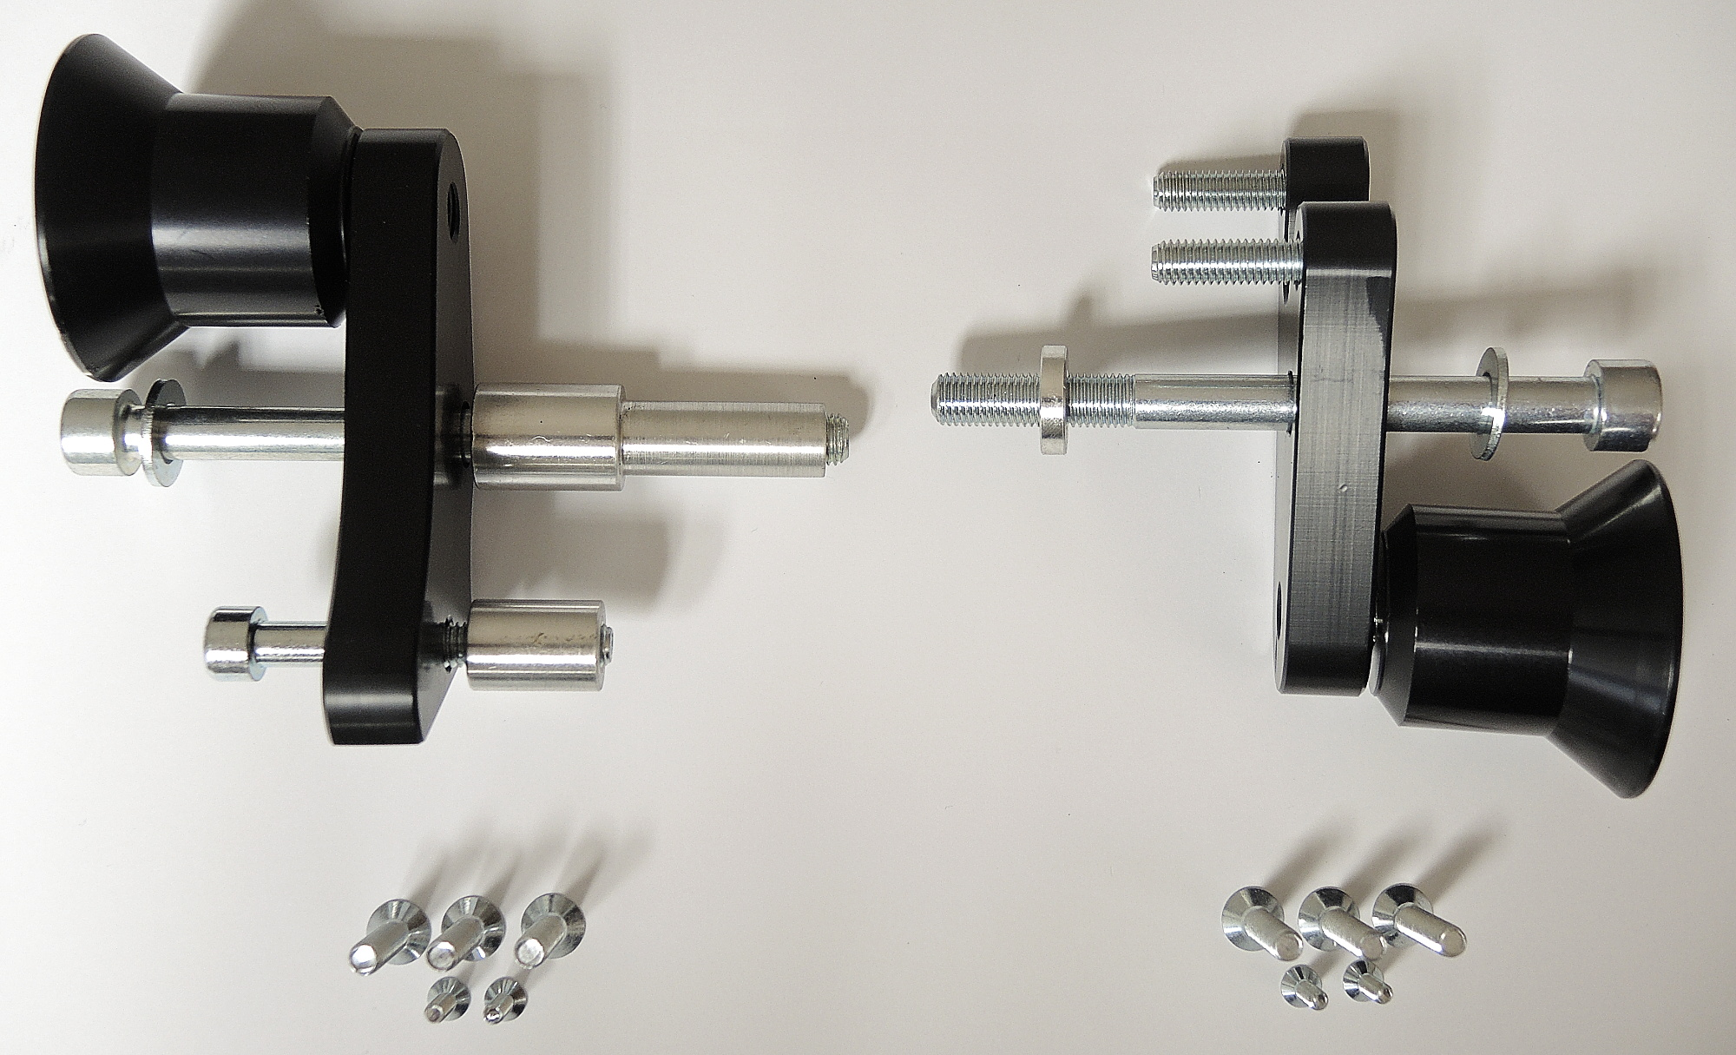
ID1+6
ID1+6
ID2
ID3
ID2
ID3
ID4+7+10
ID4+7+9
ID5+8
ID5
ID5
ID8
ID9

Instructions (left side):

- Dismantle side fairing.
- Fit steel adapter ID9 on the frame using two bolts (ID4+7+10 and ID5+8) according to the picture above.
- Fit slider adapter ID1 using M10 bolt ID6 into the steel adapter.
- In the end mount slider using three bolts (ID2) and coloured cover using two bolts (ID3).

We recommend to use the safety glue on all threads.

Instructions (right side):

- Dismantle side fairing.
- Fit steel adapter ID8 on the frame using two bolts (ID4+7+9 and two ID5) according to the picture above.
- Fit slider adapter ID1 using M10 bolt (ID6) into the steel adapter.
- In the end mount slider using three bolts (ID2) and coloured cover using two bolts (ID3).

We recommend to use the safety glue on all threads.

