K8
Kawasaki ZRX1200 2001-

Kit for left side: |  |  |  |  | Kit for right side:
ID. | Description | Cat.no. | Pcs |  |  | ID. | Description | Cat.no. | Pcs
1 | Steel box M10 | X1 | 1 |  |  | 1 | Steel box M10 | X1 | 1
2 | Bolt M10x150mm | 939 | 1 |  |  | 2 | Bolt M10x130mm | 883 | 1
3 | Dural.cylinder d=80mm | 198 | 1 |  |  | 3 | Dural.cylinder d=60mm | 196 | 1
4 | Nut M10 | 814 | 1 |  |  | 4 | Nut M10 | 814 | 1

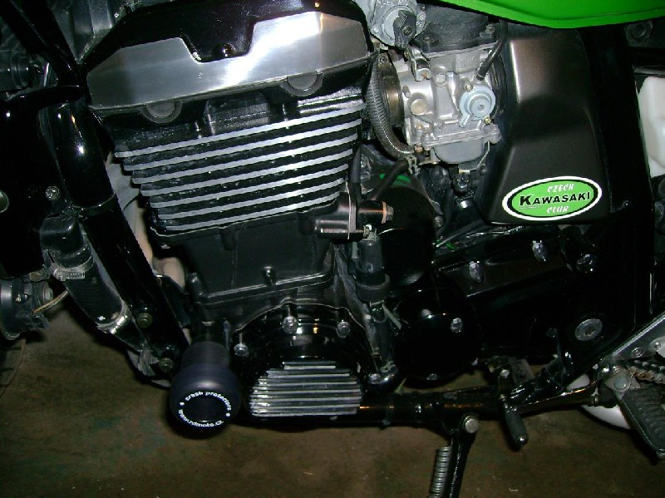

Assembly :

- Installation of the left and right protector make in gripping about the attached photo above.
- Give the steel box M10 ID.1 on both bolts. Put the duralumin cylinder ID.3 under the protector on the left side and use the bolt ID.2 together with nut ID.4 for tightening. Put the duralumin cylinder ID.3 under the protector on the right side and use the bolt ID.2 together with nut ID.4 for tightening. At first finish the one side and then mount the second side.

Warning – we recommend to use safety glue on threads of all bolts (moderate strong – blue colour).

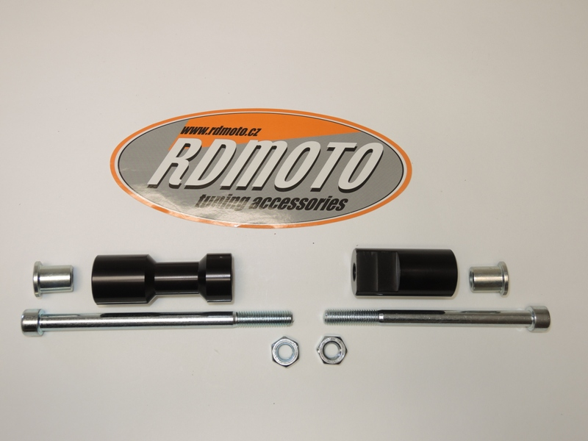
3
3
1
4
4
2
1

