K9
Kawasaki ZX-6R/RR ´05-´06

Kit for right side: |  |  |  |  | Kit for left side:
ID. | Description | Cat.n | Qt |  |  | ID. | Description | Cat.n | Qt
1 | Steel box M10 | X1 | 1 |  |  | 1 | Steel box M10 | X1 | 1
2 | Nut M10 | 814 | 1 |  |  | 2 | Nut M10 | 814 | 1
3 | Alu. spacer d=50mm | 5 | 1 |  |  | 3 | Alu. spacer d=40mm | 4 | 1
4 | Bolt M10x90 | 880 | 1 |  |  | 4 | Bolt M10x140 | 953 | 1
5 | Washer M10 | 804 | 1
6 | Lock Nut M10 | 810 | 1
7 | Steel adapter | 538 | 1
8 | Bolt M10x60 | 850 | 1
9 | Spacer d=5mm | 16 | 1

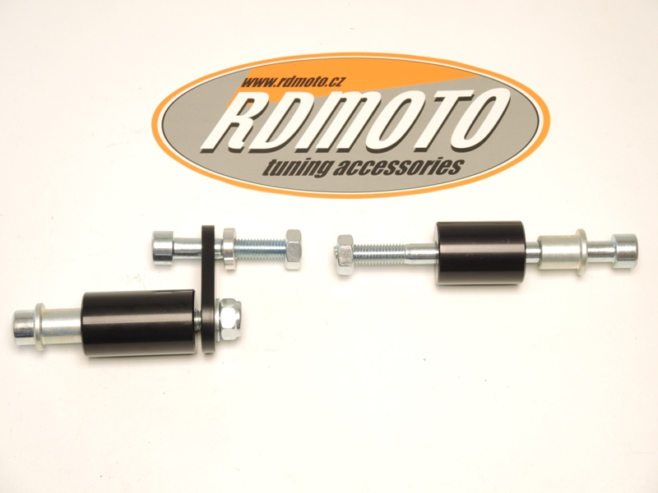

8
3
1
4
9
7

2
2
4
5,6
1
3

Warning - on the threads of the screws we recommend using premium adhesive glue (blue).

Fitting instruction:
- Right side: Into the protector insert steel box ID.1 and bolt ID.4.
- Under the protector place alu. spacer ID.3. Insert bolt throught the protector, alu. spacer, frame and engine. Tighten this bolt from back side by nut ID.2.
- Left side: Dismantle original bolt from frame. Place steel adapter on the frame, use bolt ID.8. Between the frame and adapter insert spacer ID.9.For tighten use nut ID.2
- Into the protector insert steel box ID.1 and bolt ID.4.
- Place alu. adapter ID.3 under the protector. Put washer and nut ID.5ID.6 from back side and tighten protector.

