KTM10S

**KTM 390 Duke 2018-**

|  |  |  |  |  |  |  |  |  |  |
| --- | --- | --- | --- | --- | --- | --- | --- | --- | --- |
| **Kit for left side** | | | | | **Kit for right side** | | | | |
|  |  |  |  |  |  |  |  |  |  |
| ID. | Description | Cat. No. | Pcs. |  | ID. | Description | Cat. No. | Pcs. |  |
| 1 | Dural.adapter for SL01 | 315 | 1 |  | 1 | Dural.adapter for SL01 | 315 | 1 |  |
| 2 | Dural. roller d=13mm | 464 | 1 |  | 2 | Dural. roller d=17mm | 1190 | 1 |  |
| 3 | Dural. roller d=15mm | 465 | 1 |  | 3 | Dural. roller d=17mm | 1190 | 1 |  |
| 4 | Bolt M10x45 | 847 | 1 |  | 4 | Bolt M10x45 | 847 | 1 |  |
| 5 | Bolt M8x45mm | 964 | 2 |  | 5 | Bolt M8x45mm | 964 | 2 |  |
| 6 | Steel adapter | 628 | 1 |  | 6 | Steel adapter | 628 | 1 |  |
| 7 | Bolt M6x25 | 877 | 3 |  | 7 | Bolt M6x25 | 877 | 3 |  |
| 8 | Bolt M4x16 | 876 | 2 |  | 8 | Bolt M4x16 | 876 | 2 |  |
|  |  |  |  |  |  |  |  |  |  |

**Mounting instructions:**

1. Mounting procedures of the crash protectors is the same for both sides.
2. Begin with one side only. First, take off the original M8 bolts.
3. Insert dural. rollers into the frame (ID.2 close to the front wheel and ID.3 to the rear wheel).
4. Use ID.5 bolts to attach the steel adapter ID.6 to the motorcycle frame.
5. Put the ID.4 bolt into the ID.1 dural. adapter.
6. Take this assembly and mount it onto the steel adapter on the motorcycle frame (as shown on attached pictures).
7. Finally, mount the slider with ID.7 bolts and insert the cover into the protector. Fix it with ID.8 bolts.

**Note – We recommend using medium strenght glue for threads of all screws (blue color).**

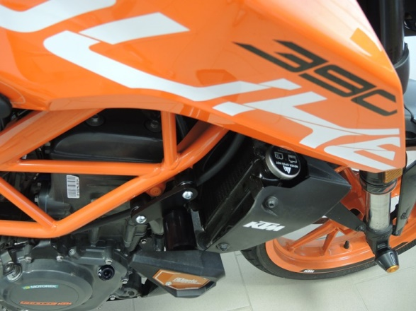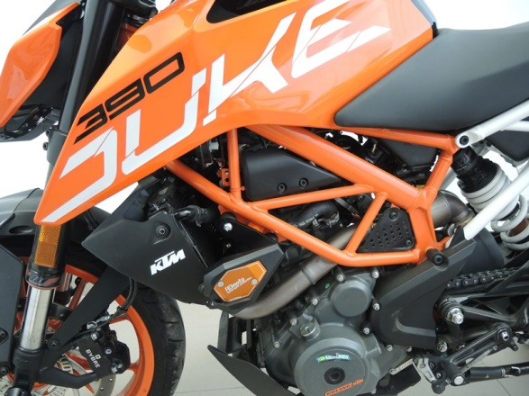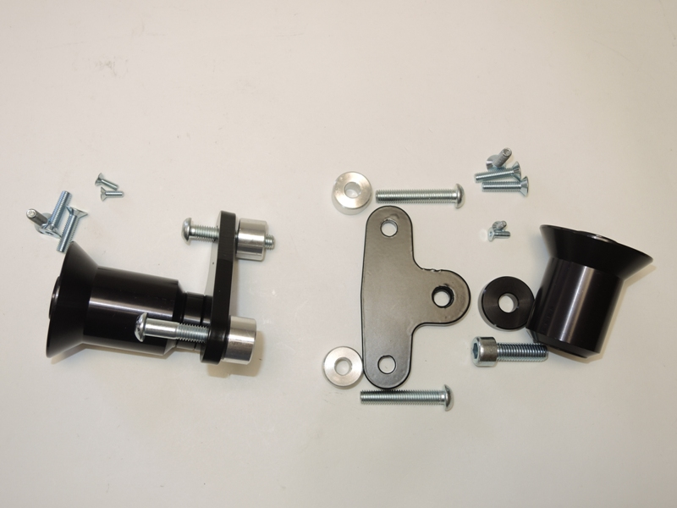

8

7

6

5

5

4

3

2

1