KTM10

**KTM 390 Duke 2018-**

|  |  |  |  |  |  |  |  |  |  |
| --- | --- | --- | --- | --- | --- | --- | --- | --- | --- |
| **Kit for left side** | | | | | **Kit for right side** | | | | |
|  |  |  |  |  |  |  |  |  |  |
| **ID.** | **Description** | **Cat. No.** | **Pcs.** |  | **ID.** | **Description** | **Cat. No.** | **Pcs.** |  |
| 1 | Steel insert M10 | X1 | 1 |  | 1 | Steel insert M10 | X1 | 1 |  |
| 2 | Bolt M10x75mm | 1007 | 1 |  | 2 | Bolt M10x75mm | 1007 | 1 |  |
| 3 | Dural. Roller d=13mm | 464 | 1 |  | 3 | Dural. Roller d=17mm | 1190 | 1 |  |
| 4 | Dural. Roller d=15mm | 465 | 1 |  | 4 | Dural. Roller d=17mm | 1190 | 1 |  |
| 5 | Dural. Roller d=40mm | 4 | 1 |  | 5 | Dural. Roller d=40mm | 4 | 1 |  |
| 6 | Bolt M8x45mm | 964 | 2 |  | 6 | Bolt M8x45mm | 964 | 2 |  |
| 7 | Steel Adapter | 628 | 1 |  | 7 | Steel Adapter | 628 | 1 |  |
| 8 | Washer M10 spring | 801 | 1 |  | 8 | Washer M10 spring | 801 | 1 |  |
|  |  |  | 3 |  |  | 7 |  |  |  |

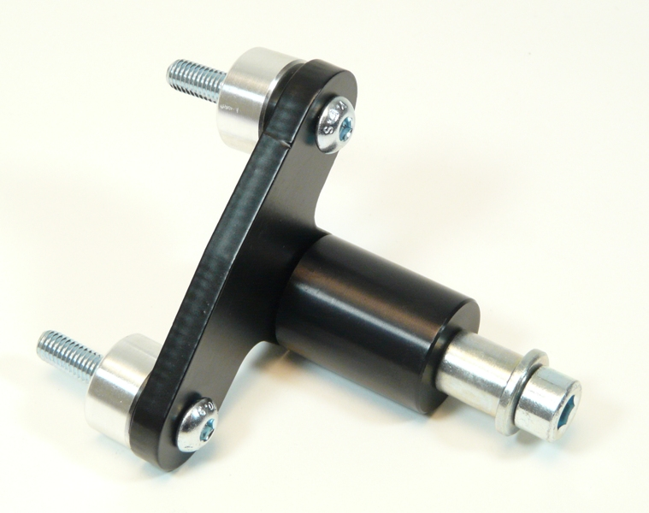

6

1

5

4

6

2

8

**Mounting Instructions:**

1. Mounting procedure for the protectors is the same for both sides.
2. Take off the original M8 bolts.
3. Insert the dural. rollers into the frame (ID.3 upper, ID. 4 lower).
4. Use the steel ID.6 bolts to mount the ID.7 steel adapter to the motorcycle frame.
5. Put the ID.1 steel insert into the protector together with ID.2 bolt and ID.8 washer.
6. Take this assembly and mount it into the adapter thread.

**Please note – We recommend using medium strenght glue for threads of all screws (blue color).**

