KTM1
KTM990 Super Duke /R 2005-

Fitting kit left side: Fitting kit right side:
ID | Description | Cat.n | Qt
1 | Steel sleeve M10 | X1 | 1
2 | Bolt M10x90mm | 880 | 1
3 | Dural. cylinder d=9mm | 87 | 2
4 | Dural. cylinder d=50mm | 13 | 1
5 | Bolt M10x45mm | 848 | 2
6 | Duralumin adapter | 557 | 1
7 | Tape 3M |  | 1
ID | Description | Cat.n | Qt
1 | Steel sleeve M10 | X1 | 1
2 | Bolt M10x90mm | 880 | 1
3 | Dural. cylinder d=9mm | 87 | 2
4 | Dural. cylinder d=50mm | 13 | 1
5 | Bolt M10x45mm | 848 | 2
6 | Duralumin adapter | 557 | 1
7 | Tape 3M |  | 1
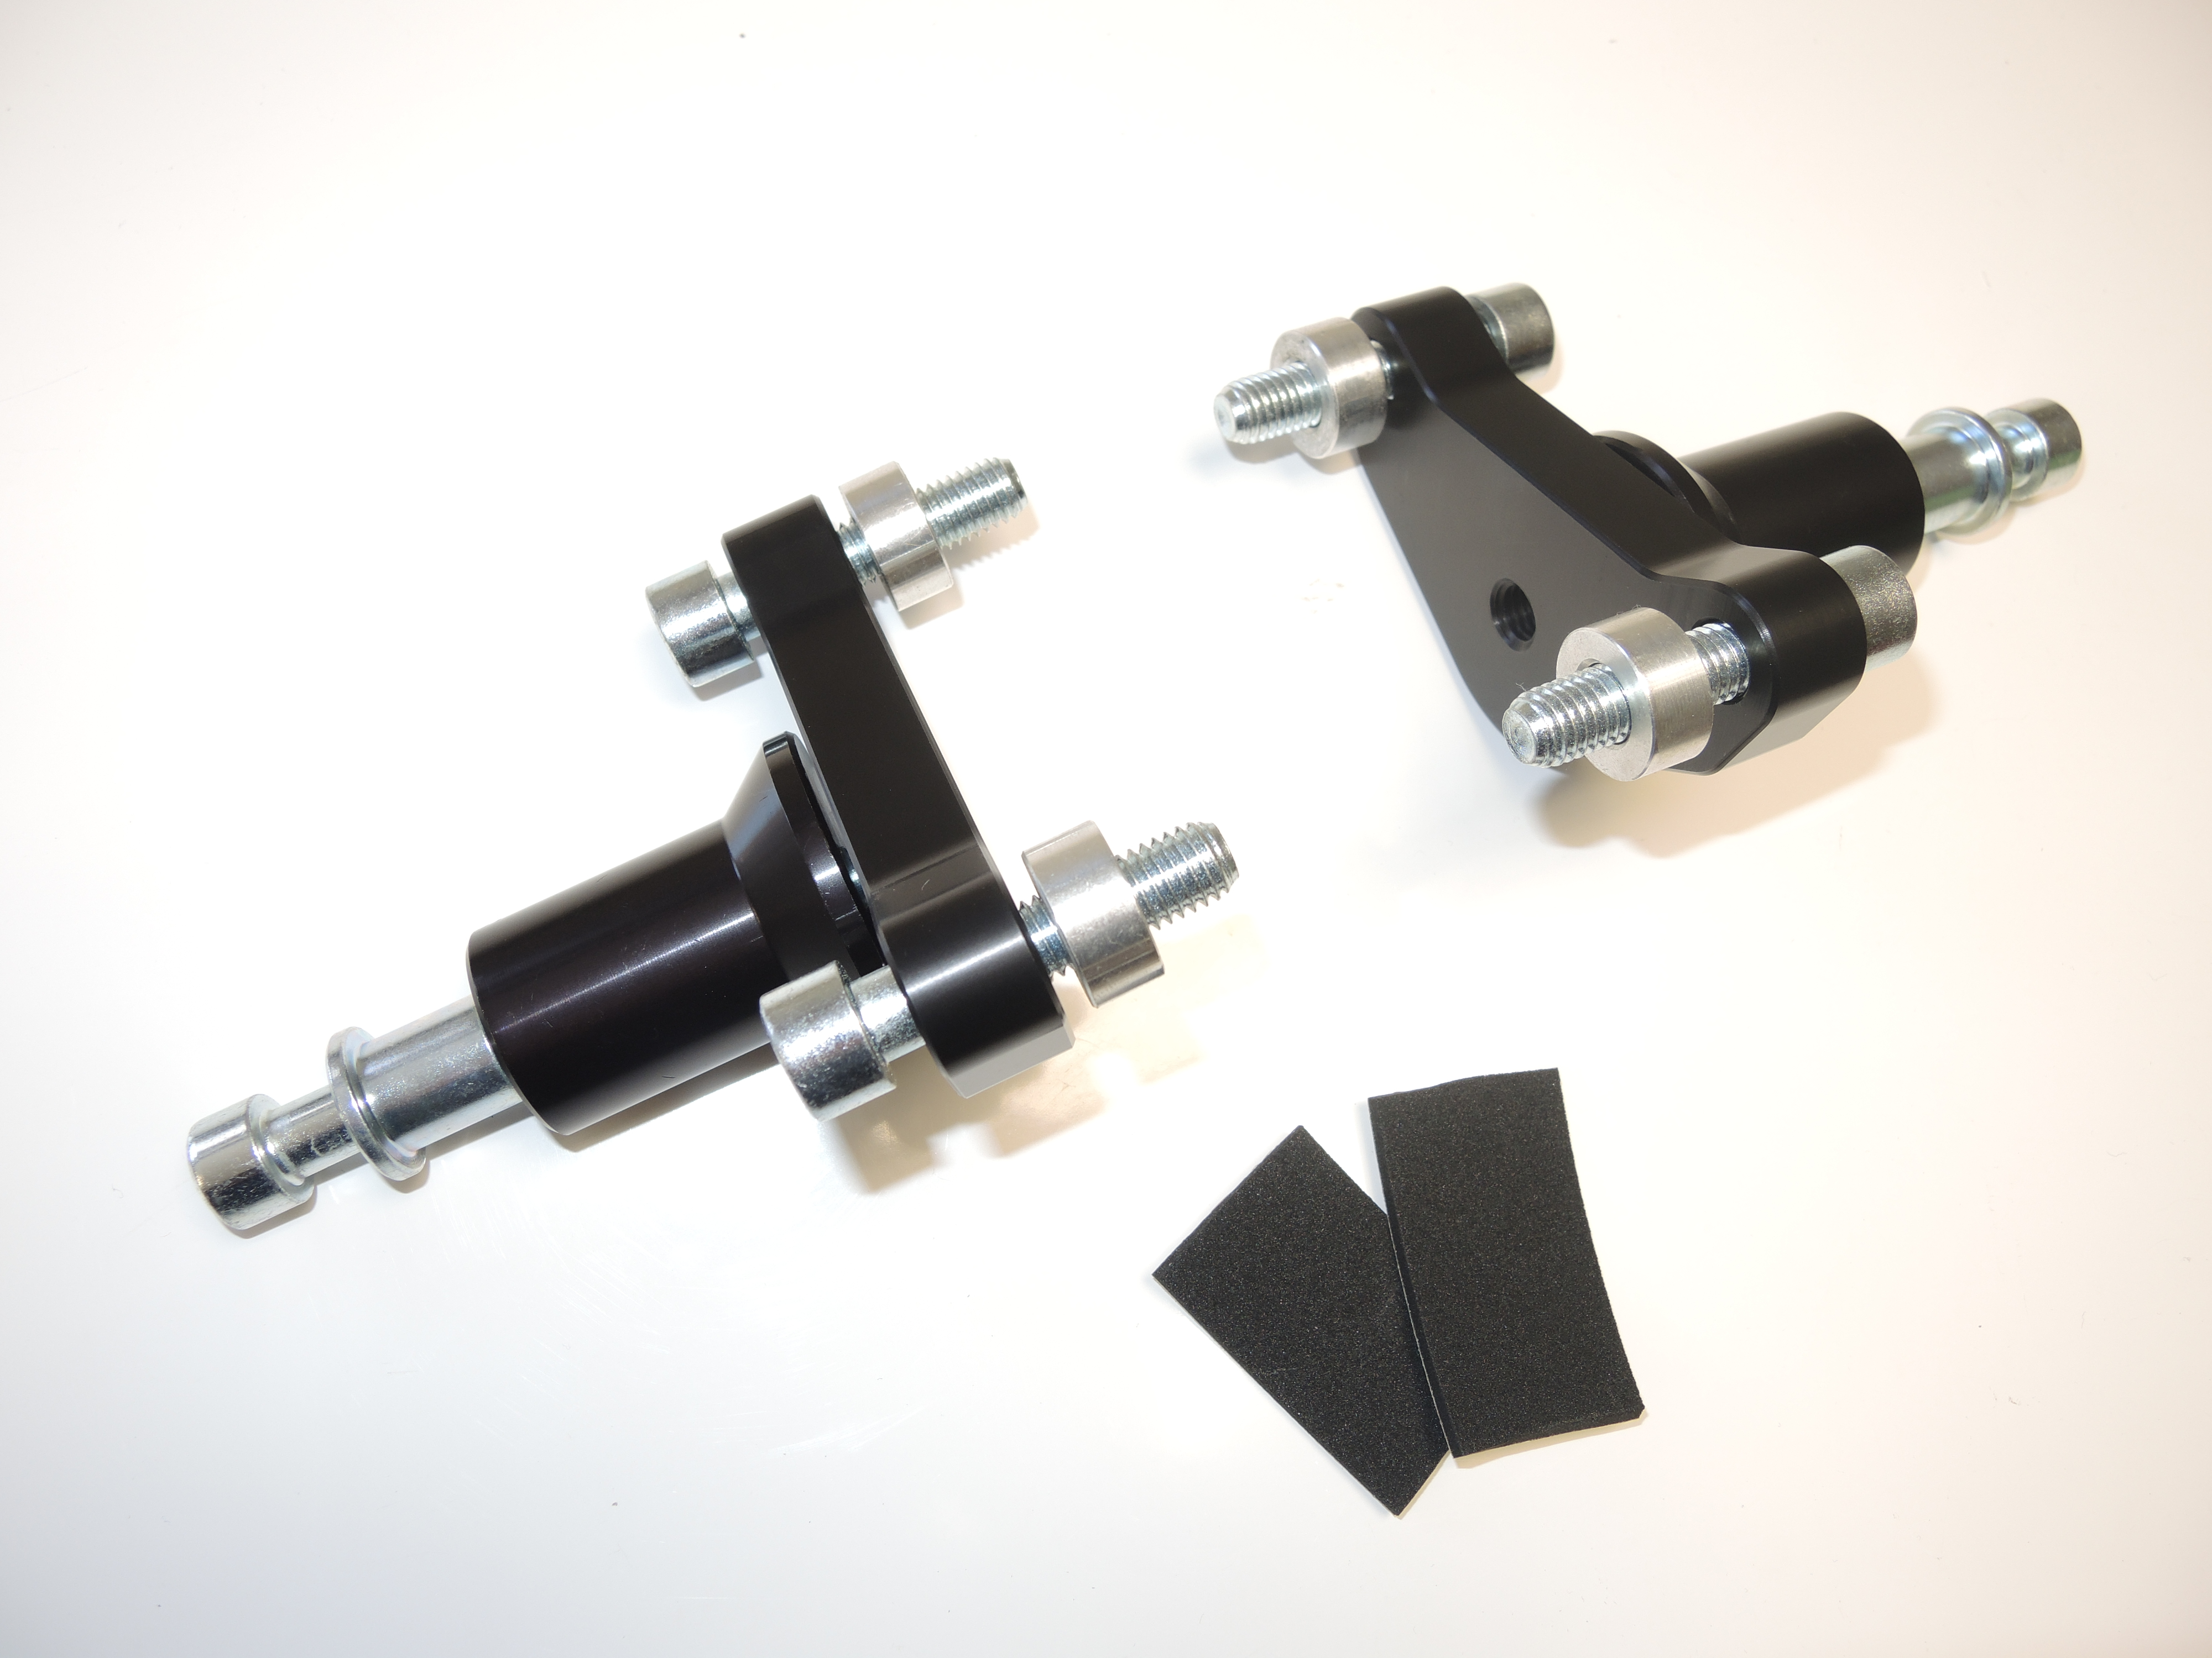

3
5
2
1
4
3
5

6
6
5

4

1
3
2
3

5

Assembly left side:

- remove the original bolts M10
- the mounting of adapter on the motorcycle is not difficult. At first give bolts (No. 5) in adapter. On reverse side of adapter give on bolst M10 the duralumin cylinder (No. 3).
Mount all carefully on the motorcycle, use 3M tape for the touch space the frame of motorcycle.
- put steel box (No. 1) together with bolt (No. 2) in protector and on reverse side of protector give duralumin cylinder (No. 4) on bolt.
- all this set mount to thread on adapter

Assembly right side:

- remove the original bolts M10
- the mounting of adapter on the motorcycle is not difficult. At first give bolts (No. 5) in adapter. On reverse side of adapter give on bolst M10 the duralumin cylinder (No. 3).
Mount all carefully on the motorcycle, use 3M tape for the touch space the frame of motorcycle.
- put steel box (No. 1) together with bolt (No. 2) in protector and on reverse side of protector give duralumin cylinder (No. 4) on bolt.
- all this set mount to thread on adapter

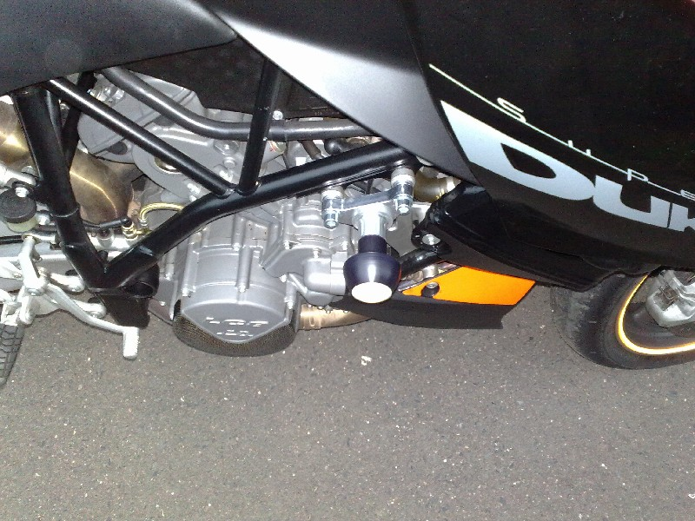
Warning – we recommend to use safety glue on threads of all bolts (moderate strong – blue colour).

