KTM3S
KTM 125/200 Duke 2013-

Kit for right side: |  |  |  |  | Kit for left side:
ID. | Description | Cat.N | Qt |  | ID. | Description | Cat.N | Qt
1 | Dural.cylinder d=10mm | 1 | 1 |  | 1 | Dural.cylinder d=10mm | 1 | 1
2 | Dural.adapter for SL01 | 317 | 1 |  | 2 | Dural.adapter for SL01 | 317 | 1
3 | Dural. cylinder d=13mm | 464 | 1 |  | 3 | Dural. cylinder d=13mm | 464 | 1
4 | Dural. cylinder d=15mm | 465 | 1 |  | 4 | Dural. cylinder d=15mm | 465 | 1
5 | Bolt M10x30 | 882 | 1 |  | 5 | Bolt M10x30 | 882 | 1
6 | Bolt M8x45mm | 964 | 2 |  | 6 | Bolt M8x45mm | 964 | 2
7 | Steel adapter | 628 | 1 |  | 7 | Steel adapter | 628 | 1
8 | Bolt M6x25 | 877 | 3 |  | 8 | Bolt M6x25 | 877 | 3
9 | Bolt M4x16 | 876 | 2 |  | 9 | Bolt M4x16 | 876 | 2

Instruction to assembly:

- Instruction to assemlby for left and right hand side are same.
- Do the mounting left side first.
- Take out original bolts M8 from frame.
- Insert duralumin cylinders into the frame (ID.3 is UP and ID.4 is down).
- Take bolts ID.6 and gripping steel adapter ID.7 on the bike.
- Bolt ID.5 insert into the dural.adapter ID.2. Under the adapter put cylinder ID.1.
- Do mounting this kit on the motorcycle frame. (see photo).
- By bolts ID.8 gripping slider. Put alu. cover into the slider, use bolts ID.9.

Warning - on the threads of all bolts recommend the use of medium strong glue for threads (blue).

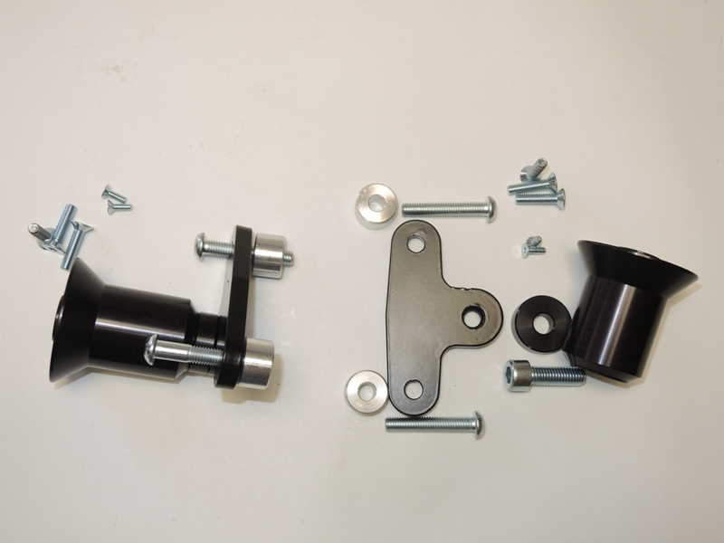
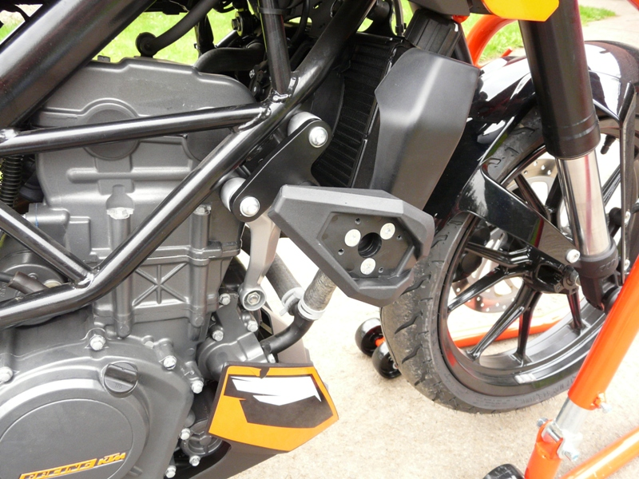
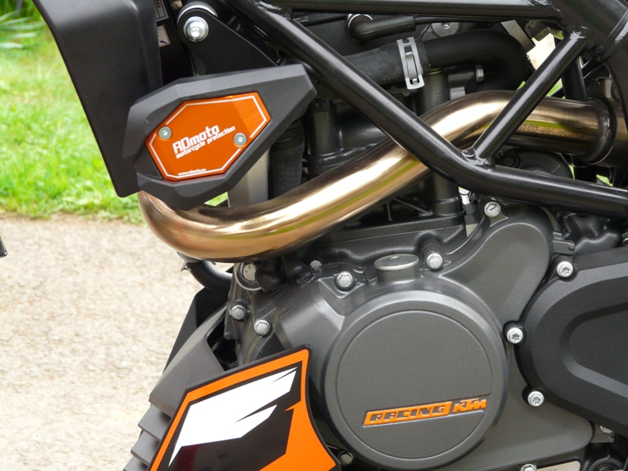
9
8
6
5
4
3
2
1
6
7

