KTM3

**KTM 125/200 Duke 2013-**

|  |  |  |  |  |  |  |  |  |  |
| --- | --- | --- | --- | --- | --- | --- | --- | --- | --- |
| **Kit for the left side** | | | | | **Kit for the right side** | | | | |
|  |  |  |  |  |  |  |  |  |  |
| **No.** | **Description** | **Cat.no.** | **Pcs** |  | **No.** | **Description** | **Cat.no.** | **Pcs** |  |
| 1 | Steel box M10 | X1 | 1 |  | 1 | Steel box M10 | X1 | 1 |  |
| 2 | Bolt M10x75mm | 1007 | 1 |  | 2 | Bolt M10x75mm | 1007 | 1 |  |
| 3 | Dural. cylinder d=13mm | 464 | 1 |  | 3 | Dural. cylinder d=13mm | 464 | 1 |  |
| 4 | Dural. cylinder d=15mm | 465 | 1 |  | 4 | Dural. cylinder d=15mm | 465 | 1 |  |
| 5 | Dural. cylinder d=40mm | 4 | 1 |  | 5 | Dural. cylinder d=40mm | 4 | 1 |  |
| 6 | Bolt M8x45mm | 964 | 2 |  | 6 | Bolt M8x45mm | 964 | 2 |  |
| 7 | Steel adapter | 628 | 1 |  | 7 | Steel adapter | 628 | 1 |  |
| 8 | Washer M10-spring | 801 | 1 |  | 8 | Washer M10-spring | 801 | 1 |  |
|  |  |  |  |  |  |  |  |  |  |

3

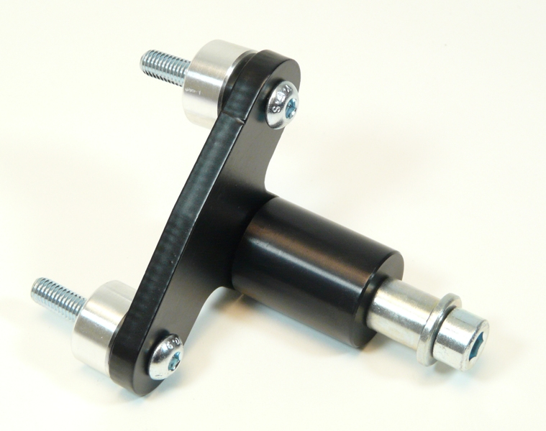

8

7

6

6

5

4

2

1

**Installation:**

1. the installation of crash protectors for the left and right side is the same
2. remove the original bolts M8
3. give duralumin cylinder (No. 3 UP, No. 4 Downl) into the frame
4. use the bolts (No. 6) for gripping of steel adapter (No. 7) to the frame of the motorcycle
5. give steel box (No. 1) in protector together with bolt (No. 2) and washer No.8 under the protector put dural. cylinder No.5
6. all this set mount to thread on adapter

**Warning – we recommend to use safety glue on threads of all bolts (moderate strong – blue colour).**

