KTM4S
KTM 390 Duke 2013-17´

Kit for right side: |  |  |  |  | Kit for left side:
ID. | Description | Cat.N | Qt |  | ID. | Description | Cat.N | Qt
1 | Dural.adapter for SL01 | 315 | 1 |  | 1 | Dural.adapter for SL01 | 315 | 1
2 | Dural. cylinder d=13mm | 464 | 1 |  | 2 | Dural. cylinder d=17mm | 1190 | 1
3 | Dural. cylinder d=15mm | 465 | 1 |  | 3 | Dural. cylinder d=17mm | 1190 | 1
4 | Bolt M10x45 | 847 | 1 |  | 4 | Bolt M10x45 | 847 | 1
5 | Bolt M8x45mm | 964 | 2 |  | 5 | Bolt M8x45mm | 964 | 2
6 | Steel adapter | 628 | 1 |  | 6 | Steel adapter | 628 | 1
7 | Bolt M6x25 | 877 | 3 |  | 7 | Bolt M6x25 | 877 | 3
8 | Bolt M4x16 | 876 | 2 |  | 8 | Bolt M4x16 | 876 | 2

Instruction to assembly:

- Instruction to assemlby for left and right hand side are same.
- Do the mounting left side first.
- Take out original bolts M8 from frame.
- Insert duralumin cylinders into the frame (ID.2 is UP and ID.3 is down).
- Take bolts ID.6 and gripping steel adapter ID.6 on the bike.
- Bolt ID.4 insert into the dural.adapter ID.1.
- Do mounting this kit on the motorcycle frame. (see photo).
- By bolts ID.7 gripping slider. Put alu. cover into the slider, use bolts ID.8.

Warning - on the threads of all bolts recommend the use of medium strong glue for threads (blue).

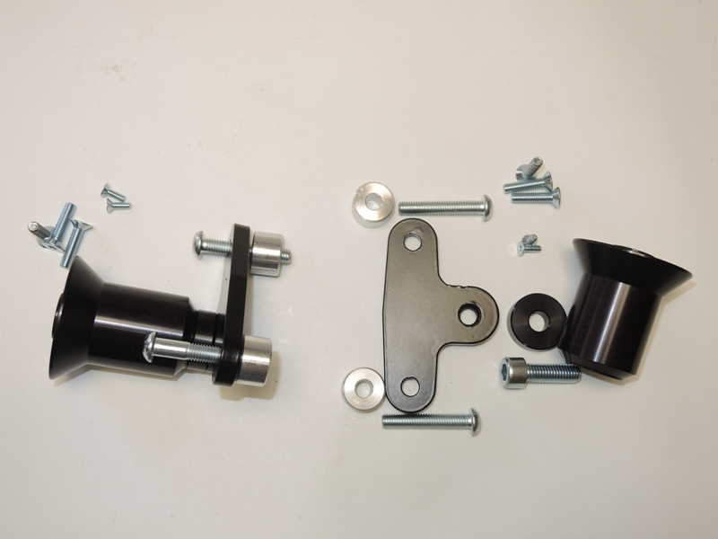
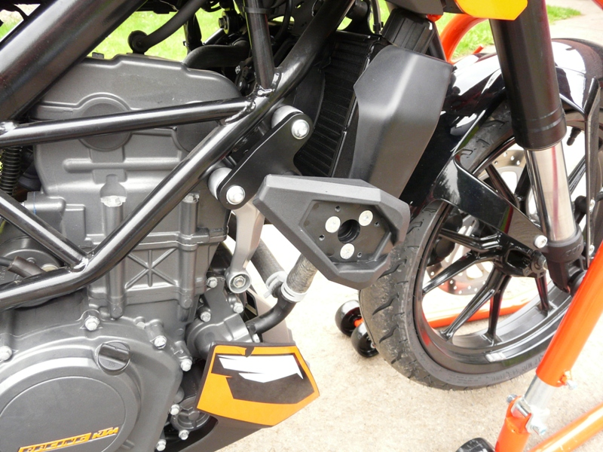
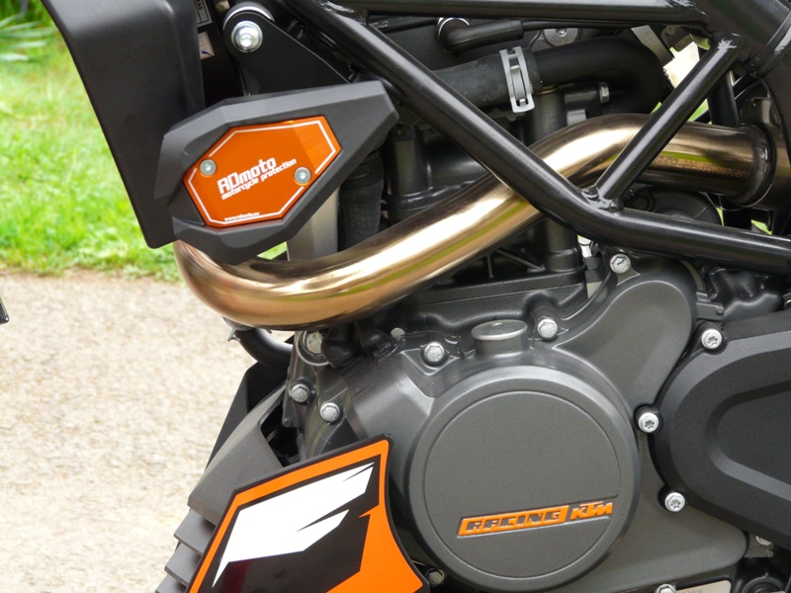
9
8
6
5
4
3
2
1
6
7

