KTM5SD

**KTM RC 125/200/390 2014-**

|  |  |  |  |  |  |  |  |  |  |
| --- | --- | --- | --- | --- | --- | --- | --- | --- | --- |
| **Kit for the left side** | | | | | **Kit for the right side** | | | | |
|  |  |  |  |  |  |  |  |  |  |
| **No.** | **Description** | **Cat.no.** | **Pcs** |  | **No.** | **Description** | **Cat.no.** | **Pcs** |  |
| 1 | Left mounting plate | 678 | 1 |  | 1 | Right mounting plate | 679 | 1 |  |
| 2 | Clamp spacer 22mm | 680 | 1 |  | 2 | Clamp spacer 22mm | 680 | 1 |  |
| 3 | Thread clamp 22mm | 682 | 1 |  | 3 | Thread clamp 22mm | 682 | 1 |  |
| 4 | Clamp spacer 16mm | 681 | 1 |  | 4 | Clamp spacer 16mm | 681 | 1 |  |
| 5 | Thread clamp 16mm | 683 | 1 |  | 5 | Thread clamp 16mm | 683 | 1 |  |
| 6 | Bolts M6x35 button head | 989 | 4 |  | 6 | Bolts M6x35 button head | 989 | 4 |  |
| 7 | Dural.spacer | 15 | 1 |  | 7 | Dural.spacer | 15 | 1 |  |
| 8 | Dural. slider holder | 537 | 1 |  | 8 | Dural. slider holder | 537 | 1 |  |
| 9 | Bolt M10x90 | 880 | 1 |  | 9 | Bolt M10x90 | 880 | 1 |  |
| 10 | Bolt M8x25 | 815 | 2 |  | 10 | Bolt M8x25 | 815 | 2 |  |
| 11 | Washer spring M8 | 800 | 2 |  | 11 | Washer spring M8 | 800 | 2 |  |
|  |  |  |  |  |  |  |  |  |  |

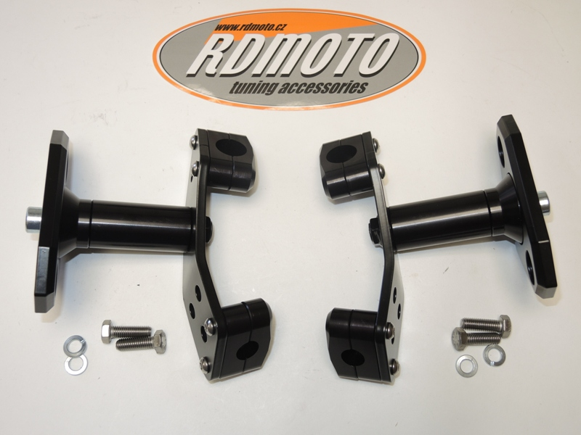

8

2

3

8

2

3

6

6

7

7

6

6

9

9

1

1

10

10

11

11

2

6

4

5

5

4

6

6

**Instructions:**

1. Remove fairing of motorcycle.
2. Place the clamp spacer ID.2 and ID.4.
3. Place the appropriate threaded clamps ID.3 and ID.5 around the frame and secure using the M6x35 bolts ID.6.
4. Bolt ID.9 insert through the dural. holder ID.8 and dural. spacer ID.7.
5. This kit assembly into the threaded hole in the mounting plate ID.1 and tighten ensuring.
6. Slider position must be as shown on the picture.
7. Place slider and tighten it by bolts ID.10 and washers ID.11.

**Warning – we recommend to use safety glue on threads of all bolts (moderate strong – blue colour).**

