KTM5

**KTM RC 125/200/390 2014-**

|  |  |  |  |  |  |  |  |  |  |
| --- | --- | --- | --- | --- | --- | --- | --- | --- | --- |
| **Kit for the left side** | | | | | **Kit for the right side** | | | | |
|  |  |  |  |  |  |  |  |  |  |
| **No.** | **Description** | **Cat.no.** | **Pcs** |  | **No.** | **Description** | **Cat.no.** | **Pcs** |  |
| 1 | Left mounting plate | 678 | 1 |  | 1 | Right mounting plate | 679 | 1 |  |
| 2 | Clamp spacer 22mm | 680 | 1 |  | 2 | Clamp spacer 22mm | 680 | 1 |  |
| 3 | Thread clamp 22mm | 682 | 1 |  | 3 | Thread clamp 22mm | 682 | 1 |  |
| 4 | Clamp spacer 16mm | 681 | 1 |  | 4 | Clamp spacer 16mm | 681 | 1 |  |
| 5 | Thread clamp 16mm | 683 | 1 |  | 5 | Thread clamp 16mm | 683 | 1 |  |
| 6 | Bolts M6x35 button head | 989 | 4 |  | 6 | Bolts M6x35 button head | 989 | 4 |  |
| 7 | Steel box | X1 | 1 |  | 7 | Steel box | X1 | 1 |  |
| 8 | Dural spacer d=60mm | DV 6 | 1 |  | 8 | Dural spacer d=60mm | DV 6 | 1 |  |
| 9 | Bolt M10x100 | 885 | 1 |  | 9 | Bolt M10x100 | 885 | 1 |  |
|  |  |  |  |  |  |  |  |  |  |

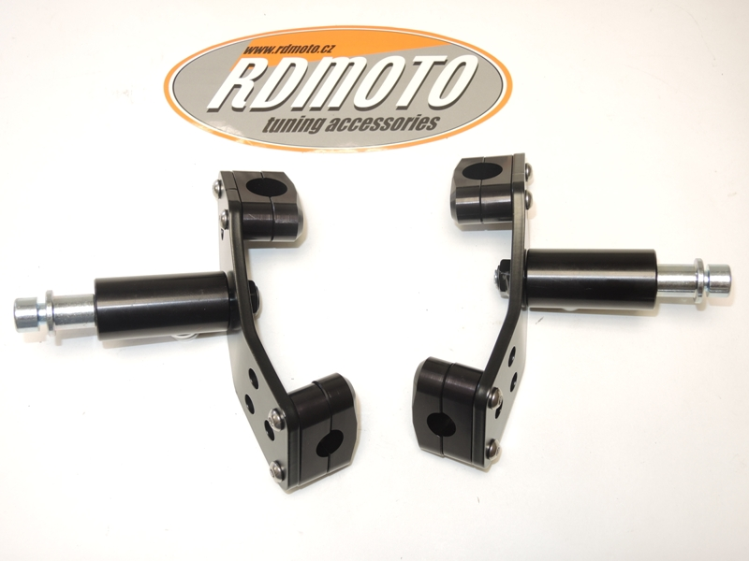

3

2

3

2

6

6

9

8

7

6

6

9

7

8

1

1

6

6

2

6

5

4

5

4

**Instruction to assembly left hand side:**

1. Remove the fairing original bolts M8.
2. Place the clamp spacer ID.2 and ID.4.
3. Place the appropriate threaded clamps ID.3 and ID.5 around the frame and secure using the M6x35 bolts ID.6.
4. Place the steel box ID.7 into the protector, protector with steel box place onto bolt ID.9, next under the protectors place dural.spacer ID.8.
5. This kit assembly into the threaded hole in the mounting plate ID.1 and tighten ensuring.

**Instruction to assembly right hand side:**

1. Remove the fairing original bolts M8.
2. Place the clamp spacer ID.2 and ID.4.
3. Place the appropriate threaded clamps ID.3 and ID.5 around the frame and secure using the M6x35 bolts ID.6.
4. Place the steel box ID.7 into the protector, protector with steel box place onto bolt ID.9, next under the protectors place dural.spacer ID.8.
5. This kit assembly into the threaded hole in the mounting plate ID.1 and tighten ensuring.

**Warning – we recommend to use safety glue on threads of all bolts (moderate strong – blue colour).**

