KTM6S

**KTM 1290 Super Duke 2013-**

|  |  |  |  |  |  |  |  |  |  |
| --- | --- | --- | --- | --- | --- | --- | --- | --- | --- |
| **Kit for left side:** | | | | | **Kit for right side:** | | | | |
|  |  |  |  |  |  |  |  |  |  |
| **ID.** | **Description** | **Cat.N** | **Qt** |  | **ID** | **Description** | **Cat.N** | **Qt** |  |
| 1 | Steel bracket for SL01 | 688 | 1 |  | 1 | Steel bracket for SL01 | 689 | 1 |  |
| 2 | Bolt M10x80 | 852 | 1 |  | 2 | Bolt M10x80 | 852 | 1 |  |
| 3 | Washer M10 | 804 | 1 |  | 3 | Washer M10 | 804 | 1 |  |
| 4 | Plastic cap | X4 | 1 |  | 4 | Plastic cap | X4 | 1 |  |
| 5 | Polyamid cylinder with threadd=40mm | X65 | 1 |  | 5 | Polyamid cylinder with threadd=40mm | X65 | 1 |  |
| 6 | Bolt M8x40 cone | 835 | 1 |  | 6 | Bolt M8x40 cone | 835 | 1 |  |
| 7 | Dural.spacer d=60mm | 318 | 1 |  | 7 | Dural.spacer d=60mm | 318 | 1 |  |
| 8 | Bolt M6x25 | 877 | 3 |  | 8 | Bolt M6x25 | 877 | 3 |  |
| 9 | Bolt M4x16 | 876 | 2 |  | 9 | Bolt M4x16 | 876 | 2 |  |
| 10 | 3M Tape | 3M | 1 |  | 10 | 3M Tape | 3M | 1 |  |
| 11 | Bolt M10x30 | 882 | 1 |  | 11 | Bolt M10x30 | 882 | 1 |  |
| 12 | Dural. roller d=7mm | 405 | 1 |  | 12 | Dural. roller d=7mm | 405 | 1 |  |
|  |  |  |  |  |  |  |  |  |  |

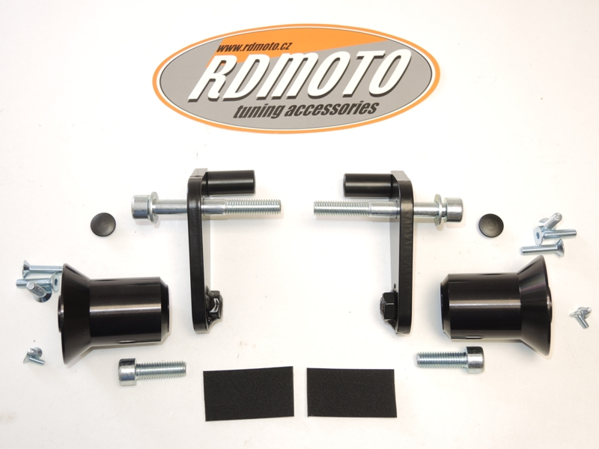

6

6

5

5

4

4

3

3

8

2

2

8

7

1

1

7

9

5

10

11

11

9

**Instruction to assembly left side:**

1. Mounting polyamide cylinder ID.5 on the steel bracket ID.1 by bolt ID.6.
2. Stick 3M tape on the frame. In the place where is polyamide cyl. touching the frame.
3. Take out original bolt M10 from frame. Original dural. spacer leave in frame and insert a roller into it ID.12.
4. Insert washer ID.3 on the bolt ID.2. Steel bracket mounting on the frame.
5. Tighten bolt M10 and put plastic cover ID.4 into the head.
6. Dural. spacer ID.7 mounting on the steel bracket, use bolt ID.11. For right position Cheb photo.
7. Bolts ID.8 gripping slider and insert alu.cap. Mounting it by bolts ID.9.
8. **Do this assembly on the right side.**

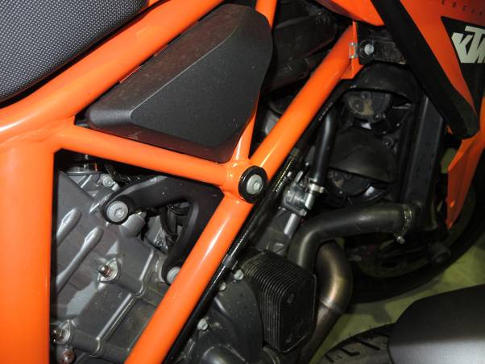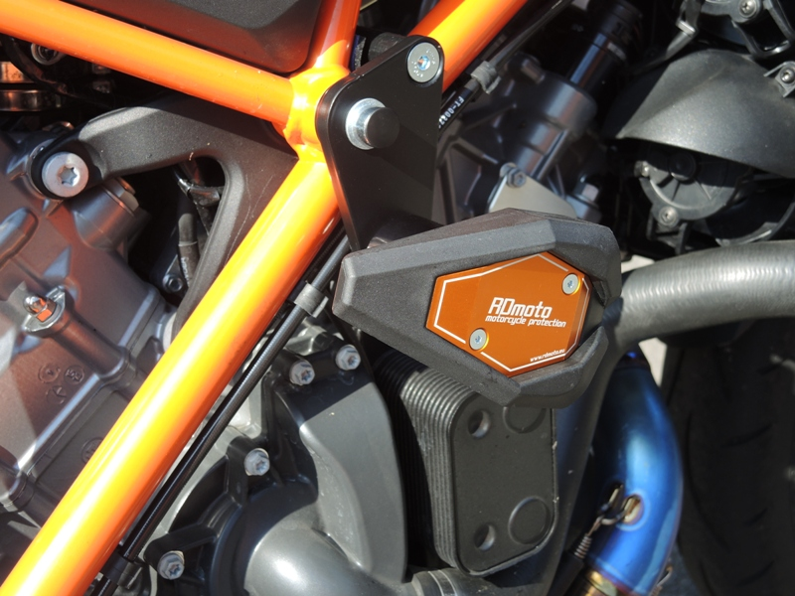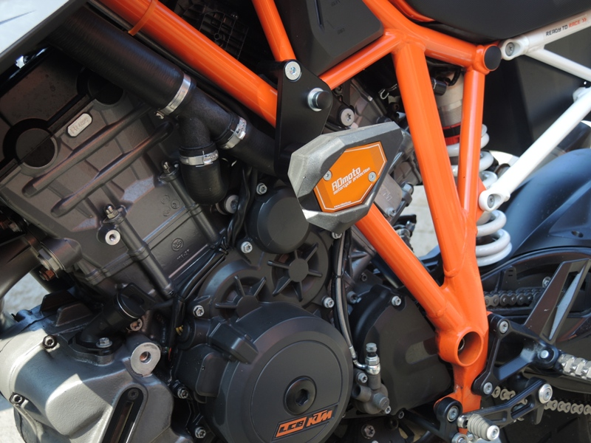**Warning- Use the glue of all threads. Medium strong.**

Original spacer leave in the same place.