KTM6

**KTM 1290 Super Duke 2013-**

|  |  |  |  |  |  |  |  |  |  |
| --- | --- | --- | --- | --- | --- | --- | --- | --- | --- |
| **Kit for left side:** | | | | | **Kit for right side:** | | | | |
|  |  |  |  |  |  |  |  |  |  |
| **ID.** | **Description** | **Cat.N** | **Qt** |  | **ID.** | **Description** | **Cat.N** | **Qt** |  |
| 1 | Steel bracket for protector | 688 | 1 |  | 1 | Steel bracket for protector | 689 | 1 |  |
| 2 | Bolt M10x80 | 852 | 1 |  | 2 | Bolt M10x80 | 852 | 1 |  |
| 3 | Washer M10 | 804 | 1 |  | 3 | Washer M10 | 804 | 1 |  |
| 4 | Plastic cover | X4 | 1 |  | 4 | Plastic cover | X4 | 1 |  |
| 5 | Poly. nut d=40mm | X65 | 1 |  | 5 | Poly. nut d=40mm | X65 | 1 |  |
| 6 | Bolt M8x40 cone head | 835 | 1 |  | 6 | Bolt M8x40 cone head | 835 | 1 |  |
| 7 | Spacer d=30mm | DV3 | 1 |  | 7 | Spacer d=30mm | DV3 | 1 |  |
| 8 | 3M tape | 3M | 1 |  | 8 | 3M tape | 3M | 1 |  |
| 9 | Bolt M10x70 | 851 | 1 |  | 9 | Bolt M10x70 | 851 | 1 |  |
| 10 | Stainelss steel box | X1 | 1 |  | 10 | Stainelss steel box | X1 | 1 |  |
| 11 | Dural. roller d=7mm | 405 | 1 |  | 11 | Dural. roller d=7mm | 405 | 1 |  |
|  |  |  |  |  |  |  |  |  |  |

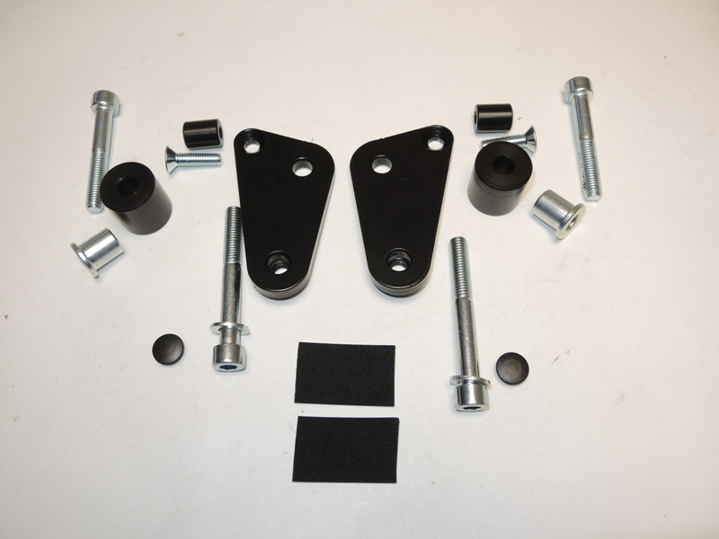

6

6

5

5

1

1

9

9

10

2

10

7

7

3

2

3

4

4

8

**Instruction to assembly left side:**

1. Mounting polyamide cylinder ID.5 on the steel bracket ID.1 by bolt ID.6.
2. Stick 3M tape on the frame. In the place where is polyamide cyl. touching the frame.
3. Take out original bolt M10 from frame. Original dural. spacer leave in frame, insert a roller into it ID.11.
4. Insert washer ID.3 on the bolt ID.2. Steel bracket mounting on the frame.
5. Tighten bolt M10 and put plastic cover ID.4 into the head.
6. Insert ID.10 into the protector, under the protector place dural.spacer ID.7. This kit mount on the steel bracket by bolt ID.9 Tighten protector.
7. Do this assembly on the right side.

**Warning- Use the glue of all threads. Medium strong.**

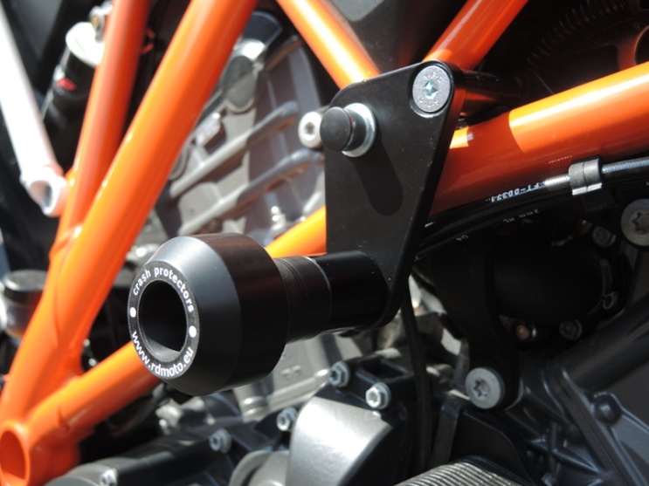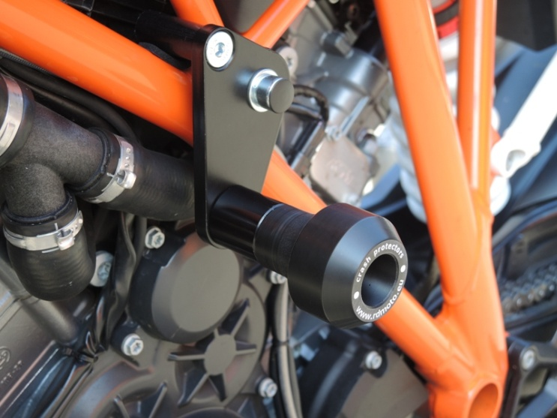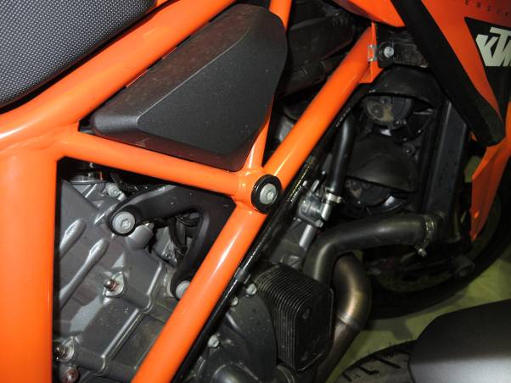

Original spacer leave in the same place.