MV1SD
MV Agusta F800 Brutale/Rivale/ Dragster

Mounting kit:
ID. | Description | Cat. n | Qty
1 | Nut M12 | 811 | 2
2 | Dural.adapter | 494 | 2
3 | Dural. holder for SLD | 537 | 2
4 | Steel bar 12x445x30x30 |  | 1
5 | Bolt M8x25 | 815 | 4
6 | Washer M8 spring | 800 | 4

Instruction:

1. Remove original bolt from frame.
2. Through the frame place steel bar ID.4 (M12x445x1,5mm).
3. Insert dural.adapters ID.2 into the frame and place dural.holders ID.3 tighten it by NUTS ID.1.
4. Put sliders on adapters and use bolts ID.5 with washers ID.6.

Warning - the threads of the screws is recommended to use glue (blue color).

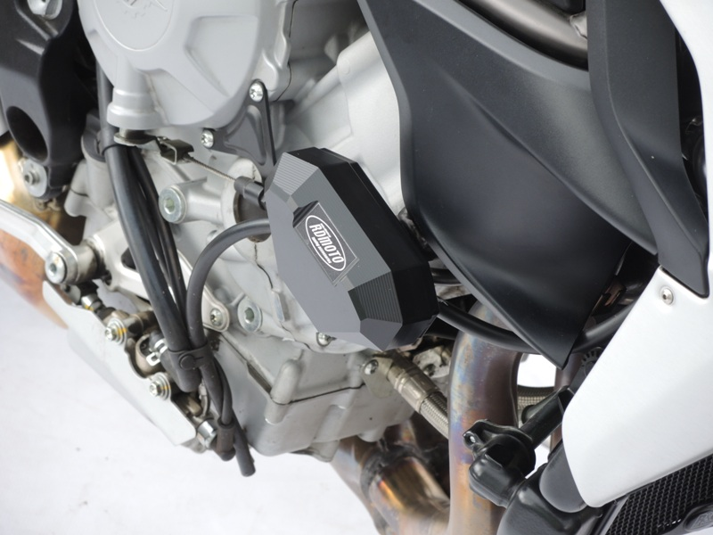
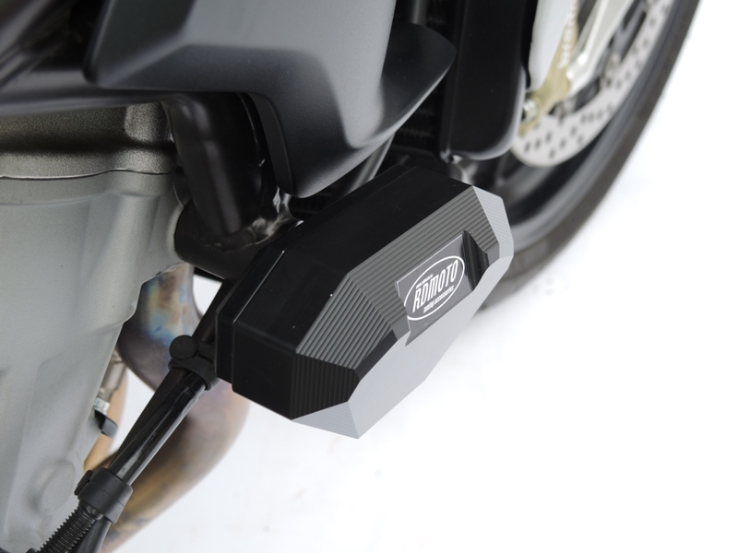
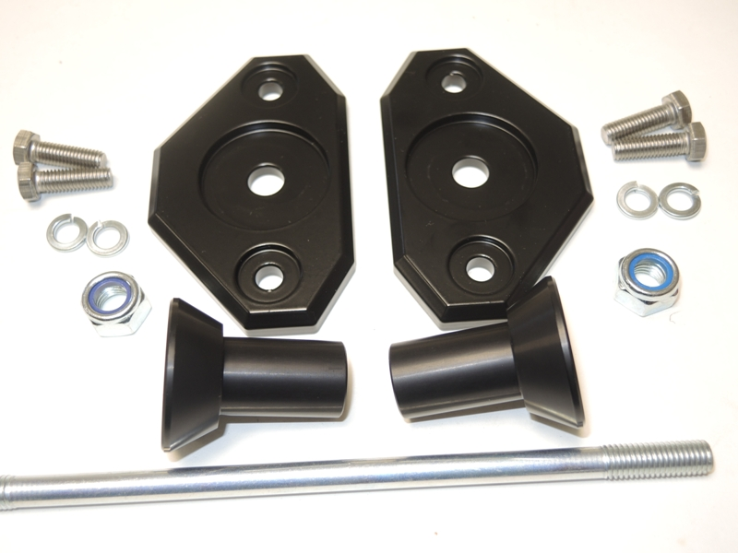
6
6
5
5
3
3
1
1
2
2
4

