MV3S
MV Agusta F3 675 2012-

Fitting kit left side: Fitting kit right side:
ID | Description | Cat.n | QTY
1 | Welded assembly | 662 | 1
2 | Dural.adapter | 317 | 1
3 | Bolt M10X35 | 847 | 1
4 | Loc Nut M10 | 810 | 2
5 | Washer M10 | 804 | 1
6 | Dural. cylinder 40mm | 1142 | 1
7 | 3M Tape | - | 2
8 | Bolt M6x25 | 877 | 3
9 | Bolt M4x16 | 876 | 2
ID | Description | Cat.n | QTY
1 | Welded assembly | 663 | 1
2 | Dural.adapter | 317 | 1
3 | Bolt M10X35 | 847 | 1
4 | Loc Nut M10 | 810 | 2
5 | Washer M10 | 804 | 1
6 | Dural. cylinder 37mm | 1141 | 1
7 | 3M Tape | - | 2
8 | Bolt M6x25 | 877 | 3
9 | Bolt M4x16 | 876 | 2
Bars:
10 | Engine bar (12)M10(16)x407x1,5x16x16 |  | 1
11 | Spanning bar (12)M10(18)x417x1,5x18x18 |  | 1

Fitting kit without cut fairing.

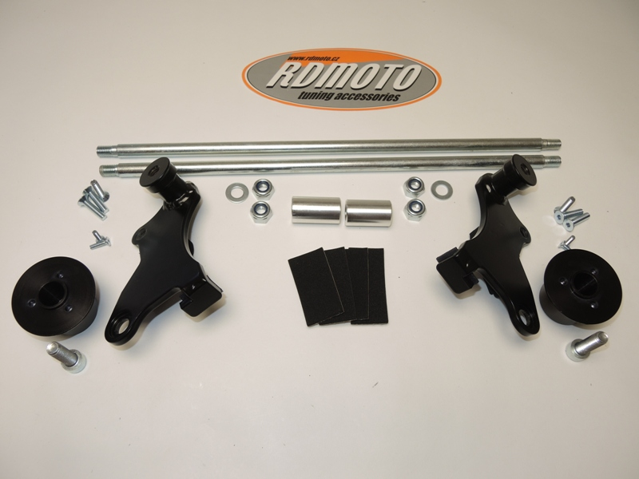

10
2
6
6
1
2
1
4
3
3
5
4
5
7
11
8
9
8
9

Instruction to assembly:
- Stick 3M tape on to each bracket ID.1 as arrowed in picture.
- Remove the side fairings from both sides of the motorcycles.
- Remove bolt, which connect engine with frame. To do this, remove the nut and spacer on the right side of the bike and begin to slide the bolt out.
- Insert engine bar ID.10 into the frame. Put dural. cylinder lenght 40mm ID.6 from left side and 37mm dural. cylinder ID.6 from right side into the frame.
- Fitting loosely Nut M10 ID.4 from both sides.
- Take the spanning bar ID.11 and insert it through the bike. For fitting this bar to steel bracket on the right side use washer and nut (ID.4 and ID.5). Nut fitting loosely.
- Spanning bar fitting to steel bracket on the left side use washer and nut (ID.4 and ID.5). Nut fitting loosely.
- NOW tighten all nuts.
- Re-fit the fairings to both sides of the bike.
- Fitting dural. adapters ID.2 on the brackets, use bolts ID.3 and on it fitting sliders, use bolts ID.8 and insert covers by bolts ID.9.

Warning: We recommend use the glue of all threads. Medium strong.

