MV4S
MV Agusta Brutale 990/ 1090

Fitting kit left side: Fitting kit right side:
ID | Description | Cat.N | Qt
1 | Dural. adapter for slider | 347 | 1
2 | Bolt M6x25 | 877 | 3
3 | Bolt M4x16 | 876 | 2
4 | Bolt M12x70x1,25 | 937 | 1
ID | Description | Cat.N | Qt
1 | Dural. adapter for slider | 347 | 1
2 | Bolt M6x25 | 877 | 3
3 | Bolt M4x16 | 876 | 2
4 | Bolt M12x70x1,25 | 937 | 1

Instruction to assembly:
We recommend to finish one side and after make assebly sekond side.

1. Remove orig. bolts M12 from chassis.
2. Into the adapter ID.1 insert bolt ID.4.
3. This kit mounting into the frame.
4. Place slider on the dural. adapter and fix it by bolts ID.2.
8. Place aluminum cover into the slider, use bolts ID.3.

Warning - on the threads of the screws we recommend using premium adhesive moderate (blue).

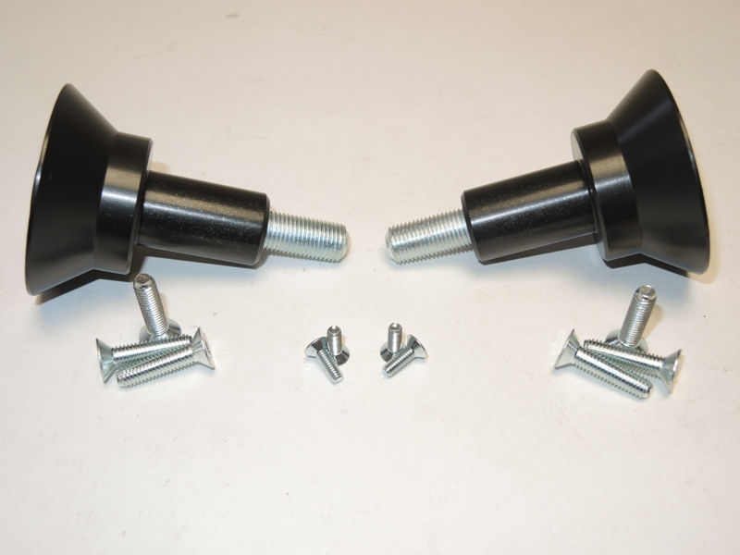

1
1
4
4

3
3
2
2

